
Deanship of Graduate Studies
Al-Quds University

Assessing the Exploitations and Violations of Children’s Digital Rights on YouTube: Palestinian Kidinfluencers as a case study

Diana “Mohammad Faisal” Alkhayyat

M.Sc. Thesis

Jerusalem – Palestine
1443 / 2022
Assessing the Exploitations and Violations of Children’s Digital Rights on YouTube: Palestinian Kidinfluencers as a case study

Prepared By:
Diana “Mohammad Faisal” Alkhayyat

B.Sc of Journalism and Political Science/ Birzeit University/ Palestine

Supervisor: Dr. Hanna Kreitem

A thesis submitted in partial fulfillment of requirements for the degree of Masters of Media / Digital Media and Communications Program/ Art Faculty/ Deanship of Graduate Studies/ Al-Quds University

1443 / 2022

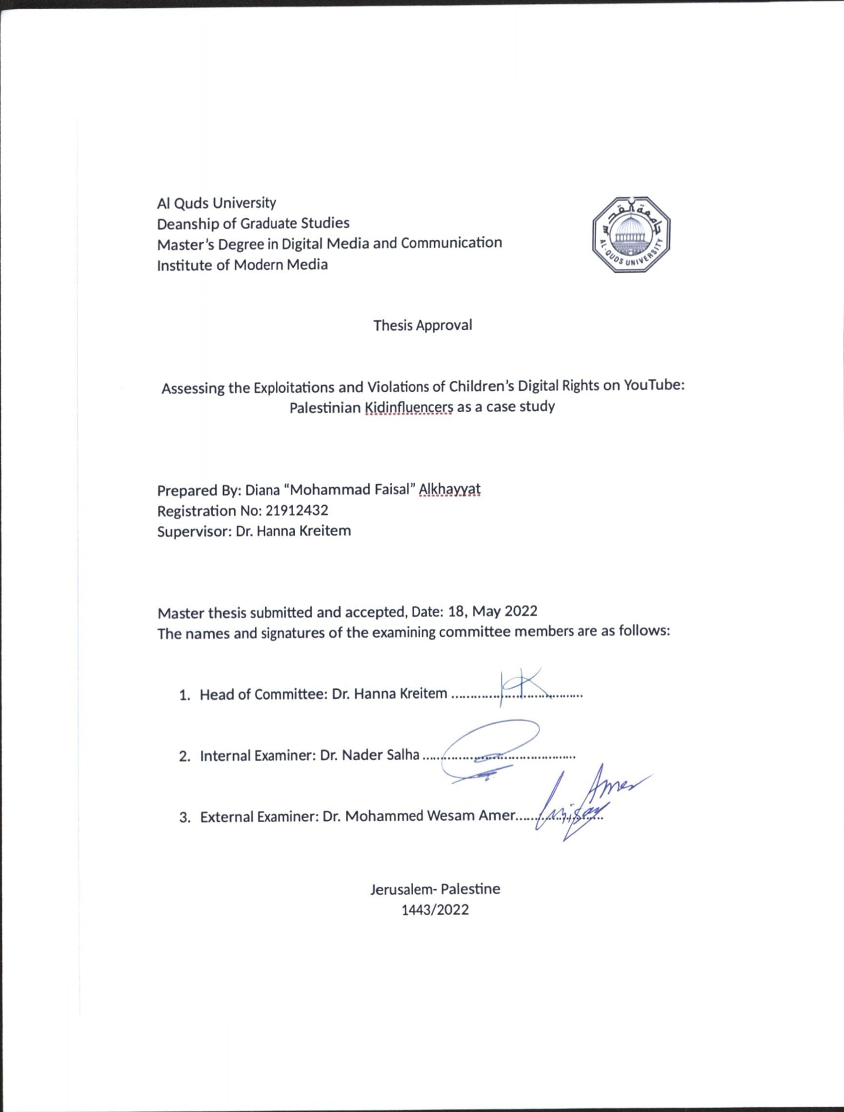

Dedication

To the one who lightened my road with unconditional love and support, to the jewel of my heart, to my warm shield… I couldn’t make it without you Mom.

To my number one supporter, who kept my determination and faith all over the way, to the white pure heart… My beloved dad.

To the hand that pulled me up in hard times, and to the heart who keeps filling me with strength and faith, my dear husband Yazan… Thank you is not enough.

To my little prince, my best friend, and my guardian angel who pushed me every day with his smile to keep going and to never deviate from the goal, my son Zaid.

To the soul of the idol, the late martyr Shireen Abu Akleh… This work is to your brave path in never hesitating to tell the truth and defend your beloved Palestine… You will never be forgotten.

I dedicate this thesis to my parents, family and friends. Thanks for making me see this adventure through the end.

And to the children all over the world... This is for you

Declaration

I certify that this thesis submitted for the degree of Master, is the result of my own research, except where otherwise acknowledged, and that this study has not been submitted for a higher degree to any other university or institution.

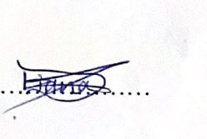

Signed….

Diana “Mohammad Faisal” Alkhayyat

Date: May, 18, 2022

Acknowledgments

I would like to express my gratitude to my primary supervisor, Dr. Hanna Kreitem, who guided me throughout this academic journey with lots of patience and support.
I also wish to sincerely thank and show my appreciation to the head of Digital Media and Communication program Dr. Nader Salha for all the support and knowledge he provided throughout the past three years.

And special thanks go to my family, friends and colleagues for the support.

Abstract

The rise of social media platforms and the rapid evolution of today’s life led to the emergence of “Kidinfluencers”, children who creates content on social media networks and have large social media followings. This study looks at content of key Palestinian “Kidinfluencers” YouTube channels and tracks the exploitation and violations of children's rights through the lens of the United Nations Convention on the Rights of the Child (UNCRC) and YouTube guidelines. Moreover, the study examines the current Palestinian laws and regulations and its jurisdiction in observing and dealing with “kidinfluencers” content where violations of children rights exist, especially that this phenomenon holds a series of consequences that may expose children to potential risks. Using mixed methods (concurrent nested) in analysis and data collection; this study analyses selected content of the 5 most subscribed to and viewed YouTube channels of Palestinian kidinfluencers within the Communication Privacy Management (CPM) theory. The study showed that all channels violated one or more of the UNCRC articles and YouTube guidelines, and that there are shortcomings in the Palestinian judicial body when monitoring the content of YouTube channels. One of the most prominent recommendations this study is calling for updating the current laws to be more harmonized and consistent with the global status in protecting children online.

تقييم انتهاكات واستغلال حقوق الأطفال الرقمية على اليوتيوب: الأطفال المؤثرون في فلسطين حالة دراسية
إعداد: ديانا "محمد فيصل" الخياط
المشرف: د. حنا قريطم

ملخص:

أدى ظهور منصات التواصل الاجتماعي والتطور السريع في حياتنا اليومية إلى ظهور ظاهرة جديدة تسمى "Kidinfluencers" أو "الأطفال المؤثرون"، وهم الأطفال الذين ينشئون محتوى على شبكات التواصل الاجتماعي ولديهم عدد كبير من المتابعين على هذه الشبكات. تتعقب هذه الدراسة انتهاكات واستغلال حقوق الأطفال من منظور اتفاقية الأمم المتحدة لحقوق الطفل وإرشادات وتعليمات موقع يوتيوب في محتوى قنوات الأطفال المؤثرون الفلسطينية. علاوة على ذلك، فإنها تتناول كيفية تعامل ومراقبة القوانين واللوائح الفلسطينية الحالية لمحتوى "الأطفال المؤثرين" عند انتهاك أي من حقوق الأطفال، لا سيما وأن هذه الظاهرة تحمل سلسلة من التبعات التي قد تعرض الأطفال لمخاطر محتملة. مستخدمة طرق مختلطة في التحليل وجمع البيانات، تنتهج هذه الدراسة تحليل محتوى للقنوات الخمس الأكثر اشتراكًا ومشاهدة على منصة يوتيوب الخاصة بالأطفال الفلسطينيين المؤثرين بناءً على كل من مواد اتفاقية الأمم المتحدة لحقوق الطفل وإرشادات مجتمع يوتيوب، في ضوء استخدام نظرية إدارة خصوصية التواصل كإطار نظري للدراسة. من أبرز النتائج التي توصلت إليها الدراسة أن جميع القنوات التي تم تحليلها خالفت مادة أو أكثر من مواد اتفاقية حقوق الطفل وإرشادات يوتيوب، وأظهرت الدراسة كذلك أن هناك قصور في الجسم القضائي الفلسطيني والتشريعات الخاصة بمراقبة محتوى قنوات اليوتيوب ومنصات التواصل الاحتماعي الأخرى. وتوصي هذه الدراسة بتحديث القوانين الحالية لتكون أكثر تناسقًا وتوافقًا مع الوضع العالمي في حماية الأطفال عبر الإنترنت، في ظل الحاجة الملحة لتوفير بيئة رقمية آمنة لهم.

Table of Contents

Thesis Approval Error! Bookmark not defined.
Dedication 3
Declaration i
Acknowledgments ii
Abstract iii
Arabic Abstract iv
List of Tables vii
List of Figures vii
List of Appendices vii
1. Chapter One: Introduction 1
1.1 Introduction 1
1.2 Research significance 3
1.3 Research Aims 4
1.3 Research Questions 5
1.4 Limitations 5
2. Chapter Two: Literature Review 6
2.2 Social Media Branding and Marketing 9
2.3 YouTube and Unsafe Child Content 12
2.4 YouTube Community Guidelines 15
2.5 Global Privacy and Data Protection Laws 18
2.6 Digital Rights in Palestine 19
2.7 Jurisdictions and Children Rights in Palestine 22
Chapter Three: Theoretical and Conceptual Framework 24
3.1 Conceptual Framework 24
3.1.1 Kidinfluencers: 24
3.1.2 The United Nations Convention on the Rights of the Child (UNCRC) 25
3.1.3 YouTube Community guidelines 26
3.2 Theoretical Framework 28
4. Chapter Four: Methodology 30
4.1 Methodology 30
4.2 Methods and Data Collection 31
4.2.1 Content analysis: 31
4.2.2 Focus group: 32
4.2.3 Interview: 32
4.3 Sample 34
4.3.1 Channels description 35
5. Chapter Five: Results 36
5.1 Data Analysis 36
5.2 Video Analysis 37
5.3 Results 54
6. Chapter Six: Discussion and Conclusions 66
6.1 Discussion and Conclusions 66
6.2 Recommendations 69
Bibliography 71
Appendices 75

List of Tables

Table 1: UNCRC Articles Coding
Table 2: YouTube Guidelines Coding
Table 3. Sample description
Table 4. Channels description
Table 5. Videos Analysis for all channels.

List of Figures

Figure 1. Number of UNCRC violations in each video/ Malak Tube l
Figure 2. Number of UNCRC violations in each video/ Mera and Yazan Tube l
Figure 3. Number of UNCRC violations in each video/ Rahaf pro li
Figure 4. Number of UNCRC violations in each video/ Deema cam li
Figure 5. Number of UNCRC violations in each video/ Mera World lii
Figure 6. Number of YouTube guidelines violations in each video/ Malak Tube liii
Figure 7. Number of YouTube guidelines violations in each video/ Mera and Yazan Tube liii
Figure 8. Number of YouTube guidelines violations in each video/ Rahaf Pro liv
Figure 9. Number of YouTube guidelines violations in each video/Deema cam liv
Figure 10. Number of YouTube guidelines violations in each video/ Mera world lv
Figure 11. Number of YouTube guidelines and UNCRC violations in each channel lvi
Figure 12. Percentage of the UNCRC articles violations in all channels lvii
Figure 13. Percentage of the YouTube guidelines violations in all channels lviii
Figure 14. Percentage of UNCRC articles violation in each channel lix
Figure 15. Percentage of YouTube Guidelines violations in each channel lx

List of Appendices

Figure 2.16. YouTube studio page when uploading videos after the new 2020 policy
Table 5.5: Video Analysis for all channels

Chapter One: Introduction

Introduction

The introduction of social media has forever changed communication, politics, and business. With the invasion of social media platforms into our lives, families and privacy; children have become more likely to be affected by such change than their elders. Moreover, social media and blogging have indeed changed the landscape facing today’s children as they come of age (Steinberg, 2016), and the challenges facing families have grown to be more prominent.
Coinciding with these major changes in the digital era, there is a growing rise in children appearing on social media, which paved the way for the emergence of a new phenomenon called “kidinfluencers”. The term “kidfluencers” refers to minors who engage in sponsorship for product placements, brand promotion, and entertainment, and children appearing in other social media content such as YouTube.
The rise of social media has allowed average individuals to obtain a path to stardom by obtaining followers on social media platforms such as YouTube (Geider, 2021). This has serious repercussions on the users of these platforms. However, the kidinfluencers phenomenon has revealed many risks related to children as well as necessity to regulate and observe the content attached to minors.
Children involved in social media production are facing the types of threats that have long existed in the entertainment industry. These threats could be including the risk of financial exploitation and harm to their well-being, reaching in some cases to child labor, considering that social media has given rise to new forms of profit. Such threats have raised various fears concerning children’s essential digital rights, especially after “kidinfluencers” phenomenon became a trend among children that is spreading widely all over the world.
Throughout the 1960s and 1970s television was the most common media watching device. However, the Video Home System (VHS) technology dominated the 1980s, allowing individuals to watch pre-recorded material as well as make their own recordings of television programs in the comfort of their own homes. In the 1990s, Portable camcorders made original video creation affordable, while DVDs (Digital Versatile Discs) became the industry standard by the 2000s. By 2005, with the proliferation of the World Wide Web, the concept of video was transformed with the launch of the YouTube platform (Neumann & Herodotou, 2020).
In its beginnings, YouTube was known as a video recording and production website. Now, YouTube stands as the main video sharing platform and the second largest search engine, with over two billion active users monthly (GMI, 2022). Children are active consumers of audiovisual content, especially that the website has grown significantly among the younger audience in recent years.
The consequences of consumption of social media on children are far-reaching and federal and state governments are still wrestling with how to safeguard children from these effects. This study will focus on the violations observed in the Palestinian kidinfluencers YouTube channels and to what extent the content of the channels in compatible with children digital rights. In addition to focusing on presence of unsafe content for children, the study examines if the jurisdiction is capable of protecting children from any type of transgression in the digital space. Additionally, the effectiveness of YouTube community guidelines in blocking any unsafe and inappropriate content on the channels.

Research significance

This study expands and encourage literature development on the consequences and effects of “kidinfluencers” phenomenon in the Arab world and help providing a better understanding of the family and children’s content, and the urgent need to regulate such content and moderate it. Moreover, social media has turned children into potential sources of fame and income, and therefore puts children at risk of exploitation. Accordingly, this study takes a closer look at how children’s rights are to be defined and observed in an era of globalization.
By focusing on the regulations attached to “kidinfluencers” content in YouTube channels, this study also interprets the role regulations plays in organizing the social media content, and discuss the Palestinian case in dealing with such content and platform as a new emerging phenomenon. Precisely, this study examines the content related to children which indeed needs to be organized, observed, and subject to certain regulations that assures providing a safe environment for our children. This content will be examined by focusing on the violations observed in the Palestinian kidinfluencers YouTube channels, and to what extent the content of these channels is compatible with children digital rights.
On the other hand, by analyzing the content of the YouTube channels creating content from children themselves directed to children, and comparing it to the selected guidelines and regulations; this study presents a diagnosis of social media platforms status, to help providing future solutions and develop new mechanisms to deal with such content especially in Palestine.
This study also looks at the ethical aspects of the “Kidinfluencers” phenomenon, especially that it is contagious and touches our families and kids directly. So, it’s vital to understand the recent changes that have taken place in the social media scene, mainly after the uprising of social media platforms, and their implications on children not only in Palestine, but all over the world. It’s also vital to understand the aims and intentions these YouTube channels tries to achieve by exposing their lives to millions of people all around the world. On the other hand, this study describes the global regulations related to children's digital rights, the efforts made and achievements that have been recorded in this field worldwide. Moreover, it describes how YouTube is dealing with children content (policies, guidelines, and actions) and what are the shortcomings in observing unsafe child content.

1.3 Research Aims

With obvious scarcity of research on “kidinfluencers” in the Arab world and particularly in Palestine, this study emphasizes the importance of this phenomenon as an emerging trend in the world and in the Palestinian society in specific. As the consequences of social media on children are far-reaching, the study further aims to understand the regulations and guidelines of the Palestinian “kidinfluencers” channels and to what extent does it comply with the international laws related to child digital safety. It also aims to highlight the desperate need of the Palestinian society to regulate the social media content related to children, as there’s a huge dereliction and failure to legislate it weather those children were actors, creators or recipients. In addition, by analyzing the content of kidinfluencers YouTube channels, this study aims to provide future recommendations for all the stakeholders to legalize digital content related to children in Palestine. It also aims to reveals the weaknesses in YouTube guidelines and policies when dealing with children content.

Research Questions

This study answers the following two questions:

- How does Palestinian “Kidinfluencers” content on YouTube channels relate to and preserve creators’ digital rights?

- Does Palestinian laws have any jurisdiction on online content related to children?

Limitations

Through conducting this study, a number of limitations and challenges appeared:
- The sampling of the YouTube channels was very challenging. With the absence of any software and analytical social media tool that could offer sufficient and comprehensive data about the channels, it was hard to decide which are the most subscribed Palestinian Kidinfluencers channels on YouTube.

- The channels are miss-categorized and could not be found under any family or kids-oriented classifications, which doubled the challenge to decide our sample.

- The variation in frequency and intensity of posting videos between the channels, made it harder to define the time limits of the study. While some channels are very active and creates with an average of 4-5 videos every month; other channels publish one video only. To overcome this issue, the analysis was based on the most viewed videos from each of the 5 sampled channels between a certain time period.

- The recording of changing data through the analysis process, including the number of views or followers, which by the dynamic nature of YouTube changes in a matter of minutes. Noting that this is an individual work and the researcher was conducting all the analysis and research steps by herself with no help from any other parties.

2. Chapter Two: Literature Review

The debate on “kidinfluencers” has recently taken significant attention among scientists, and some momentous research studies have risen focusing on various issues related to this new emerging concept. Disparately, literature studied the concept of “kidinfluencers” from many perspectives; highlighting evolving matters such as child labor, social media influencer food marketing, children rights and its’ relationship with unsafe child content. In this chapter we discuss what did the literature of Kidinfluencers and YouTube children videos focus on and what did it undercover, as well as what gabs resulted from previous literature this study covers.
2.1 Child labor
At the time Kidinfluencers industry is growing and reaching billions of dollars of social media earnings each year (Masterson, 2020b), with no legal right for these children to these earnings or safe working conditions; the risk of exploitation became the main concern of scientists worldwide. Masterson (2020) explains how kidfluencers fit in the child labor regime, specifically when considering child actor law. As child actors -in the United States for instance- are not covered by federal child labor laws, this puts their situation in a patchwork of state regulations. Therefore, Masterson proposes state legislation that would protect kidfluencers rights. The issue is nuanced because parents significantly control the production of their children’s content, and states are limited in how much they may regulate a parent’s decisions in raising their child. This controversial issue raised the question on children’s rights and the necessity to regulate Kidinfluencers content on social media by certain legislation. Accordingly, Masterson (2020) suggests that current child actor laws should not simply be expanded to include social media influencers, but instead, tailored legislation is needed. In her paper, Masterson also presents an analytical view of the issue from several perspectives, focusing on child labor exploitation whether it was financial exploitation or mental harm, due to the nature of social media production that differ from traditional child acting, stressing that there’s a desperate need for protection by states governments for Kidinfluencers.
Studying the effects of social media on children and how federal and state governments are still debating how to safeguard children from such effects; has risen the necessity on how to govern and regulate child labor in such an environment. Consequently, Geider (2021) discuss furthermore the concerns about how to govern child labor in this new environment as well as the challenges about how to strike a balance between parents' rights to raise their children and the government's obligation to act in the best interests of children. Geider’s article goes further to presents a historical sequence of Child Labor and Child Entertainment in the United States and the California Labor Code restrictions along with other states situation on child protection in the entertainment industry and social media era. On the other hand, Geider (2021), also studies Lack of Regulation on Social Media Production and Kidfluencers, concluding that the differences between work or play may be seen as semantics, but the consequences are not. He illustrates that social media production involving children as relatively new phenomenon; operates somewhat differently from the use of children in the traditional entertainment industry. Moreover, he explains the consequences as children in social media often appear to film in their own homes. Geider featured famous YouTube Kidinfluencers cases that included child abuse and child neglect, describing that there have been cases of physical and mental abuse to children.
The study raises greater questions about the potential for child abuse that social media production can enable and how YouTube guidelines react with such concerns. in this context, Geider believes that YouTube’s terms of service have not evolved enough to sufficiently address the issue of child safety. Still Geider (2021) asserts that the law has been slow to catch up, recognize, and solve the issue at hand. While there’s a worldwide attention towards studying the kidinfluencers phenomenon, Palestine is still behind in diagnosing this phenomenon and children’s condition on digital platforms. However, this research will examine to what extend Palestinian kidinfluencers YouTube channels commit to the previously mentioned YouTube guidelines, as there’s a major lack in local regulations regarding digital content and broadcast.
Nevertheless, Guzman (2020) also emphasizes on child labor industry in the United States stressing the historical roots and development of this phenomenon, and featuring the shortcomings of federal laws in dealing with YouTube Kids content in particular. It also underlined YouTube’s failure and inability to monitor children’s content effectively. Furthermore, Guzman also illustrates those violations of child labor regulations are not grounds for a channel's deletion on YouTube. Instead, YouTube specifically notes that when "employing" a kid, it is the parent's obligation to guarantee compliance with local labor laws and for the artist to get the permissions needed. On the other hand, the study also mentions YouTube zero-tolerance policy for channels that involve several acts such as sexualization of children, hazardous or dangerous behaviors involving minors, and deceptive family content.
Though there have been significant efforts on diagnosing the effects of social media on children on both governmental and social levels, the policies are not enough to provide a safe and healthy digital environment for our kids. Therefore, there’s a necessity to take a step forward toward conducting more in-depth research on the risks of children content on social media platforms.

2.2 Social Media Branding and Marketing

Studies have agreed that advertising occupies a large part of the child stars content, and therefore focused in its entirety on the negative consequences of their exposure to the marketing industry, mainly their practices as toy marketing influencers on social media (Doek, 2019).
While some studies focus on the presence of unsafe content for children and users who promote it by detecting comments and videos frames aiming to build a system that provides a safe YouTube experience for kids; others discussed the practices of kid influencers on YouTube and the presence of brands in the videos they generate, highlighting the need for global and effective regulation (Tur-Viñes, 2018). Clearly, the desperate need for the management of the communication practices of kid influencers on YouTube, to ensure they are developed in a secure, positive, fun and responsible environment (Tur-Viñes, 2018).
In Spain, kids YouTube channels also caught the attention of researchers and prompted them to address the issue from several aspects. Especially that the Spanish case is significant as it involves top influencers in the world in the toy sector, surpassing even the Spanish pioneering channels from other categories all over the platform. Castillo-Abdul et al. (2020) conducted an exploratory study that analyzed the content of videos of the ten Spanish children's YouTube channels with the highest number of followers and video plays to identify correlations between the thematic axes of the videos (such as the number of subscribers and the type of content) and the increase in digital engagement data. The study demonstrated that the majority of the children who are the main characters of the channel are presently between the ages of 10 and 12, with the channels being formed an average of five years ago, demonstrating how early many YouTubers start in this sector. There are also variances in thematic axis of the channels' videos based on the gender of the children's influencers, with a greater proportion of male YouTubers committed to gameplays, while their female counterparts have a greater presence in videos in the lifestyle category. Nevertheless, throughout all the previous studies featuring YouTube phenomenon in Spain (especially kidinfluencers); it is determined that there is a need to supervise the information accessed by children on this platform. Since it was clearly specified that it might not only widen gender gaps but also serve as an untruthful reference of role models. However, in a similar study, Vizcaino-Laorga et al. (2021) illustrated kid Youtubers practices as toy marketing influencers on YouTube. The paper adopts content analysis approach by analyzing the audio-visual content of the channels of Spanish child YouTubers in which the children interact with toys to promote them and raise brand awareness without their audience identifying that content as advertising, the names of presented brands, the type of products advertised and the advertising formats used. The paper also concluded that there’s a need for further research that would contribute to describing the structure of those practices, in addition, they highlight the importance of considering and identifying this content from the perspective of its persuasive nature. Since the majority of the content examined lacked visible or auditory cues identifying it as such, adults and children mistook it for educational or entertaining content rather than advertising.
Available studies on social media food marketing agrees that marketing of unhealthy food is highly prevalent and has a detrimental and negative effect on children’s eating habits and diet(A. Coates & Boyland, 2021) . A new study highlights how a new type of social media influencer -children themselves- is contributing to this phenomenon. In this study, Alruwaily and colleagues (2020), determines the frequency with which kid influencers promote branded and unbranded food and drinks during their YouTube videos and assess the nutritional quality of food and drinks shown. The researchers used data from a social media marketing platform (SocialBakers) to select the five mostwatched kid influencers (aged 3–14 years) on YouTube in 2019, who collectively have generated ~48 billion views to date. The results shows that from a total sample of 418 videos, just over 40% featured food and/or drinks, which were calculated to have made approximately 16.5 million advertising impressions. Additionally, around 90% of the advertised products were unhealthy branded items. The study is the first to quantify food and drink product and/or brand messages that children receive from child YouTube celebrities, and it paints an alarming picture.
Another important study (A. E. Coates et al., 2019), covered food and beverage cues which explored the extent and nature of food and beverage cues featured in YouTube videos of influencers popular with children.
The data resulted from this exploratory study provided the first empirical assessment of the extent and nature of food and beverage cue presentation in the chosen YouTube videos. Although given the emerging evidence of the effects of influencer marketing of food and beverages on children’s eating behavior, this study offers a novel methodological platform for digital food marketing assessment and delivers important contextual information that could inform policy deliberations in this area. Based on previous content analyses of broadcast marketing, cues were categorized by product type and classified as “healthy” or “less healthy” according to the UK Nutrient Profiling Model. Moreover, (A. E. Coates et al., 2019) shows that in total, the sample comprised 380 YouTube videos (119.5 h) and, of these, only 27 videos (7.4%) did not feature any food or beverage cues.

2.3 YouTube and Unsafe Child Content
Being the second largest search engine after Google (Wagner, 2017), and with over three billion searches per month, YouTube has found various innovative ways to change the availability of user-generated content (Wagner, 2017).
The platform allows users that upload their content to have the ability to monetize their videos and, in return, receive compensation from advertisers who wish to purchase the advertising time available before, during, or after the user generated content. However, children are active consumers of the platform, as children started to launch their own channels, despite the minimum age required by Google to manage an account is 13 (or 14 depending on the country). This has put the platform under huge challenges with monitoring all the content uploaded, especially the one related to children.
With the rapid growth of mobile parenting that is linked to a convergence of digital technology, parenting practices, and the emergence of young children as a targeted demographic and imagined audience (Burroughs, 2017), the apps attached to children also developed to collaborate with such changes.
Accordingly, Burroughs (2017) investigated in his research the growing relationship between media industries and the everyday viewing patterns and lives of young children, focusing mainly on the development of the YouTube Kids app, with well over 10million downloads, which seeks to capture and monetize youth attention. In his paper he illustrates how the technologies are also a part of larger parenting practices through the watching of televisual content by children on mobile phones and tablets.
Another analytical study focused on the child safety on YouTube, especially that large number of users has been recently publishing what can be categorized as inappropriate and unsafe, conducted by Kaushal and colleagues (2016). Their main concern was devoted to content that is placed around cartoon videos which are typically watched by kids. Their study focused on presence of unsafe content for children and users who promote it by detecting such a content and its promoters especially that there is limited control over the content as they assert.
The researchers concluded that unsafe content promoters are less popular and engage less as compared with other users. Moreover, the study discovered that unsafe content is present very close to safe content, and unsafe content promoters form very close knit communities with other users based on their engagements (likes, subscription, and playlist addition) and other factors, thereby increasing the likelihood of a child being exposed to unsafe content (Kaushal et al., 2016).
Another paper that discussed YouTube as a global phenomenon among young children is by Neumann & Herodotou (2020). They discussed the platform’s popularity with young children as well as what children are watching on YouTube and how they interact with the platform at different ages. The study focuses on the potential benefits of YouTube in supporting the education process and in the classrooms developing the student’s critical media skills. Moreover, children interviewed in the chosen sample were careful to avoid pop-up advertisements and clickbait, and quickly clicked away from inappropriate content and pressed the dislike button. On the other hand, the paper raises a question on the concerns about children’s use of YouTube which included risks of exposure to commercial advertisements and disturbing videos. It also mentioned YouTube’s algorithms for circulating videos that may expose children to distressing content.
Though, the paper called for tighter regulations and restrictions on YouTube policies, it still presents a very general glance about children use of YouTube ignoring the real dangers it can have on their lives and security. It misses essential risks attached to the content of these videos especially the one created by children themselves, threating their rights and behaviors.
There’s no doubt that recently several research studies have shed the light on children’s use of social media platforms especially as content creators; still more studies need to highlight the issues facing those children and the risks attached to the industry from different aspects. As most of the literature focused on the advertising, branding and business sides of the issue, none has dealt with it legally or from the children rights aspect. Additionally, analyzing the content on YouTube channels is not very popular among researchers, and even when analyzing YouTube channels, it is usually dependent on exploratory studies and quantitative approach. Nevertheless, in the Arab world the studies on such phenomena (Kidinfluencers) are still scarce and needs more development on various levels.

Conclusively, the importance of this research stems from the fact that the Kidinfluencers phenomenon has not been highlighted or assessed in any of the Arabic or the Palestinian societies. Consequently, this research will pave the way for future studies to address the various perspectives attached to this trendy widespread phenomenon.

2.4 YouTube Community Guidelines

As UNCRC considers the child to be under 18 (UNICEF, 1989), YouTube Child safety policy guidelines also consider minors (Youtube, 2021).
YouTube restricts content makers from posting any material including sexualization or dangerous acts involving minors, causing emotional distress or exposing them to mature themes, and putting minors under the danger of cyberbullying and harassment.

The policies make it unacceptable if the content maker posts any content that may harm the child's emotional health, such as parental abuse, and coercing minors is not allowed. Any content that humiliates anyone is not allowed. It is also not allowed to reveal personal information or to record anyone without permission. YouTube warns from filming content in private spaces such as bedrooms or bathrooms, or filming any act that may lead to undesired attention to kids such as somebody's movements, or giving personal information about the minor. YouTube content creators avoid classifying their channels under “Family” or “Child oriented” content to avoid being restricted by YouTube guidelines, along with commercial considerations as child content may reduce their commercial and financial revenues (Youtube, 2021).

YouTube doesn’t allow content that endangers the emotional and physical well-being of minors, and so it created the following community guidelines for child safety which are used in this study as a tool to analyze Palestinian kidinfluencers videos. YouTube has a strict ‘three strikes and you’re out’ policy. If a creator accumulates three policy violations, the YouTube account will be permanently shut down, and the creator will not be able to access videos and other info uploaded to it. Moreover, YouTube states for users not to post content on if it fits any of the descriptions below:

- Sexualization of minors: Sexually explicit content featuring minors and content that sexually exploits minors.
- Harmful or dangerous acts involving minors
- Infliction of emotional distress on minors: Content that could cause minor participants or viewers emotional distress, including:
  - Exposing minors to mature themes
  - Simulating parental abuse
  - Coercing minors
  - Violence
- Misleading family content: Content that targets young minors and families, but contains:
  - Sexual themes
  - Violence
  - Obscenity or other mature themes not suitable for young audiences
  - Family friendly cartoons that target young minors and contain adult or age-inappropriate themes such as violence, sex, death, drugs and more.

- Cyberbullying and harassment involving minors
- Filmed in private spaces at home such as bedrooms or bathrooms.
- Features minors soliciting contact from strangers, dares or challenges online, or discussing adult topics.
- Shows activities that could draw undesired attention to the minor, such as performing body contortions or ASMR.
- Reveals personal details about a minor.
Forced to pay a record $170 million for alleged violations of Children’s Privacy Law, YouTube has decided to begin enforcing new, children-related regulations. As of January 2020, YouTube creators had to explicitly state their videos’ projected audience. During the upload process, creators will need to check a box that indicates that the video in question is ‘directed to children’, as part of its policy in best practices for content with children. Ticking this box will prevent the video from running algorithm-based, recommended ads, triggered by prior indication of interest (Yampolsky, 2021). This new policy applies to every single video that exists on YouTube’s database. Even if users have uploaded thousands of videos, each will need to be reviewed and deemed either “kid-directed” or suitable for a more mature audience. Figure (16) in the appendices describes how it looks like when uploading any video.
Videos caught targeting children while containing content deemed by YouTube as unsuitable for kids can result in creators paying the US Federal Trade Commission (FTC) fines of up to $42,530.
On the other hand, YouTube illustrates that “Regardless of your location, we require you to tell us whether or not your videos are made for kids according to an agreement with the US Federal Trade Commission (FTC) and to help you comply with the Children’s Online Privacy Protection Act (COPPA) and/or other applicable laws. Failure to set your content appropriately may result in consequences on YouTube or have legal consequences under COPPA and other laws” (YouTube Help, 2022). However, given its amorphous terminology, it is still unclear what content will fall outside of the definition of ‘child-directed’, which this study will examine

2.5 Global Privacy and Data Protection Laws

Rising digital rights issues cannot be separated from the human rights system. Globally, 128 out of 194 countries of the UN have passed laws or are in the process of adopting laws to protect privacy and digital data (UNCTAD, 2021), according to data from the United Nations Conference on Trade and Development. One of the aspects of Digital Rights is data protection, and here the European Union’s General Law on General Data Protection Regulation (EU GDPR), enacted in 2018, provided a positive framework for users and individuals to regain control of their personal and digital information. This is of the most comprehensive laws in this aspect and has become a source of inspiration for many governments, legislative and legal bodies (Abu Arqoub, 2021). Nevertheless, Palestine did not join or get involved in any of the digital rights conventions or movements that have taken place, which reflects a great dereliction in considering the digital rights situation in Palestine.
Considering privacy as a human right, it is certainly a part of the digital rights in the digital space, and whoever violates these rights should be subject to legal accountability. According to the American Judicial Institute for instance; “every person who seriously and unlawfully violates the right of another person not to have his or her affairs and conditions reach others, and his image not being exposed to the public’s attention, shall be considered responsible before the victim” (Goutel, 2013).

As for children in particular, there is not any legislation concerning a child's digital rights or those related to their use of the Internet. The Palestinian Child Law No. (7) of 2004 lacks of any mention of the child’s rights, and the mentioned rights are limited to his basic rights and his social, health, educational and cultural status.

Although this law contains articles related to the right of the child to protection and explains child protection mechanisms; there’s absence of any digital rights that can provide children a safe and healthy environment online.

Working to protect and promote digital rights in Palestine, including freedom of opinion and expression, the right to access information, the right to privacy, and the right to access the Internet are basic rights guaranteed in international laws, and they require collective efforts and effective integrative action at the local, regional and international levels.

2.6 Digital Rights in Palestine

The past few years have seen great interest in the importance of enacting a Palestinian law and legislation of digital rights and specially protecting the privacy and data of Palestinians. Though speaking about digital rights is still a relatively new concept in Palestine.
The nature of the complex Palestinian reality, as the absence of the Legislative Council along with the Israeli occupation restrictions, necessarily means that it is not possible to talk about enacting a Palestinian digital rights law. The absence of an effective legislative authority capable of enacting laws and legislation that keep pace with technological changes, opens the door to abuses and violations of privacy and personal data protection. There is no clear and comprehensive Palestinian personal and digital data protection law in place as of yet.
One of the main challenges Palestine faces is the Israeli restrictions on the Internet. In addition to the violations by international companies that all users are exposed to, Palestinians face Israeli violations. The Israeli occupation controls the Palestinian ICT infrastructure as well as electronic monitoring tools that collect data and violate the privacy of every Palestinian under the pretext of security (Abu Arqoub, 2021).
According to AccessNow's report on privacy and personal data protection in Palestine, the Palestinian Authority's adoption of a data protection law will provide only a limited level of protection. This is due to the fact that the Palestinian information and communication technology infrastructure has been under full Israeli control since Israel's occupation of the Palestinian territories in 1967. Despite signing the Oslo peace agreement in 1993, Israeli authorities continue to control information, communications, and electromagnetic waves, as well as the import and installation of any equipment by Palestinian telecommunications companies and Internet service providers, for unspecified "security reasons." (Fatafta & Samaro, 2021).
On the other hand, the absence of a responsible party to monitor and follow up digital rights acts, as well as the absence of a law protecting the citizens’ right to privacy in order to preserve their digital data, make the Palestinian reality even it more complicated.
Moreover, there are shortcomings in the current Palestinian Basic Law and the Decree-Law on Cybercrime in protecting the right to privacy and users’ data. What these existing laws primarily address is the traditional concept of privacy, which fails to secure the protection of digital data for them.

Cybercrime law 16 was approved by presidential decree and faced several criticisms since then. Although the law was amended in 2018, it still faces strong opposition from Palestinian activists, journalists, and civil society due to its vaguely worded provisions that threaten freedom of expression and the right to privacy on the Internet (Abdeen, 2020).
Essentially the Cybercrime Law deals with privacy and protection of personal data, as Article (22) stipulates that:
1. Arbitrary or unlawful interference with the privacy, family, home, or correspondence of any person is prohibited.
2. “Anyone who creates a website, application, or electronic account, or publishes information on the electronic network or an information technology means with the intention of publishing news, photos, audio or video recordings, whether live or recorded, related to illegal interference in the private or family life of individuals even if they are correct, shall be punished by imprisonment for a period of no less than one year, or by a fine of no less than one thousand Jordanian dinars, and not more than three thousand Jordanian dinars, or its equivalent in the legal currency of circulation, or by both penalties.
Furthermore, the only mention of children in Cybercrime law was in Article (16) related to sexual exploitation which states that:
“Whoever intentionally sends or publishes through the electronic network or any information technology means everything that is audible, readable or visual that includes pornographic acts for those who have not completed eighteen years or relates to their sexual exploitation, shall be punished by imprisonment for a period of no less than one year, or a fine of no less than one thousand Jordanian dinars, and not more than three thousand Jordanian dinars, or its equivalent in the legal currency of circulation, or with both penalties”. The law lacks any mention of children's digital rights and providing protection to them online.
According to Human Rights Watch report, efforts on the ground to protect the privacy of Palestinian individuals and preserve their personal information appear to be limited, as the Palestinian Authority has given priority to adopting the cybercrime law despite the deep controversy surrounding it (Watch, 2017).
In terms of privacy, data protection, and associated electronic crimes, as well as the right to knowledge; Palestinian laws, regulations, and policies remain deficient. This is what generated actual concerns worthy of evaluating reality and moving forward with procedures and laws regulating all of these advances and developments (Abu Arqoub, 2021).

2.7 Jurisdictions and Children Rights in Palestine
While there are five main laws and legislations related to the rights and protection of the child in Palestine, the Juvenile Protection Law is the most essential of these laws. On February 4, 2016, Palestinian President Mahmoud Abbas signed the Juvenile Protection Law into effect, which unified and updated the existing juvenile justice system, bringing it in line with international child rights standards. Previously, the Jordanian law dating back to 1954 was applied.
The Juvenile Protection Law updated the Palestinian juvenile legal system, recognizing minors accused of criminal offenses – those under the age of 18 – as victims in need of protection, rehabilitation, and reintegration into society, rather than as criminals deserving of punishment.
The best interests of the child serves as the guiding principle of the Juvenile Protection Law and the law mandates that children deprived of their liberty will be housed in rehabilitation facilities as opposed to prisons. The law also created juvenile courts and specialized units among the police, prosecutors, and judges for dealing with children in conflict with the law.
However, according to the head of the Juvenile Prosecution Thaer Khalil, who has been interviewed as part of this thesis, “There is no follow-up from any party regarding online violations against children, and no child abuse content has been reported on social media according to the Child Law and the stipulated protection mechanisms, and there is a flaw in Palestinian law in this regard”.
As for reporting the violations that children are subject to, Khalil illustrates that: “The Palestinian Child Law establishes mechanisms for reporting cases of child exposure to risks, and these mechanisms are part of the police, the Ministry of Education, the Ministry of Health, the Ministry of Social Development, and the Public Prosecution”. However, there has been no reporting of any cases related to child content on any of the social media platforms so far according to Khalil.
Regarding the cooperation with global and international parties in digital rights, Khalil confirms: “There is continuous communication with all international and regional bodies in the United Nations Committee on the Rights of the Child regarding children’s issues, but there is no focus or follow-up from the concerned authorities in Palestine according to the law on digital content related to children”.
Concerning the penalties that must be applied on whoever violates any child right, they are according to both “Palestinian Child Law” and “Cybercrime Law”. The Cybercrime Law confirms that the child should not be placed in locations that are dangerous to him, that his privacy should be respected, and that he should not be made available to the public in a way that offends him, his family, his culture, or his personality, according to Khalil.
Concludingly, the mentioned laws concerning child rights and safety ignores the digital space for children in Palestine. It can be concluded that these laws have no jurisdiction on the online space, and its jurisdiction is very limited regarding children’s issues. There is an urgent need to update the laws related to child protection and safety online to be consistent with the global change taking place in the social media industry.

Chapter Three: Theoretical and Conceptual Framework

3.1 Conceptual Framework

The study is attached to many concepts due to the forked and complex issues it covers. Mainly in this chapter, we highlight the three core concepts on which the study is based, which are: Kidinfluencers, the United Nations Convention on the Rights of the Child (UNCRC), and YouTube Community guidelines.

3.1.1 Kidinfluencers:
The term “Kidinfluencers” has emerged recently in the past few years with the rapid rise of social media platforms and the recent changes in the entertainment sector, as children have been an essential part of this change. It simply refers to children with large social media followings who creates content on social media networks. In the past few years, “kidfluencers” have been integral to the rise of an $8-billion social media advertising industry (Masterson, 2020a). These children make money both from sponsors who ask kidfluencers to advertise their products and from social media platforms that sell advertisement space on the kidfluencer’s channel. However, the most successful kidfluencers make up to $26 million in a year by posting sponsored content and monetizing ad space on their social media pages (Masterson, 2020a).
In contrast to conventional child acting, parents do not need industry contacts or expensive acting schools to make their child a star; all they need is an idea, a social media account, some filmmaking skills, and luck (Masterson, 2020a).
On the other hand, social media has turned children into potential sources of fame and income and therefore puts children at risk of exploitation. Since kidfluencers have no legal right to these earnings or safe working conditions (Geider, 2021), the risk of exploitation is extreme and immediate. Consequently, Kidfluencers face many threats, including financial exploitation and harms to well-being, both physical and mental (Masterson, 2020b).

3.1.2 The United Nations Convention on the Rights of the Child (UNCRC)

Children's issues have always been a focus of attention since the very beginning of human history. In ancient times, more precisely in the era of Romans, the child was considered as the property of his parents. However, Roman law played a major role in expanding and developing the laws in Europe reaffirming the concept that a child is the property of his or her parents and that their power is unlimited (Doek, 2018).
Later, at the beginning of the twentieth century, the power of parents over children was limited by law in a number of European countries such as France, Germany and the Netherlands. These laws at the time, allowed state authorities to intervene in family life in the interest of the child (Doek, 2018). This has changed the perception of the child not only as a person at the discretion of parents but also as a person who may be in need of protection persisted throughout most of the twentieth century (Doek, 2018). The road to the recognition of the human rights of children started with the Geneva Declaration of the Rights of the Child (1924) followed by the UN Declaration of the Rights of the Child (1959).
Later on, in 1989, world leaders made a historic commitment to the world’s children by adopting the United Nations Convention on the Rights of the Child – an international agreement on childhood.
The United Nations Convention on the Rights of the Child (UNCRC) created an important reference for children’s rights. It is a legally-binding international agreement setting out the civil, political, economic, social and cultural rights of every child, regardless of their race, religion or abilities. Moreover, it has become the most widely ratified human rights treaty in history and has helped transform children’s lives around the world.
In this research we will be analyzing the channel’s contents based on UNCRC articles measuring how and where those videos violated the articles in addition to YouTube community guidelines.

3.1.3 YouTube Community guidelines

As UNCRC considers the child to be under 18 (UNICEF, 1989), YouTube also considers minors in its’ Child safety policy guidelines and policies (Youtube, Child Safety Policy/ Youtube Help, 2022).
YouTube has had a tough time keeping track of all of the content published, with over 300 hours of video uploaded every minute. In 2017, YouTube was knocked by advertising boycotts for unsuitable content, including terrorist videos and content with young children targeted by pedophiles (Spangler, 2018).
In response, YouTube stated that they are “working to improve the accuracy of videos deemed advertise-unfriendly”. Although the platform moved to enforce stricter ad policies by changing various standards in the YouTube Partner Program, YouTube’s core focus was once again on the advertisers and the loss of revenue and not the actual content of the videos themselves (Spangler, 2018).

YouTube’s standards dealt with the platform’s new requirements that channels must meet a certain threshold for minimum number of subscribers and watch time before being eligible for monetization from advertisements; channels that do not meet these requirements will not be eligible to place advertisements on their videos. Such changes were designed to give the platform more time and data to decide if the channels stick to the community guidelines and policies (Spangler, 2018).
In its guidelines attached to minors and children, YouTube restricts content makers from posting any material including sexualization or dangerous acts involving minors causing emotional distress or exposing them to mature themes, and putting minors under the danger of cyberbullying and harassment.

The policies make it unacceptable to reveal personal information or to record anyone without permission. YouTube in its’ recent guidelines published on the platform’s website, also warns from filming content in private spaces such as bedrooms or bathrooms. The platform also informs from filming any act that may lead to undesired attention to kids such as somebody's movements, or giving personal information about the minor (Youtube, Chid Safety Policy/ Youtube Help, 2022). Additionally, YouTube clarifies that any misleading family content targeting young minors and families that contains sexual themes, violence, obscenity or other mature themes not suitable for young audiences is unacceptable (Youtube, Chid Safety Policy/ Youtube Help, 2022).
However, as noticed through this research, YouTube content creators avoid classifying their channels under “Family” or “Child oriented” content to avoid being restricted by YouTube guidelines. They prefer classifying their channels under “Entertainment” category taking into consideration commercial concerns related to reducing their commercial and financial revenues if classified under “Child content”.

3.2 Theoretical Framework

Given that YouTube is a social networking tool used by a diverse audience, this study employs Communication Privacy Management (CPM) theory as a framework to investigate how child content created by “kidinfluencers” violate children's rights in the digital era.
Starting by identifying Communication privacy management (CPM) theory, originally known as communication boundary management, it is a systematic research theory designed to develop an evidence-based understanding of the way people make decisions about revealing and concealing private information.

(CPM) theory argues that disclosure is the process by which we give or receive private information (Petronio, 2010). Generally, CPM theory argues that individuals believe they own their private information and have the right to control said information, as usually private information is what people reveal (Petronio, 2010).
In today’s world, many social media website users consistently engage in disclosing their activities and information (Joinson et al., 2011; Nguyen et al., 2012). Though, the engagement degree also varies from one person to another. These websites are usually used by individuals to find new friends, (re)connect with old friends, family, and relatives, maintain relationships, share information, join groups, and much more. However, at the time many users consistently engage in disclosing their personal information on social media, several others hold themselves back due to privacy concerns.
Unlike face-to-face engagement, which may express a variety of nonverbal gestures and social cues, online social networking platforms are unable to do so (Walther et al., 2008; Schouten et al., 2007). As a result, increased self-disclosure in terms of amount and depth is required on social media sites to compensate for missing cues and augment shared understanding among participants (Christofides et al., 2009; Gibbs et al., 2011), as unwillingness to disclose information prevents individuals from fully enjoying their experience and utility of using social media websites. As for kidinfluencers it’s different. The more they disclose information, the more they have more followers and so better revenues.
Therefore, the communication privacy management (CPM) theory has been shown to explain the process of self-disclosure in both social and online environments (Petronio, 2002; Metzer, 2007; Child et al., 2009; Thompson, 2011). Mostly, it describes the ways in which both the disclosing individuals as well as the disclosure recipients manage their privacy boundaries and the disclosure of private information.
The CPM theory is predicated on five main principles of private information management that represent organizing tenets interlinking both individuals and collectives, such as families: (a) ownership of information, (b) control, (c) regulation through privacy rules, (d) co-ownership or guardianship of another’s private information, and (e) turbulences or regulation of privacy breakdowns (Petronio, 2010). In this study precisely, the main focus will be on the principles related to regulations through privacy rules, co-ownership or guardianship of another’s private information, and turbulences or regulation of privacy breakdowns. Based on these three main principles the study will examine the relationship between the kidinfluencers videos content and the children's digital rights.
Employing (CPM) theory in this research coincides with the way the chosen “Kidinfluencers” YouTube channels disclose personal information. Specifically, how these self-disclosures create protective boundaries according to the theory’s principles regarding regulation through privacy rules and other principles too. Moreover, one of the main structures of the theory is related to the effect such disclosure can have on users (kidinfluencers in our case). The theory states that when co-owners of private information don't effectively negotiate and follow mutually held privacy rules, boundary turbulence is the likely result. Such a result can explain more on what we examine in the attitude of “Kidinfluencers” in their broadcasted videos, and the potential risks that may their videos hold.
On the other hand, most of CPM theory applications examined the effects of individual motives and privacy concerns on the amount and depth of self-disclosure on both Facebook and Instagram platforms, but not on YouTube. Applying CPM theory on YouTube content, especially in the Palestinian case, is a contribution of CPM to conceptualizing privacy in meaningful ways, along with enriching current research trends and future directions for CPM research and theorizing.

4. Chapter Four: Methodology

4.1 Methodology

This study uses mixed methods, more specifically “concurrent nested” approach that gives priority to one of the methods and guides the project, while another is embedded or “nested”. Such an approach is usually used to explore a phenomenon, and can also help generalize qualitative data. The methodology consisted of two approaches in order to answer the research questions. The first is quantitative approach to collect primary data, while the second is qualitative to analyze the content of the sampled videos. Mixed methods approach is used in the study due to its’ forked and branched nature as it addresses various levels. Focusing on social media networks and the YouTube platform, children digital rights, and also the Palestinian laws and regulations and its jurisdiction. The used concurrent nested approach helps combining all three axes of the research leading to answer the research questions.

4.2 Methods and Data Collection

The methods used to perform the study were three methods as follows:

4.2.1 Content analysis:

The data was conducted analysing content of the 5 most subscribed Palestinian kidinfluencers YouTube channels. However, choosing the most subscribed channels was a challenge as none of the software or known social media tools and websites were able to provide comprehensive data about the Palestinian kidinfluencers channels. After a long procedure in filtering the kidinfluencers YouTube channels, the most 5 subscribed channels have been chosen based on professional consultation and assistant from various social media experts. Then, the chosen videos from each channel were the most viewed between Sep, 2021 till Mar, 2022, which is the study time limit. However, the number of videos chosen through these months varies in each month due to the difference in the frequency and intensity of publishing among the channels. As some of the kidinfluencers channels upload videos twice a week; others publish one video every month. The analysis included vlogs and ignored live videos, music video clips and YouTube Shorts as they are out of the focus of our study. All 25 analyzed vlogs from the chosen channels were viewed and analyzed based on UNCRC articles and the updated general comment No. 25 (2021) on children’s rights in relation to the digital environment, as well as YouTube guidelines.

4.2.2 Focus group:

A focus group with “Save the Children” organization was another tool of this study to examine the credibility and reliability of the analysis, especially the part related to children’s rights and its conformance with UNCRC and international laws and regulations. The work of the organization which is dedicated to children’s rights and safety, was a great motivation to get it involved in the study. The role of the organization was to help maintain the validity and reliability of the results. Consulting “Save the Children” in the criteria of the study analysis as well as informing them with samples of the videos, helped providing a safe floor for the study approach. Expert judgment served here an essential statistical inference method for the construction of an analysis model especially that this study is concerned in children and their rights.

4.2.3 Interview:

A semi-structured interview with the Public Prosecution - Juvenile Prosecution Department was performed to check the law’s role in observing unsafe child content online, and to what extent the Palestinian laws is capable of protecting children and Kidinfluencers from the potential risks arising from their online content. The interview with the head of the Juvenile Prosecution consisted of main 11 questions, as well as various follow up questions, focusing on the laws and regulations attached to children online content, along with the censorship on social media platforms with content related to children and their digital rights. It also revealed if the judicial body has ever dealt with online violations and/or exploitation attached to children’s online activities. This method lightened the road to answer the second research question and provided significant information about the Palestinian regulations and its jurisdiction in providing a safe digital environment for children as well as kidinfluencers.

As for the coding of the analysis, UNCRC articles were coded as shown in the table (1) below:

Table 4.1: UNCRC Articles Coding
UNCRC Article Code | Description
A3 | Best interests of the child
A8 | Protection and preservation of identity
A12 | Respect for the child's views
A13 | Freedom of expression
A16 | Right to privacy
A19 | Protection from violence, abuse, and neglect
A32 | Child labor
A34 | Sexual exploitation
A36 | Other forms of exploitation

While the YouTube guidelines, they were coded as illustrated in the table (2) below:

Table 4.2: YouTube Guidelines Coding
YouTube Guideline Code | Description
YT1 | Sexualization of minors
YT2 | Harmful or dangerous acts involving minors
YT3 | Infliction of emotional distress on minors
YT4 | Misleading family content
YT5 | Cyberbullying and harassment involving minors
YT6 | Filmed in private spaces at home such as bedrooms or bathrooms
YT7 | Features minors soliciting contact from strangers, dares or challenges online, or discussing adult topics
YT8 | Shows activities that could draw undesired attention to the minor
YT9 | Reveals personal details about a minor

4.3 Sample

To perform the content analysis, the top 5 kidinfluencers YouTube channels in terms of the highest number of subscribers were selected. Afterwards, 5 videos from each channel were selected based on the most viewed through the study time limits, making a total of 25 videos. The study was confined to channels whose lead character of the channel are children and teenagers between 6 and 16 years old, thus covering childhood stage which extends from 0 to 10 years, and the stage of adolescence which is determined by the World Health Organization to be between 10 and 19 years (WHO, 2008). The channels described in the below table are all broadcasting from Gaza, except for one channel (Malak tube) who left Gaza to Turkey in Sep, 2021 and published various vlogs from Turkey.
For the execution of this study, the analytical tool Social Blade was used, a software that allows generating statistics and analysis of social networks considering the criteria of influence established by Perez-Torres et al. (2018), in which they set to consider a channel of 'influencers' a record of at least 10,000 visits and more than 100,000 subscribers. This tool contributed in collecting the data about the YouTube channels of the Palestinian kidinfluencers and their content.
It is necessary to emphasize that the current work meets all ethical standards when visualizing and analyzing videos on the YouTube platform. As this platform is a social network in which both the influencers and their legal guardians have given their prior consent and approval for the public display of the aforementioned videos, despite the fact that they are minors.

Table 4.3: Sample Description
 | YouTube Channel Name | Channel Type | Subscribers | uploaded videos | Video views | Date created | Channel URL
1 | Mera world | people | 1.38M | 327 | 267,238,709 | July 14, 2018 | https://www.youtube.com/channel/UCwGk2jNbT4YXtyxjVnfBKew/videos
2 | Mera and Yazan Tube | Entertainment | 1.57M | 926 | 426,273,655 | May 10, 2017 | https://www.youtube.com/channel/UCbrjv96zKZ8RtfOX0BvfQUw
3 | Malak Tube | people | 2.14M | 148 | 161,792,920 | July 14, 2017 | https://www.youtube.com/channel/UCjxtmM9Zb5eCu9W_IL8R8XA
4 | deema cam | people | 1.42M | 124 | 76,356,924 | March 15, 2019 | https://www.youtube.com/channel/UCkj9YYu84FBXLt5jRWNlDkw/featured
5 | Rahaf Pro | people | 1.97M | 295 | 195,103,882 | September 3, 2017 | https://www.youtube.com/channel/UCT8_xgAtnJmH3hIiowwa6XQ

4.3.1 Channels description

The following table describes the 5 analyzed YouTube channels, their activity, the type of content they present, who moderates and produce the content, and some details about the kidinfluencers themselves.

Table 4.4: Channels Description
Channel Picture | Channel Name | Description
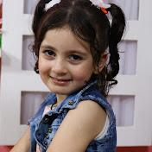 | Mera world | Controlled by her dad, the channel presents vlogs of 8 years old Mera, most of the time pranks, dares and challenges, with an average of 3-4 videos weekly. The channel has more than 267Million views and features the daily life of Mera and her two brothers Adam and Kareem.
 | Mera and Yazan Tube | Mera (13) and her brother Yazan (11) living in Gaza upload almost daily vlogs about their life and share with their audience many experiences and challenges, with their mom Neda leading most of the channels’ content. Very active channel with an average of 4 videos weekly. The channel describes itself as an entertainment family channel.
 | Malak Tube | Channel of Malak, a 13-year-old girl who now lives in Turkey. She shares vlogs, challenges and adventures with help from her two sisters Maram (16 y/o) and Haya (18 y/o). Malak mostly upload vlogs about her daily routine as well as dares and challenges with her family.
 | Deema cam | This channel features Deema, a 15-year-old teenager who joined YouTube 3 years ago. She records videos exposing details about her daily life as well as challenges and dares with her family, most of the time her three brothers. Deema also shares her talent in singing in almost every video.
 | Rahaf Pro | Rahaf is a 15-year-old girl who started on the Internet and mainly on YouTube at the age of 10. She shares videos about the daily life of a teenage girl that includes tips on several topics, challenges and daily routine.

5. Chapter Five: Results

5.1 Data Analysis

All of the 25 videos from the five channels sampled were viewed and analyzed to the UNCRC and YouTube guidelines transgressions in each video in its whole context. The analysis has been categorized and sorted in a specially designed table, in which all data have been entered, including: thumbnail of each video, video ID, video title, video date, number of views on the video, UNCRC articles violations, and YouTube guidelines violations.
The table of analysis was verified through expert judgment from Save the Children organization, taking into consideration the criteria of validity and reliability. Expert judgment served here an essential statistical inference method for the construction of an analysis model especially that this study is concerned in children and their rights.
The following results illustrate the number of all UNCRC and YouTube guidelines violations in each channel and in each video, the percentage of every UNCRC article violations in each channel, the percentage of YouTube guidelines violations in each channel, as well as the percentage of all violations in all the channels. Additionally, a more detailed analysis describing the videos content (each video separately) is also included.

5.2 Video Analysis

The chosen videos are from the 50 most viewed videos on each of the analyzed channels between Sep, 2021 till Mar, 2022. Each video has been viewed and analyzed as a whole integrated content. The following analysis describes the content of the videos in each channel and what were the violations observed and in what context it has been categorized, based on the table of analysis attached.
    - Mera world
With an average of 3-4 videos each week, the channel features vlogs of 8-year-old Mera, most of which are pranks, dares, and challenges. The channel has over 267 million views and depicts Mera and her two brothers, Adam and Kareem, in their daily lives.
      - Video no. 1 titled: The prank of ugly photos in Mera… Do not miss her reaction!
In this prank Mera’s dad decided to gather some ugly photos of Mera (taken from video shots in spontaneous moments), print all the photos and hang them all over the house, telling her they are making a big surprise for her. Once Mera enters the house, she finds a different kind of surprise! After she saw her photos placed all over the house walls and inside the rooms, she starts yelling and starts shredding all the photos and crying.
In this prank, she is put under huge emotional distress violating YT3, as well as YT5 (Cyberbullying and harassment involving minors) as her dad keeps repeating that Mera got insane and blaming her for her reaction as well as insulting her in several positions. On the other hand, this prank clearly violates the UNCRC articles (A3: best interests of the child, A8: protection and preservation of identity, A13: freedom of expression, and A12: respect for the views of the child).
      - Video no. 2 titled: We threw Mera in the street while sleeping... She was shocked and thought she's dreaming
Another prank by Mera’s dad that contained many transgressions against his daughters’ rights. In this prank, Mera’s dad moves her while she’s sleeping after midnight outside the house. Afterward, he waits till she wakes up to see her reaction until he finally awakes her telling her it’s morning and she’s late for school.
This prank exposes Mera to several risks, especially that it violates A3 (best interest of the child) and A16 (right to privacy). Moreover, it’s misleading family content that featured Mera in dares or challenges online violating YT7 guideline. On the other hand, this prank is considered to violate YT8 which shows activities that could draw undesired attention to the minor as it showed Mera in her sleeping clothes and in private spaces.
      - Video no. 3 titled: The dancing cactus got a jinn! Mira ran away from her room in the middle of the night
While most of the vlogs on Mera world channel are pranks, this prank reached the highest number of views with 220,355 views. Also performed by Mera’s dad, this prank can be considered one of the most harmful and risky pranks on the child’s emotional and mental health. Putting the recently famous dancing cactus in Mera’s room while she’s sleeping, in a very late time after midnight; he makes 3 cactuses to make scary sounds. When Mera wakes up and see all the 3 cactuses dancing and making scary sounds, she gets very scared and panics. After she starts calling for her dad and mom, her dad comes and tries to convince her that she’s dreaming and there’s nothing with the cactuses as they are turned off. Mera tries to prove that she heard the scary noise but her dad insists she’s having some kind of dream. He continues the prank in Mera and repeats it again with obvious panic and fright.
In this video Mira’s dad is exposing her to emotional distress and presenting misleading family content violating both YT3 and YT4. It also violates UNCRC articles A3 and A16 as this prank is against Mera’s best interest and violates her right to privacy as if was filmed at her bedroom and while sleeping. Additionally, A36 (other forms of exploitation) is also broken, as Mera’s dad exploits Mera to gain more likes, subscribers and views on the channel, which also can be categorized under economic exploitation.
      - Video no. 4 titled: The revenge prank on Mira 😱 she peed on herself for the first time! See her reaction, she was going to cry
In this prank also little Mera is exposed to a number of risks and dangers. Also performed while she’s sleeping and after midnight; Mera’s dad wants her to think she peed on herself by putting water on her bed without she knows or feels. After her dad wakes her up, blaming her on peeing on her bed and performing emotional stress on her attached with cyberbullying; Mera says it’s a prank and she did nothing.
This video recorded 5 YT guidelines violations (YT3, YT4, YT5, YT6, and YT7). It’s also against the best interest of the child (A3) which UNCRC articles stated on the importance of preserving the best interest of the child in any actions and behaviors, as well as (A16) violating her privacy, and (A36) exploiting Mera to reach more views on the channel by making pranks.
      - Video no. 5 titled: Prank I told them they drank bathroom water I didn't expect their reaction! They beat me
Another prank also performed by Mera’s dad but this time involving Kareem, Mera’s brother. Their dad decides to tell Mera and Kareem whoever drinks more water will win a big amount of money so that they discover later that what they drank is bathroom water from the toilet. Their dad filmed a video earlier while he was filling water from the toilet in a similar bottle to the one they drank from. After he tells them they drank from toilet water they get extremely angry and disgust. This prank is against the best interest of the child, although what they drank is clean water, but it puts them under emotional distress and can be considered as a form of exploitation in the interest of building a bigger YouTube audience. This prank violates both A3 and A36 of UNCRC articles, as well as two of YouTube guidelines YT3 and YT4. There was infliction of emotional distress on minors, and it’s a misleading family content especially at minute 12:15 of the video when all the kids go to the bathroom trying to throw up the water they drank, and start hitting their dad as an expression of anger towards his prank in them.
    - Malak Tube channel
Malak, a 13-year-old girl who currently lives in Turkey. She posts vlogs, challenges, and experiences with the support of her two sisters, Maram (16 years old) and Haya (18 years old). Malak's vlogs are mostly about her everyday routine, as well as dares and challenges with her family.
      - Video no. 1 titled: I threw Malak’s clothes in the trash... Her reaction shocked me
In this video Malak’s sister decides to make a prank in Malak by throwing all her clothes in the garbage outside the house. By putting her sister under emotional stress and shock, she violates several UNCRC articles as well as YouTube guidelines, especially that Malak’s reaction was tough, and starting hitting her sister after she found her clothes outside in the garbage.
This prank put Malak at risk as it is against article 3 which states that “The best interests of the child must be a top priority in all decisions and actions that affect children”. Additionally, UNCRC articles (A16, A19, and A12) have been violated, along with 6 YouTube guidelines (YT5, YT3, YT4, YT7, YT9, and YT6).
      - Video no. 2 titled: Malak fill ill !! Her condition is very hard!

This video is about Malak’s illness when she had Covid 19 and the tough times she went through. Her two sisters are involved in this video mainly focusing on the bad condition Malak is put in due to her illness. Featuring her lying on the couch the whole time and making jokes and pranks mocking her situation. In this video, Malak is filmed in a very bad health condition showing that she is sick and trying to gain sympathy over her sickness.
Exposing her suffering, symptoms, and pain are all practices that transgress her right to privacy. On the other hand, they can be considered a kind of exploitation to reach more likes, views, and subscribers, and so it was considered to violate UNCRC article36 (other forms of exploitation). This was obvious by first, the headline chosen; second, the sad music that started the video with black and white shots of Malak shown extremely tired and sick; and finally, by the close-up shots on Malak’s pale face that were frequent many times during the video. In this video, three UNCRC articles transgressions were observed which are A3, A16, and A36, and 3 YouTube guidelines violations (YT3, YT4, YT9).

      - Video no. 3 titled: Rolling and hitting challenge… For the first time we are battling in front of the camera

This vlog represents a challenge between the three sisters (Malak, Maram, and Haya), where they roll a bottle of water on a table full of gadgets as well as food. Wherever the bottle stops, one should take the object in front of it.
This video had two UNCRC articles violations (A16 and A36), as well as two YouTube guidelines violations (YT3 and YT5). It is considered to put minor under emotional distress, such as when Maram had to eat the chili and got very tired afterward. It also included some cyberbullying between the sisters.

      - Video no. 4 titled: My evening routine for school night + my skincare routine 2021

Another vlog by Malak that reached 903,477 views, reveals much about her daily life and routine. In this vlog, Malak exposes her night routine before school showing her followers how she spends the evening. By filming in private areas and conditions such as the bedroom and bathroom; Malak discloses a lot of personal details about her life.
In this video A16 (right to privacy) as well as A3 (best interest of a child) have been violated. As for the YouTube guidelines, two guidelines have been broken. The first is YT6 (filming in private spaces) when Malak was shown several times in her bedroom lying on the bed, as well as in the bathroom when she was putting on her masks and brushing her teeth.

      - Video no. 5 titled: Finally, I dyed my hair the color of my dreams… My family's reaction shocked me

This vlog is about Malak’s experience when dying her hair in unique colors as well as a tour of shopping for Malak with her family. Malak in this vlog shows a lot of details from the moment she enters the beauty salon. At the mall Malak also takes her followers with her while shopping for new clothes, trying different styles, and filming inside the fitting room.
This video invades Malak’s privacy (A16 from UNCRC articles), along with revealing many personal details about Malak, what she likes and what she hates and her whole experience at the salon, going against YT9 guidelines from YouTube policies.
    - Mera and Yazan Tube
Mera (13) and her brother Yazan (11) from Gaza upload practically daily vlogs about their lives and share numerous adventures and challenges with their viewers, with their mom Neda driving the majority of the channels' content. With an average of four videos posted each week, this is a very active channel.

      - Video no. 1 titled: A brother forces his sister to wear the hijab...A problem broke out

In this video, Yazan decides to make a prank on his bigger sister Mera with help from his mom, the idea owner. The prank is about Yazan forcing Mera to wear Hijab by performing different types of pressure on her (emotionally and verbally). By greatly provoking her and threatening her that she will not go out with her friends or anywhere from this day on without his permission. In this video, he is putting his sister under emotional distress as he is practicing cyberbullying in several positions. Mera was in shock and didn’t believe what his brother was trying to do and then she turned angry and refused his attitude as he went more aggressive and intense. This is shown precisely from minutes 7:52 to 9:24 as Mera and her brother discussion becomes more intense.
Four UNCRC articles have been violated which are (A8, A13, A12, and A16). As for YouTube guidelines, five YouTube guidelines have been broken which are (YT3, YT4, YT5, YT7, and YT9).

      - Video no. 2 titled “Mera came back crying from school... What’s the reason?”

This video uploaded on Jan, 26, 2022, reached more than 203K views until the day it was retrieved. Starting with shots of Mera crying and smacking her room door, is a frequent way the kid’s mom follows in most of the videos to attract more audience and followers. In this video Mera is shown upset and angry after having a bad day at school, despite that, her mom insists to film the vlog featuring her crying and angry. After Mera gets home from school, she goes inside her room crying and slams the door, her mom follows her and enters the room holding the camera and asking what is wrong with her. Mera clearly asks her mom not to record. In this video, Mera’s mom act is not in the best interest of her child.
The mom in this video violates (A3) from UNCRC articles, as the filming was not in Mera’s best interest. She also didn’t respect her desire and view that she doesn’t want to be filmed in this situation, which leads to the violations of A12, as well as invading her privacy (A16). The vlog also violates 4 YT guidelines which are (YT3, YT4, YT6, and YT9).

      - Video no. 3 titled: “The prank of disgust and gluttony in Mera... Her reaction shocked me”

The video uploaded on Mar 18, 2022, had 45,609 views until the day retrieved, and includes the three kids Mera, Yazan, and Adam with attractive title and thumbnail. It represents a prank in Mera, performed by Yazan mainly and with previous agreement with his mom. In the prank Yazan starts eating his meal (which is supposed to be part of a challenge between the three brothers), in a disgusting annoying way. After Mera notices his way of eating, she gets angry and upset and can’t eat her food.
This prank in Mera was harmful on her emotional level at most, and it visibly violates two of the UNCRC articles (A3 and A36) as it’s against the best interest of the child and also is considered one form of exploitation, mainly economic exploitation. As for sticking to the YouTube policy, the prank is against YT3, YT4, and YT7 of the featured YouTube guidelines.

      - Video no. 4 titled: First day of school routine! We missed the semester!

Another vlog by Mera and Yazan Tube channel taking the audience to the daily life of them. This time with content related to their school life and daily routine. In this vlog, a lot of personal details are revealed and exposed about the kids, along with filming in private spaces (bedrooms), and is considered misleading family content. It is also against the kid's right to privacy, as they are being exploited to the interest of the channels size and audience. However, 3 of the YouTube guidelines are violated (YT4, YT6, and YT9), along with two UNCRC articles (A16 and A36).

      - Video no. 5 titled: Tension before the final exam!

In this vlog Neda’, the mom of the three kids, exposes their morning and evening routine during the exams. Filming in their bedrooms and exposing their details to the public is against their right to privacy and does not lead to their best interest. It also reveals so much information and details about the kid’s life without any purposeful messages. For instance, they are filmed right after they wake up from bed, while taking their breakfast, while reviewing their exams, and many other details featuring private issues concerning the three kids.
In this vlog, three YouTube guidelines were broken (YT3, YT4, and YT9). The kid’s mom also exploits her kids' personal details to vlog on the channels their personal life, ignoring their right to privacy and the future harms that could be attached to these actions in the future.
    - Rahaf Pro
Rahaf is a 15-year-old girl who started on YouTube at the age of 10. She shares videos on a teenage girl's daily life, including tips on a variety of issues, problems, and daily routines.

      - Video no. 1 titled: Why did I enter the hospital and leave school?

Trying to attract the followers by sharing about her illness using a thumbnail that reflects the sympathy status most of the YouTubers, especially teenagers try to create. The vlog had more than 950,000 views, it shows Rahaf in pain and can’t walk on her legs. The start of the vlog was a shot of Rahaf screaming while her dad tries to hold her, then she appears describing what happened to her and she’s heading to the hospital to check if her legs are broken or not. Then, the vlog continues inside the hospital where she filmed all the details about her situation, till she gets home. During the whole vlog, Rahaf was in pain and focused on her suffering especially that she had to miss school for several days.
In this vlog Rahaf violates two of the UNCRC articles (A3 ad A16), as representing herself in such hard condition was not in her best interest, as well as the right to privacy as she filmed most of the time inside her room and showed a lot of personal details. As for the YouTube guidelines; the vlog broke (YT3, YT4, YT6, and YT9).

      - Video no. 2 titled: The results of this chapter shocked me.. Worst result/ Rahaf Pro 2022

Another vlog by Rahaf showing part of her life, this time attached to school and her midterm results. She used an attractive title and thumbnail. In the title she also chooses to catch the sympathy when she wrote “worst results” and “shocked me”, also on the thumbnail she wrote “I cried because of my scores”. The video shows the stress Rahaf is going through waiting for her scores to show up, at the same time presenting part of her day when she’s out preparing for her new room make over. As Rahaf’s mom was the first to check her scores and tell her the result; Rahaf was under so much pressure and got very nervous before her mom announce the result. This fear, tension and stress appeared mostly from the minutes 6:25 to 7:35 of the video. Although Rahaf is very outstanding and diligent at school, but she was afraid not getting on the honor bard. The vlog continues to the next day when Rahaf went to school to take her certificates and showed many details till she finally got them.
In this video (A16) was violated as there was no privacy when she revealed this much of information about her life. Furthermore, (YT3) form YouTube guidelines was obvious to be broken as she was under huge pressure and stress through the whole vlog.

      - Video no. 3 titled: She was going to pass out in our house because of diabetes… I cried for her

Like the previous two analyzed videos, Rahaf chose words in the title rich with suspense to attract the audience like “She was going to pass out.,.” and “I cried for her”. Additionally, she starts the video while she’s screaming and showing her friend passing out. In this video Rahaf is with her best friend Yasmine as they will be answering the followers questions about Rahaf by her friend Yasmine. The video turns out to be a prank planned by Yasmine and Rahaf’s mom where Yasmine pretends, she’s passing out because of diabetes. Rahaf gets really scared and tries to wake her friend to find out that everything is just a joke.
This prank was not in her best interest so it violates (A3) from UNCRC articles. On the other hand, she was under emotional distress and panicked because of what happened with her friend, so it is considered to be violating (YT3) from YouTube guidelines.

      - Video no. 4 titled: I finally changed my room after 10 years / tour of my new room.. Room tour

Another video by Rahaf where she shares her personal activities and life experiences with the audience. In this video she reveals the makeover of her room with all the details about what she changed, reflecting her personality and desires. The video is a tour in Rahaf’s new room with details about all the decorations and changes she made.
Such video is considered to be a violation of her right to privacy (A16) from UNCRC. Moreover, it is filmed in one of the most private places for a teenager, the bedroom, as well as revealing so much personal details about Rahaf and her style to the public, and so it broke both (YT6 and YT9) from the YouTube community guidelines.

      - Video no. 5 titled: My Evening Routine in Exam Days Rahaf Pro 2022 Back to School Series

Showing part of her daily routine, Rahaf describes how her evening looks like, mainly during the exams period. She starts showing what she do after coming back from school, until the end of the day. The routine included eating, studying, visiting friends, study tips as well as taking care of herself.
As most of the video analyzed, the article (A16) related to privacy was violated. Also, both (YT6 and YT9) of the YouTube guidelines were transgressed when Rahaf was shown most of the time in her room and disclosing much about herself.

    - Deema cam
Deema, a 15-year-old teenager who joined YouTube three years ago, is mainly moderating this channel. She shares videos in which she reveals a lot about her daily life as well as challenges and dares with her family, most of the time with her three brothers. In practically every video, Deema shows off her ability and special talent in singing.

      - Video no. 1 titled: I worked as a waitress in a cafe for a whole day.. I sing for customers
This video for Deema is about when she decided to work as a waitress in a cafe for a whole day. She starts the video with a promo including some teasing shots of what will be shown in the video. Then she appears talking about the video idea and a short tour in the cafe where she will be working. During the video, the cafe manager tells Deema that she will have a salary increase just because she held the tray in one hand when bringing his order. However, this might be considered as some kind of exploitation for Deema, especially that she asked her colleagues if they ever had such an increase and they replied no. On the same level, this is considered form of child labor, as Deema is being exploited to go through such an experience for the interest of having more followers and views on her channel. Especially that she mentioned earning money in several parts in the video.
Several violations where recorded in this particular video which are (A3, A32, A8, and A36). This experience could be exposing Deema to different kinds of risks as it is also not preserving her identity and personal life. As for the YouTube guidelines violated in this video, they are both (YT5 and YT7), due to some cyberbullying on Deema making fun of her height for instance.

      - Video no. 2 titled: The prank of mollycoddling with my brothers… They made me cry

This video is a prank Deema did in her two brothers where she was faking and mollycoddling through her way of speaking and looking. She chose a title that included emotional phrases such as “They made me cry” although she didn’t cry in the video, and this is to attract bigger audience and views on the video. In the video Deema tells her two brothers that she wants to film with them a challenge on who knows her better. Then she starts faking her way of talking showing as a spoilt cure girl, along with singing in a horrible voice.
The video which reached more than 1.5M views, is not in Deema’s best interest and has form of exploitation as she’s making the prank to get more viewers, and so (A3 and A36) were violated. As for sticking to the YouTube guidelines both (YT3 and YT5) were broken.

      - Video no. 3 titled: He challenged me to sing and speak in Iraqi for a whole day!

A video featuring a challenge between Deema and another Iraqi youtuber named “Mohammed Kareem” that had more than 908,000 views on the channel. In this video Deema is in a challenge to talk in Iraqi accent for a whole day. She goes shopping and check what are people’s reaction when hearing her talking in Iraqi, as this is considered unusual in Gaza to see different nationalities from other countries. Then the video features Deema’s meeting online with the YouTuber Kareem telling her some words in Iraqi.
The video reveals a lot of Deema’s personal details and life style as well as the lack of any privacy boundaries in the video and so it violated both (A16 and YT9).

      - Video no. 4 titled: Get ready with me for the engagement from zero

This is another vlog by Deema featuring her routine when getting ready to one of her relatives engagement party. She shares what will she wear along with making a make-up tutorial live and all other preparations.
The video clearly invades the privacy of Deema and is filmed in personal spaces (her bedroom) and so it violated (A16) from UNCRC articles. On the other hand, it revealed so much details about Deema so in broke the (YT9) guideline along with (YT6) when she filmed in private places.

      - Video no. 5 titled: They forced me to sing in a restaurant... People’s reaction
In this video Deema chose an eye-catching title of the video when she used “They forced me to sing”. The video is about Deema spending time with her family and friends at a restaurant, and it included a surprise for her birthday as a gift from the restaurant. The video shows how she spent her day and enjoyed time, where she also sang in different parts in the video per on a request from her friend, and got the attention of people in the restaurant.
The vlog revealed personal information about Deema’s life and invaded her private moments as she filmed most of the time during her time out. The violation of both (A16 and YT9) in the vlog has been recorded.

Table 5.5: Video Analysis for all channels
Channel Name | Video ID | Video date | Title | UNCRC transgressions | YT Guidelines transgressions | Number of views
🎥Mera World-عالم ميرا🎥
First video | qFDjZuZGyXE | Feb 23, 2022 | The prank of ugly photos in Mera.. do not miss her reaction! | A3, A36, A16, A12 | YT4, YT5,YT3, YT7 | 70952
Second video | 8mNczkSF4Oc | Nov 25, 2021 | We threw Mera in the street while sleeping.. She was shocked and thought she's dreaming | A3, A16 | YT3, YT4, YT7 | 98350
Third video | MJgMJDfB60s | Nov 10, 2021 | The dancing cactus got a jinn! Mira ran away from her room in the middle of the night | A3, A16, A36 | YT3, YT4, YT6, YT2, YT7 | 220355
Fourth video | dNt8GxwyPBo | Sep 21, 2021 | The revenge prank in Mira 😱 she peed on herself for the first time! See her reaction, she was going to cry | A3, A16, A36 | YT3, YT4, YT6, YT7, YT5 | 207176
Fifth episode | 1nLq9da0fi0 | Mar 16, 2022 | Prank I told them they drank bathroom water I didn't expect their reaction! They beat me | A3, A36 | YT3, YT4 | 44579
🎥 Malak Tube🎥
First video | UqwkmTic468 | Oct 15, 2021 | I threw Malak’s clothes in the trash... Her reaction shocked me | A3, A16, A19,A12 | YT5, YT3, YT4, YT7, YT9, YT6 | 311288
Second video | kwxuli4sEP8 | Jan 12, 2022 | Malak fill ill !! Her condition is very hard! | A3, A16, A36 | YT3, YT4, YT9 | 313734
Third video | i8Bc1ZX3y0Y | Sep 20, 2021 | Rolling and hitting challenge… For the first time we are battling in front of the camera! | A3, A36 | YT3, YT5 | 365253
Fourth video | q9usrC0qXNs | Sep 5, 2021 | My evening routine for school night + my skin care routine 2021 | A3, A16 | YT6, YT9 | 903477
Fifth Video | 9MmzWItxgmk | Sep 1, 2021 | Finally, I dyed my hair the color of my dreams My family's reaction shocked me | A16 (right to privacy) | YT9 | 717947
🎥 Mera and Yazan Tube🎥
First video | JWzx3-PEDqM | Mar 4, 2022 | A brother forces his sister to wear the hijab...A problem broke out | A13, A12, A16, A8 | YT3, YT4, YT5, YT7, YT9 | 142260
Second video | zSundM4xg3k | Jan 26, 2022 | Mera came back crying from school... What’s the reason? | A3, A12, A16 | YT3, YT4, YT6, YT9 | 202820
Third video | FFdVwdi564A | Mar 18, 2022 | The prank of disgust and gluttony in Mera... Her reaction shocked me | A3, A36 | YT4, YT7, YT3 | 45609
Fourth video | rqEBMJwVVBQ | Dec 10, 2021 | First day of school routine! We missed the semester! | A16, A36 | YT4, YT6, YT9 | 197011
Fifth video | silLaFxpizo | Feb 6, 2022 | Tension before the final exam! | A3, A16, A36 | YT3, YT4, YT9 | 162371
🎥 Rahaf pro 🎥
First video | mrsniGPBfak | Feb 15, 2022 | Why did I enter the hospital and leave school? | A3, A16 | YT3, YT4, YT6, YT9 | 809268
Second video | 7t1B3jmK60E | Jan 5,2022 | The results of this chapter shocked me.. Worst result/ Rahaf Pro 2022 | A16 | YT3 | 790712
Third video | Z7cJkeEmVac | Jan 27, 2022 | She was going to pass out in our house because of diabetes… I cried for her | A3 | YT3 | 336513
Fourth video | Zhen726hyvo | Feb 10, 2022 | I finally changed my room after 10 years / tour of my new room.. room tour | A16 | YT6, YT9 | 583682
Fifth video | qJh0NNQNEt0 | Oct 9, 2021 | My Evening Routine in Exam Days Rahaf Pro 2022 Back to School Series | A16 | YT6, YT9 | 469205
🎥 Deema cam 🎥
First video | AqSGUDJUP1Y | Mar 2, 2022 | I worked as a waitress in a cafe for a whole day.. I Sing for customers! | A3, A32, A8, A36 | YT7, YT5 | 479549
Second video | #NAME? | Jan 8, 2022 | The prank of mollycoddling  with my brothers.. They made me cry | A3, A36 | YT5,YT3 | 1471675
Third video | rdClkXakOfI | Feb 14, 2022 | He challenged me to sing and speak in Iraqi for a whole day! | A16 | YT9 | 886333
Fourth video | KWUBlHSTQn4 | Nov 2, 2021 | Get ready with me for the engagement from zero | A16 | YT6, YT9 | 1469088
Fifth video | 2VeMcGOYliU | Sep 23, 2021 | They forced me to sing in a restaurant... People’s reaction | A16 | YT9 | 880117

Results

The figures from (1-5) shows the number of UNCRC violations in every channel and in every video.
The data analyzed shows that both (Mera world) and (Mera and Yazan Tube) channels have recorded the highest number of UNCRC violations with 14 violations, while the channel (Rahaf Pro) has recorded the lowest number with 6 violations.
The figure 5.1 shows the number of UNCRC violations in Malak Tube channel, indicating that 4 violations were recorded in the first video.
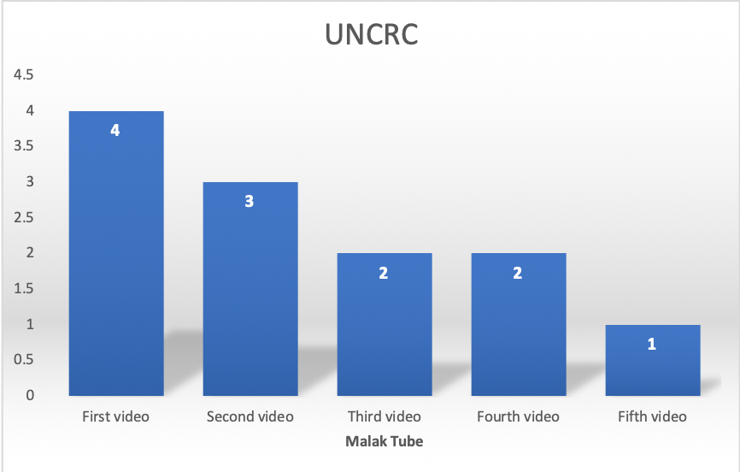
Figure 5.1: Number of UNCRC violations in each video/ Malak Tube

Figure (5.2) shows the UNCRC violations in Mera and Yazan Tube channel with close number of violations in each analyzed video.
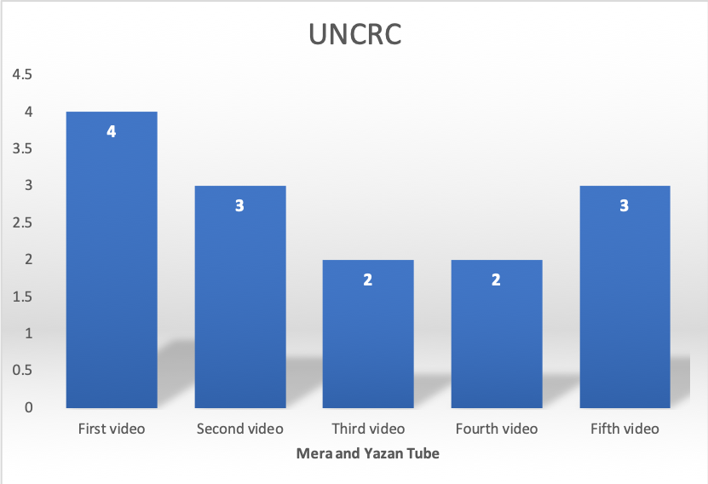
Figure 5.2: Number of UNCRC violations in each video/ Mera and Yazan Tube
Below figure (5.3) represents the number of UNCRC violations in Rahaf pro channel with very close numbers.
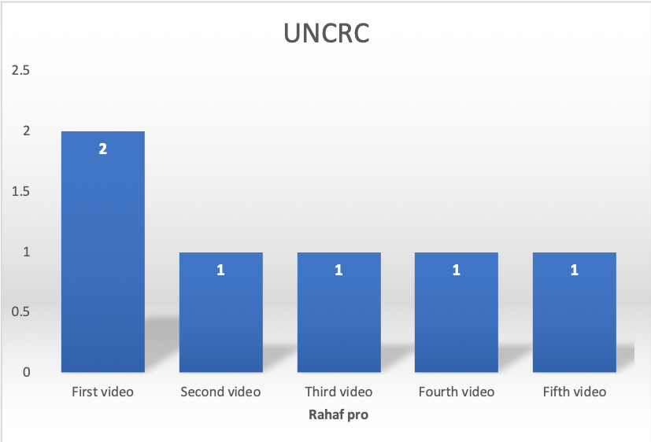
Figure 5.3: Number of UNCRC violations in each video/ Rahaf pro

As for the below figure (5.4) it describes the number of UNCRC violations in Deema cam channel as the first video had the highest number of violations.
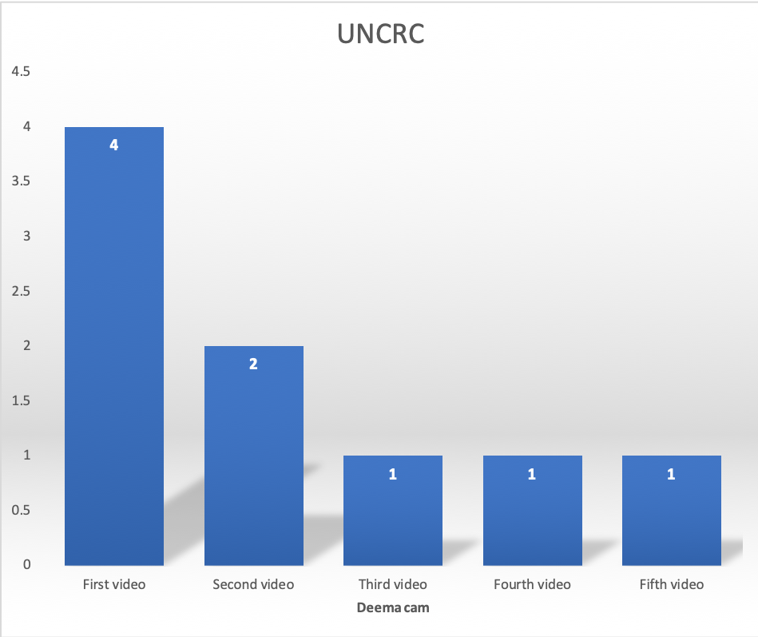
Figure 5.4: Number of UNCRC violations in each video/ Deema cam
The figure (5.5) below shows the number of UNCRC violations in Mera world videos with very close numbers of recorded violations.
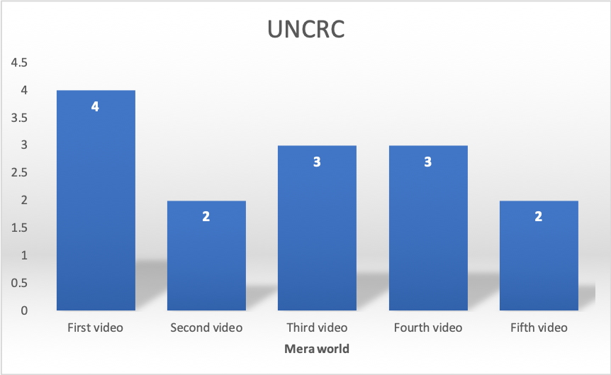
Figure 5.5: Number of UNCRC violations in each video/ Mera World

As for the YouTube guidelines policies, the figures from (6-10) illustrate that the channel (Mera world) had the largest number of infringements with a total of 19, as 4 of them were in the first episode titled “The prank of ugly photos in Mera... Don’t miss her reaction”, followed by the channel (Mera and Yazan Tube) with 18 infringements. While the channel (Deema cam) contained 8 infringements in all its videos analyzed.
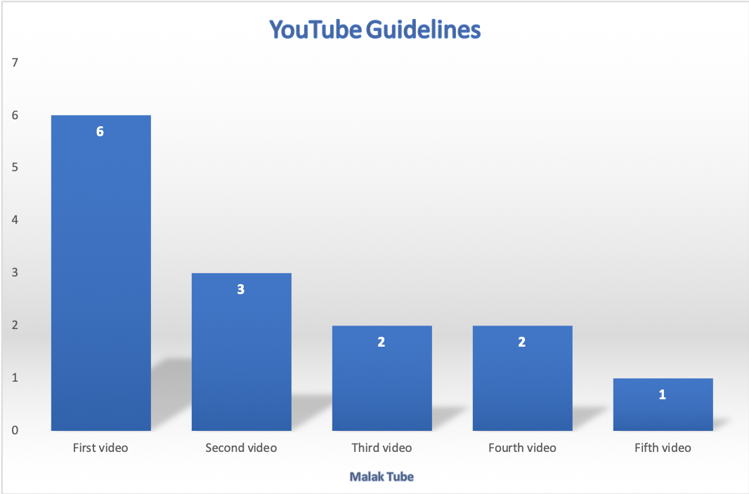
Figure 5.6: Number of YouTube guidelines violations in each video/ Malak Tube

The figure (5.7) describes the number of YouTube guidelines violations in each video of Mera and Yazan Tube channel.

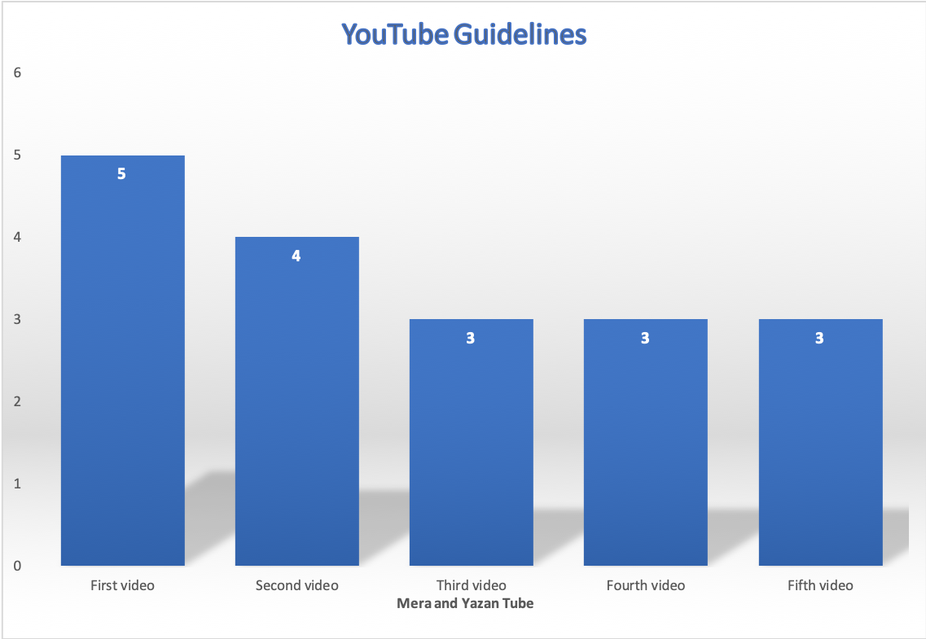
Figure 5.7: Number of YouTube guidelines violations in each video/ Mera and Yazan Tube

The figure (5.8) below shows the number of YouTube guidelines violations in of Rahaf
Pro channel videos, as the first video recorded 4 of the YouTube guidelines violations.
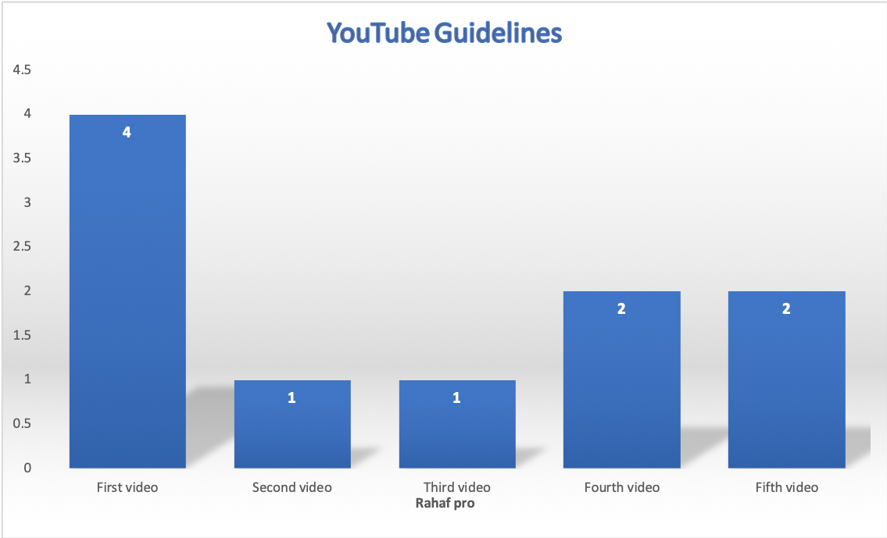
Figure 5.8: Number of YouTube guidelines violations in each video/ Rahaf Pro

The figure (5.9) below shows the number of YouTube guidelines violations in each video in Deema cam channel with very close numbers of violations.

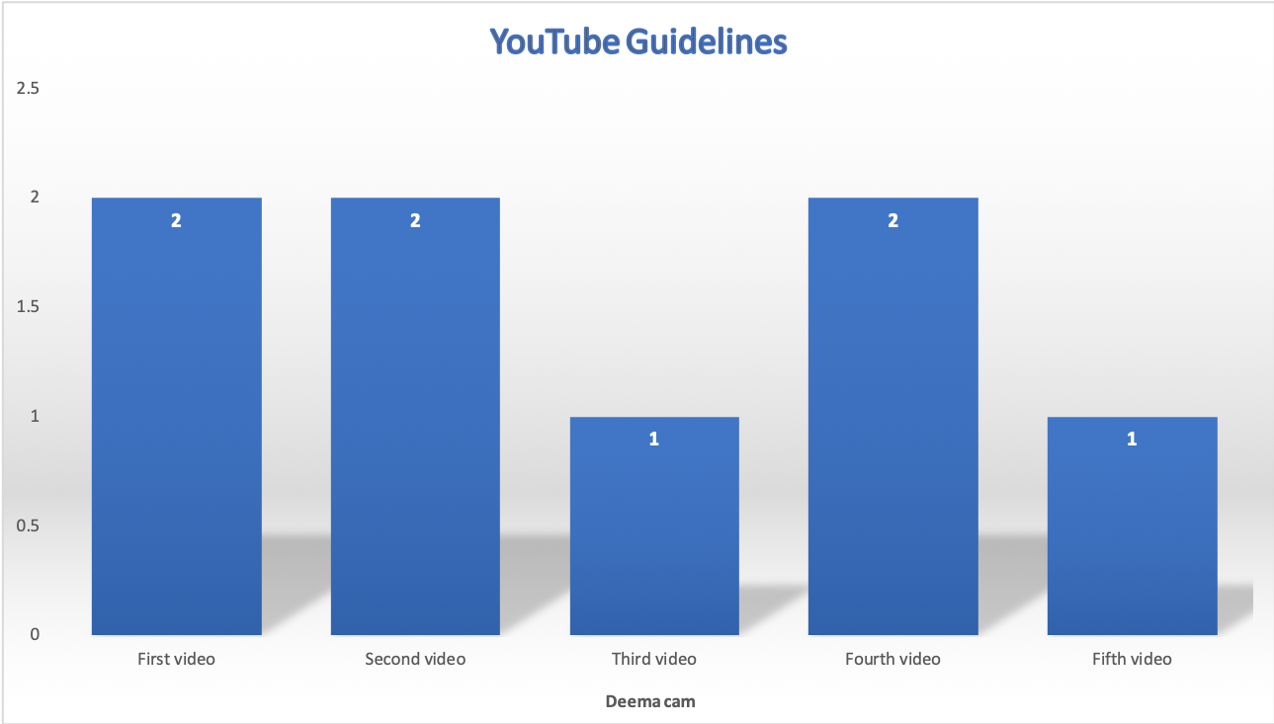
Figure 5.9: Number of YouTube guidelines violations in each video/Deema cam

Figure (5.10) illustrates the number of YouTube guidelines violations in each video of Mera world channel.
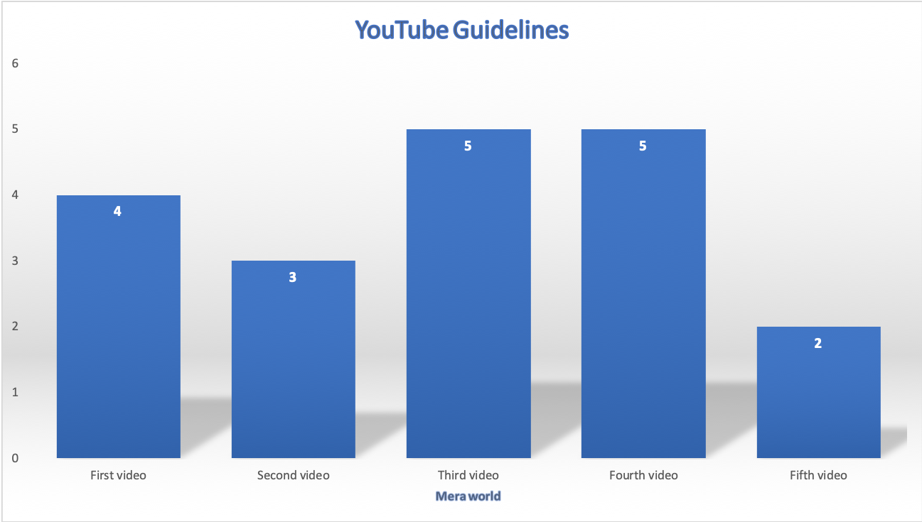
Figure 5.10: Number of YouTube guidelines violations in each video/ Mera world

On the same level, figure (5.11) below displays the number of both UNCRC articles and YouTube guidelines violations in each channel. The results indicates that both UNCRC and YouTube guidelines violations are quiet similar with minor differences.
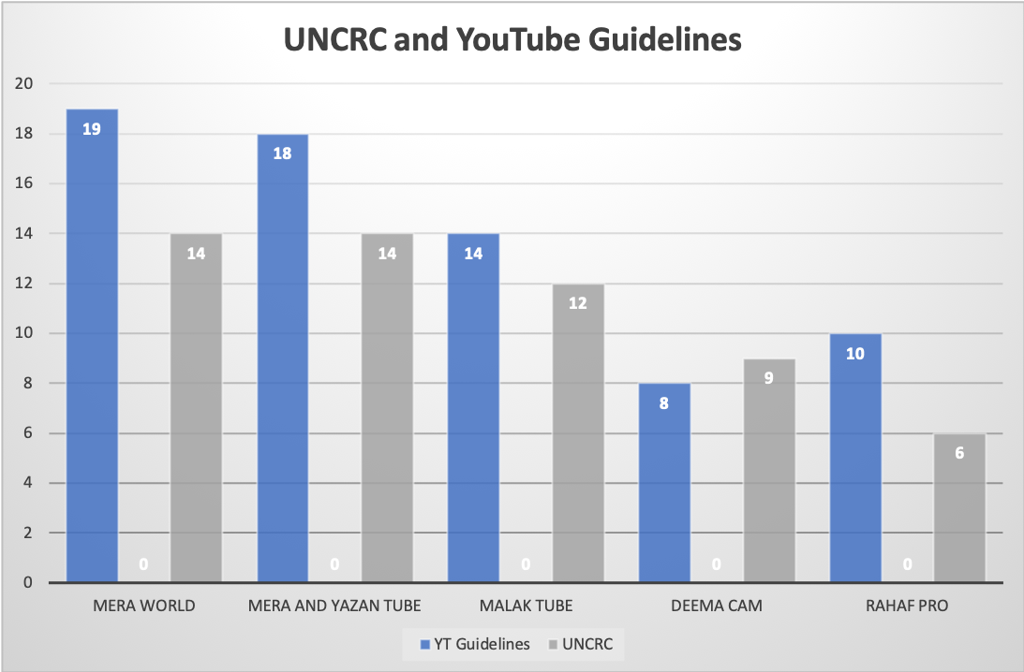
Figure 5.11: Number of YouTube guidelines and UNCRC violations in each channel

About the percentage of all UNCRC articles violations in all analyzed channels and videos, it is verified that 35% of the violations are on the Article 16 (right to privacy), followed by Article 3 (best interest of the child) of 30%. On the other hand, Articles 13(right to freedom of expression) and 19(protection from violence, abuse, neglect and other forms of exploitation) both recorded 2% of all UNCRC violations as shown in figure (12).
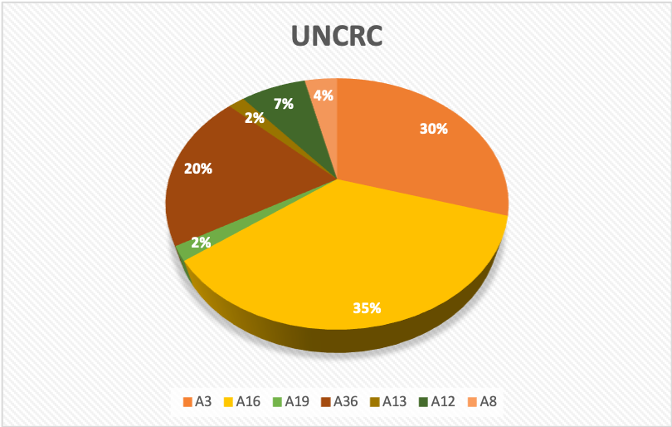
Figure 5.12: Percentage of the UNCRC articles violations in all channels

The proportions were very close as for YouTube guidelines policies violations. While YT3 attached to infliction of emotional distress on minors had the largest percent of 24%, YT9 considering the reveal of personal details about a minor had 21%. Other violations have also recorded close numbers such as YT4 concerning misleading family content which recorded 19% of all violations, most of those violations were in the channel (Mera world), with 38.4%.
Concerning other YouTube guidelines violations, percentages were also very close. However, 13% of the violations were on the YT6 (filming in private spaces at home such as bedrooms or bathrooms), followed by YT7 Features minors soliciting contact from strangers, dares or challenges online, or discussing adult topics) with 12%, and finally YT5 (Cyberbullying and harassment involving minors) with 11%, as shown in figure (13) which illustrates the percentage of all YouTube violations in all channels.

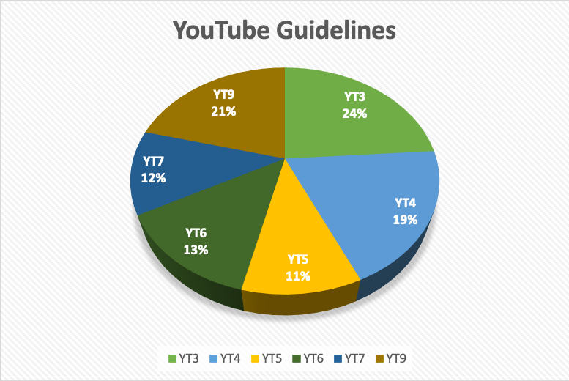
Figure 5.13: Percentage of the YouTube guidelines violations in all channels

When comparing channels based on the percentage of UNCRC violations in each channel, results shows that the channel (Mera world) recorded the highest number of violations with 26% among all other channels, followed by the channel (Mera and Yazan Tube) with 25%. Nevertheless, the channel (Rahaf Pro) had 11% of UNCRC violations, recording the lowest number of violations as shown in figure (14) below. However, the two channels with the most violations are also the highest channels with video views. As (Mera and Yazan Tube) channel has more than 426 million views, (Mera world) has more than 267 million views, among other sampled channels.

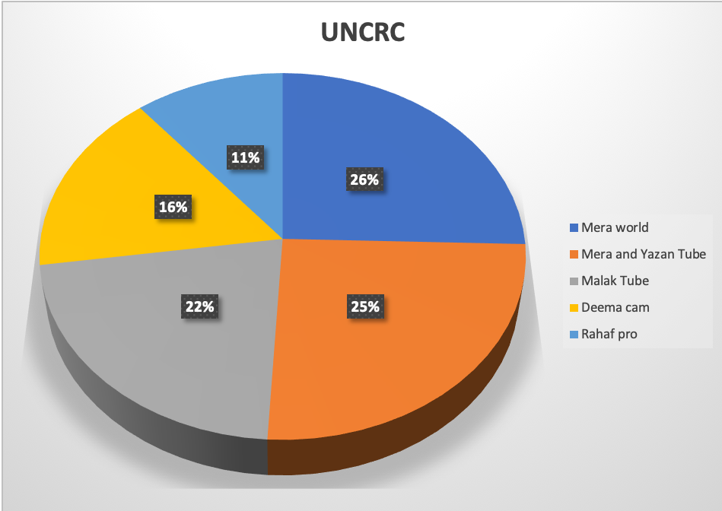
Figure . Percentage of UNCRC articles violation in each channel
Figure 5.14: Percentage of YouTube Guidelines violations in each channel
Additionally, both mentioned channels also had the top numbers in YouTube guidelines violations. The violations in YouTube guidelines as shown in figure 15, were clearly prominent for both (Mera world) and (Mera and Yazan Tube) channels, having 28% and 26% respectively. As figure (15) illustrates, all channels violated YouTube policies guidelines attached to child safety content, and the violations have been observed clearly in all sampled channels. Results indicates that the channel (Malak Tube) have also recorded 20% of YouTube Guidelines violations, while the channels (Rahaf Pro) and (Deema cam) violated 14% and 12% respectively.
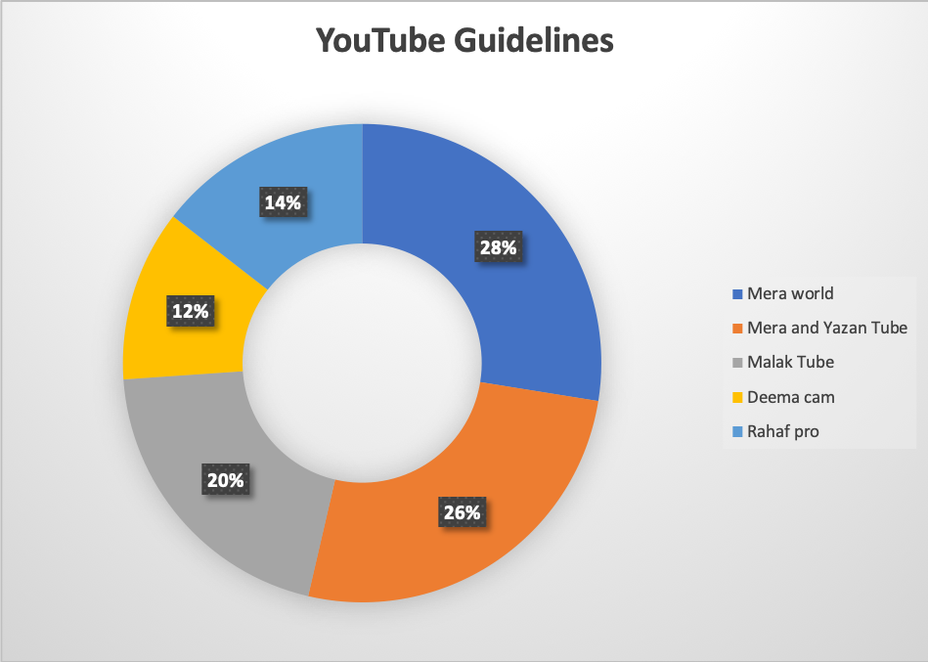
Figure 5.15: Percentage of YouTube Guidelines violations in each channel

6. Chapter Six: Discussion and Conclusions

6.1 Discussion and Conclusions

At the current age and time, managing one’s private information has become challenging. today’s families face many issues in which privacy management decisions are necessary. According to the theory applied throughout this study, the (CPM), there are regulations through privacy rules related to the user’s self-disclosure. What this study has shown is that these regulations do not seem to exist on the kidinfluencers channels. Moreover, CPM theory confirms that when co-owners of private information don't effectively negotiate and follow mutually held privacy rules, boundary turbulence is the likely result. This is indicated in the content of kidinfluencers which lacks any boundaries or restrictions, and exposes those kids to potential risks and violations.

Analysis of the video content illuminated that the channels directed and controlled by parents have recorded more children rights violations than the one moderated by kids themselves. Additionally, the younger the kidinfluencers are, the more their content includes transgressions, as Mera world (the channel moderated by Mera’s dad), for instance, had the highest percentage of all UNCRC and YouTube guidelines violation among all other channels with 54%.

One of the major results of this study is the absence of any judicial body responsible for monitoring the content of YouTube channels for children as the Palestinian law does not include in any of its articles the control of children's content online and so it fails to provide the needed protection for them.

Consistent with what Juvenile Prosecution has reported, the current presented content attached to children online is mostly offensive and inappropriate. Juvenile Prosecution considers offending a kid a crime that does not represent the child's culture and environment. Furthermore, any content that initially offends the Palestinian family ruins the child's individuality, offends him, supports the child's rebellion, and may drive him to commit crimes, and this is the risk, owing to parental carelessness and lack of attention. This leads to the main goal of this study to protect children online by certain regulations and policies that can reduce the risks and potential violations they are exposed to, through specific legislative systems.

All the sampled channels are in Gaza, adding a need for further research to explore why this phenomenon is very popular in Gaza strip and not as such in the West Bank, and what are the factors behind the tendency of children to engage in social media platforms and especially the YouTube world? Future studies can focus on the financial, social, political and cultural aspect of this newly rising phenomenon in Gaza.
The research shows that none of the channels are categorized under “family” or “child oriented” YouTube categories, for what is a clear attempt to avoid YouTube classification, as under these categories, they will face more scrutiny and their content may be censored by YouTube policies. All analyzed channels are classified under “Entertainment” and “People”, which makes them far away from accountability from any party, especially after the updated YouTube community guidelines in 2020. This update requires all content creators to indicate whether their video is directed to children or not, as part of its policy in best practices for content with children.

The analysis results also confirms that all of the videos included at least one kind of online risks and violations in varying proportions, and all channels have broken one or more of YouTube Guidelines in its content. This reflects that the risks attached to kidinfluencers phenomenon are high and visible in the channel’s content, and could increase in other YouTube channels.

The analysis reveals significant data about the content creators in Palestine, especially children. While all channels recorded transgressions, the absence of privacy boundaries and the high self-disclosure content were easily observable. The age of the sampled YouTubers also matters when identifying the violations such as misleading family content and the best interest of the child, as younger YouTubers are at risk of being exploited through their content more than older YouTubers. This should sound the alarm regarding the role of parents in protecting their child’s identity and provide a safe digital environment.
On the other hand, the analysis allows us to assert that there are common transgressions existing in the selected YouTube channels. Most of them reveal too much information about their lifestyle and personal life and violate the right to privacy. All of them seek to build bigger audience by exposing their lives inviting viewers to subscribe to the channel, share their content on social networks and be part of the content they create.

6.2 Recommendations

The phenomenon of the kidinfluencers on YouTube has generated urgent regulatory implications and the need for guidance for safe and strategic actions. As risks emerge from children’s content are detected and sensed throughout this study, more attention needs to be paid towards the protection of children’s rights, especially in Palestine.
The absence of any specialized laws in following up with content that is related to children online, and the ambiguous legislation and articles; make it necessary to take serious steps towards protecting children’s digital rights.
The Palestinian law has been slow to catch up, recognize and cope with the issue at hand solve. This study recommends amending current legislation and modifying new articles that enhance the protection of children in line with technical advancement and the rapid rise of social media platforms around the world. These adjustments must also include child labor laws which do not recognize children involved in social media production.
Protecting the future, safety, and well-being of children appearing in monetized social media content is a compelling state interest that needs to be addressed by holding parents and social media platforms to stricter and more specific guidelines that ensure children rights in a safe digital environment.
This study also argues that developing an AI algorithm application/software tracking the content involving or directed to children, would provide an additional layer of reviewing and contribute to the effectiveness of related implementation of guidelines and safeguards. By adopting such action content will be processed and filtered to match the appropriate regulations and guidelines that may guarantee to keep children safe in such a risky environment.

Bibliography

Burroughs, B. (2017). YouTube Kids: The App Economy and Mobile Parenting. Social Media + Society, 3(2), 205630511770718. https://doi.org/10.1177/2056305117707189
Castillo-Abdul, B., Romero-Rodríguez, L. M., & Larrea-Ayala, A. (2020). Kid influencers in Spain: Understanding the themes they address and preteens’ engagement with their YouTube channels. Heliyon, 6(9), e05056. https://doi.org/10.1016/j.heliyon.2020.e05056
Christofides, E., Muise, A., & Desmarais, S. (2009). Information Disclosure and Control on Facebook: Are They Two Sides of the Same Coin or Two Different Processes? CyberPsychology & Behavior, 12(3), 341–345. https://doi.org/10.1089/cpb.2008.0226
Coates, A., & Boyland, E. (2021). Kid influencers—A new arena of social media food marketing. Nature Reviews Endocrinology, 17(3), 133–134. https://doi.org/10.1038/s41574-020-00455-0
Coates, A. E., Hardman, C. A., Halford, J. C. G., Christiansen, P., & Boyland, E. J. (2019). Food and Beverage Cues Featured in YouTube Videos of Social Media Influencers Popular With Children: An Exploratory Study. Frontiers in Psychology, 10, 2142. https://doi.org/10.3389/fpsyg.2019.02142
Determining if your content is “made for kids”—YouTube Help. (2022). https://support.google.com/youtube/answer/9528076?hl=en
Doek, J. E. (2018). The Human Rights of Children: An Introduction. In W. Gao (Ed.), Metrology (pp. 1–27). Springer Singapore. https://doi.org/10.1007/978-981-10-3182-3_1-1
Geider, J. F. (2021). How to (Not) Exploit Your Internet Child Star: Unregulated Child Labor on YouTube, Instagram and Social Media. Law School Student Scholarshi, 1150. https://scholarship.shu.edu/student_scholarship/1150
Gibbs, J. L., Ellison, N. B., & Lai, C.-H. (2011). First Comes Love, Then Comes Google: An Investigation of Uncertainty Reduction Strategies and Self-Disclosure in Online Dating. Communication Research, 38(1), 70–100. https://doi.org/10.1177/0093650210377091
GMI. (2022, January 3). YouTube User Statistics 2022 | Global Media Insight. Official GMI Blog. https://www.globalmediainsight.com/blog/youtube-users-statistics/
Kaushal, R., Saha, S., Bajaj, P., & Kumaraguru, P. (2016). KidsTube: Detection, characterization and analysis of child unsafe content & promoters on YouTube. 2016 14th Annual Conference on Privacy, Security and Trust (PST), 157–164. https://doi.org/10.1109/PST.2016.7906950
Masterson, M. (2020a). When Play Becomes Work: Child Labor Laws in the Era of “Kidfluencers.”
Masterson, M. (2020b). When Play Becomes Work: Child Labor Laws in the Era of “Kidfluencers” , Forthcoming, Available at SSRN: https://ssrn.com/abstract=3650376. University of Pennsylvania Law Review, 169(577), 27.
Neumann, M. M., & Herodotou, C. (2020). Young Children and YouTube: A global phenomenon. Childhood Education, 96(4), 72–77. https://doi.org/10.1080/00094056.2020.1796459
Petronio, S. (2010). Communication Privacy Management Theory: What Do We Know About Family Privacy Regulation? Journal of Family Theory & Review, 2(3), 175–196. https://doi.org/10.1111/j.1756-2589.2010.00052.x
Schouten, A. P., Valkenburg, P. M., & Peter, J. (2007). Precursors and Underlying Processes of Adolescents’ Online Self-Disclosure: Developing and Testing an “Internet-Attribute-Perception” Model. Media Psychology, 10(2), 292–315. https://doi.org/10.1080/15213260701375686
Spangler, T. (2018, January 16). YouTube Sets Stricter Requirements for Creator Partners in Response to Advertiser Concerns. Variety. https://variety.com/2018/digital/news/youtube-changes-partner-program-google-preferred-advertisers-1202665815/
Tur-Viñes, V. (2018). Kid influencers on YouTube. A space for responsibility. Revista Latina de Comunicación Social, 73, 1211-1230.
UNICEF. (1989). The United Nations Convention on the Rights of the Child. London: UNICEF UK.

Vizcaino-Laorga, R., Martínez Pastor, E., Ojeda, M. Á. N., & Atauri Mezquida, D. (2021). Kid Youtubers in Spain and Their Practices as Toy Marketing Inﬂuencers on YouTube. Medijska Istraživanja, 27(1), 99–124. https://doi.org/10.22572/mi.27.1.5
Wagner, A. (2017, May 15). Council Post: Are You Maximizing The Use Of Video In Your Content Marketing Strategy? Forbes. https://www.forbes.com/sites/forbesagencycouncil/2017/05/15/are-you-maximizing-the-use-of-video-in-your-content-marketing-strategy/
Walther, J. B., Van Der Heide, B., Kim, S.-Y., Westerman, D., & Tong, S. T. (2008). The Role of Friends’ Appearance and Behavior on Evaluations of Individuals on Facebook: Are We Known by the Company We Keep?: Facebook Friends and Individual Evaluations. Human Communication Research, 34(1), 28–49. https://doi.org/10.1111/j.1468-2958.2007.00312.x
WHO. (2008). Development in Adolescence. World Health Organization. https://bit .ly/30N15AB
Yampolsky, Y. (2021, May 21). What are YouTube’s 2021 Guidelines? https://www.cincopa.com/blog/youtube-guidelines/
Youtube. (2021, April 28). Chid Safety Policy/ Youtube Help. From Youtube: https://support.google.com/youtube/answer/2801999?hl=en&ref_topic=9282679#zippy=%2Cmore-examples%2Cage-restricted-content%2Ccontent-featuring-minors
Youtube. (2022, Jan 28). Chid Safety Policy/ Youtube Help. From Youtube: https://support.google.com/youtube/answer/2801999?hl=en&ref_topic=9282679#zippy=%2Cmore-examples%2Cage-restricted-content%2Ccontent-featuring-minors

Appendices

Figure (2.16): YouTube studio page when uploading videos after the new 2020 policy
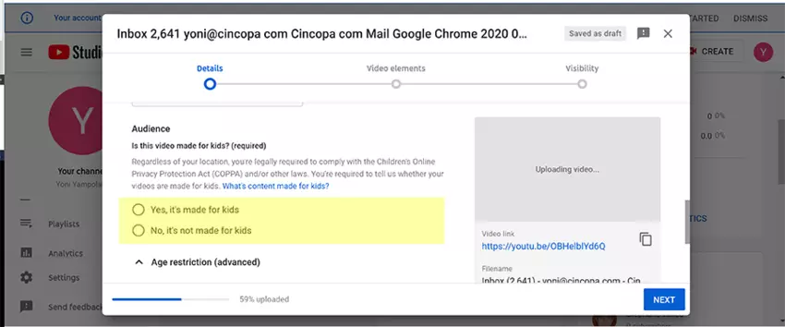

Table (5.5): Video Analysis for all sampled channels and videos

Channel Name | Video ID | Video date | Title | UNCRC transgressions | YT Guidelines transgressions | Number of views
🎥Mera World-عالم ميرا🎥
First video | qFDjZuZGyXE | Feb 23, 2022 | The prank of ugly photos in Mera.. do not miss her reaction! | A3, A36, A16, A12 | YT4, YT5,YT3, YT7 | 70952
Second video | 8mNczkSF4Oc | Nov 25, 2021 | We threw Mera in the street while sleeping.. She was shocked and thought she's dreaming | A3, A16 | YT3, YT4, YT7 | 98350
Third video | MJgMJDfB60s | Nov 10, 2021 | The dancing cactus got a jinn! Mira ran away from her room in the middle of the night | A3, A16, A36 | YT3, YT4, YT6, YT2, YT7 | 220355
Fourth video | dNt8GxwyPBo | Sep 21, 2021 | The revenge prank in Mira 😱 she peed on herself for the first time! See her reaction, she was going to cry | A3, A16, A36 | YT3, YT4, YT6, YT7, YT5 | 207176
Fifth episode | 1nLq9da0fi0 | Mar 16, 2022 | Prank I told them they drank bathroom water I didn't expect their reaction! They beat me | A3, A36 | YT3, YT4 | 44579
🎥 Malak Tube🎥
First video | UqwkmTic468 | Oct 15, 2021 | I threw Malak’s clothes in the trash... Her reaction shocked me | A3, A16, A19,A12 | YT5, YT3, YT4, YT7, YT9, YT6 | 311288
Second video | kwxuli4sEP8 | Jan 12, 2022 | Malak fill ill !! Her condition is very hard! | A3, A16, A36 | YT3, YT4, YT9 | 313734
Third video | i8Bc1ZX3y0Y | Sep 20, 2021 | Rolling and hitting challenge… For the first time we are battling in front of the camera! | A3, A36 | YT3, YT5 | 365253
Fourth video | q9usrC0qXNs | Sep 5, 2021 | My evening routine for school night + my skin care routine 2021 | A3, A16 | YT6, YT9 | 903477
Fifth Video | 9MmzWItxgmk | Sep 1, 2021 | Finally, I dyed my hair the color of my dreams My family's reaction shocked me | A16 (right to privacy) | YT9 | 717947
🎥 Mera and Yazan Tube🎥
First video | JWzx3-PEDqM | Mar 4, 2022 | A brother forces his sister to wear the hijab...A problem broke out | A13, A12, A16, A8 | YT3, YT4, YT5, YT7, YT9 | 142260
Second video | zSundM4xg3k | Jan 26, 2022 | Mera came back crying from school... What’s the reason? | A3, A12, A16 | YT3, YT4, YT6, YT9 | 202820
Third video | FFdVwdi564A | Mar 18, 2022 | The prank of disgust and gluttony in Mera... Her reaction shocked me | A3, A36 | YT4, YT7, YT3 | 45609
Fourth video | rqEBMJwVVBQ | Dec 10, 2021 | First day of school routine! We missed the semester! | A16, A36 | YT4, YT6, YT9 | 197011
Fifth video | silLaFxpizo | Feb 6, 2022 | Tension before the final exam! | A3, A16, A36 | YT3, YT4, YT9 | 162371
🎥 Rahaf pro 🎥
First video | mrsniGPBfak | Feb 15, 2022 | Why did I enter the hospital and leave school? | A3, A16 | YT3, YT4, YT6, YT9 | 809268
Second video | 7t1B3jmK60E | Jan 5,2022 | The results of this chapter shocked me.. Worst result/ Rahaf Pro 2022 | A16 | YT3 | 790712
Third video | Z7cJkeEmVac | Jan 27, 2022 | She was going to pass out in our house because of diabetes… I cried for her | A3 | YT3 | 336513
Fourth video | Zhen726hyvo | Feb 10, 2022 | I finally changed my room after 10 years / tour of my new room.. room tour | A16 | YT6, YT9 | 583682
Fifth video | qJh0NNQNEt0 | Oct 9, 2021 | My Evening Routine in Exam Days Rahaf Pro 2022 Back to School Series | A16 | YT6, YT9 | 469205
🎥 Deema cam 🎥
First video | AqSGUDJUP1Y | Mar 2, 2022 | I worked as a waitress in a cafe for a whole day.. I Sing for customers! | A3, A32, A8, A36 | YT7, YT5 | 479549
Second video | #NAME? | Jan 8, 2022 | The prank of mollycoddling  with my brothers.. They made me cry | A3, A36 | YT5,YT3 | 1471675
Third video | rdClkXakOfI | Feb 14, 2022 | He challenged me to sing and speak in Iraqi for a whole day! | A16 | YT9 | 886333
Fourth video | KWUBlHSTQn4 | Nov 2, 2021 | Get ready with me for the engagement from zero | A16 | YT6, YT9 | 1469088
Fifth video | 2VeMcGOYliU | Sep 23, 2021 | They forced me to sing in a restaurant... People’s reaction | A16 | YT9 | 880117

Children who creats content and have been posted online on different social media platforms generating large numbers of viewers and followers, often earning money for sponsored content (Masterson, 2020).
Channels that feature kids by parents, advertisement companies or by kids themselves, that produce content for children
Unsafe content on YouTube is contributed either in form of indecent videos published by unsafe uploaders or in form of abusive/inappropriate words in comments post by unsafe commenters.
Decree-Law No.10 of 2018 regarding cybercrime. Al-Muqtafi. Retrieval date: Mar 2022.
Decree-Law No.10 of 2018 regarding cybercrime. Al-Muqtafi. Retrieval date: Mar 2022.
See Sapna Maheshwari, Online and Making Thousands, at Age 4: Meet the Kidfluencers, N.Y. TIMES (March 1, 2019), https://www.nytimes.com/2019/03/01/business/media/social-media- influencers-kids.html (reporting that some kidfluencers make up to $50,000 for sponsored videos); Elizabeth Gravier, This Millennial Farmer Makes 5 Times More Money from his YouTube Channel than his Crops – Here’s How, CNBC Make It (Nov. 27, 2019), https://www.cnbc.com/2019/11/27/how-much-money-a-social-media-influencer-makes- farming.html (reporting on how one influencer makes money through Adsense).
This video is a featured video on the home page of Malak’s channel and has 311288 views until the date retrieved.
Retrieved on Mar,24th, 2022 from YouTube: https://youtu.be/FFdVwdi564A

