
Deanship of Graduate Studies
Al-Quds University

Assessment of Knowledge and Practices of Intensive Care Unit Staff of Radiation Protection during Portable Radiography in the City of Bethlehem and East Jerusalem, Palestine

Student: Elias Issa Elias Juha

M.Sc. Thesis

Jerusalem- Palestine

1444/2023
Assessment of Knowledge and Practices of Intensive Care Staff Unit of Radiation Protection during Portable Radiography in the City of Bethlehem and East Jerusalem, Palestine

Student: Elias Issa Elias Juha

B.Sc. of Medical Imaging, Palestine Ahliya University/ Palestine
Supervisor: Prof. Adnan Lahham

A Thesis Submitted in Partial Fulfilment of Requirements for the Degree Master of Medical Imaging Technology Track Functional Imaging/ Faculty of Health Professions/ Al-Quds University
Jerusalem- Palestine
1444/2023

Al-Quds University
Deanship of Graduate Studies
Faculty of Health profession
Medical Imaging Technology

Thesis Approval

Assessment of Knowledge and Practices of Intensive Care Staff Unit of Radiation Protection during Portable Radiography in the City of Bethlehem and East Jerusalem, Palestine

Student: Elias Issa Elias Juha
Registration Number: 22010006
Supervisor: Prof. Adnan Lahham

Master Thesis submitted and accepted, Date: 13/5/2023

The name and signatures of the examining committee members are as follows:
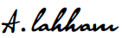

1- Head of the committee: Prof. Adnan Lahham Signature:
2- Internal Examiner: Dr. Hussein ALMasri Signature:
3- External Examiner: Dr. Ali Abu-Arra Signature:

Jerusalem-Palestine

1444 / 2023

Dedication
This research is dedicated to
Family, Instructors, and Colleagues.

Declaration
I certify that this thesis submitted for the degree of master's is the result of my research, except where otherwise acknowledged, and that the thesis has not been submitted for a higher degree to any other university or institution.

Signed
Elias Issa Elias Juha
Date:13/ 5 / 2023

ACKNOWLEDGEMENT

I want to thank God for everything in my life; some were blessings and lessons, and I am grateful for everything he sent me. A high appreciation to Prof. Adnan Lahham for his support and guidance. Thanks to all physicians and nurses for participating and cooperating in making this study a reality. My gratitude to my Father and my Mother for their support and help. My most profound appreciation and love are owed to my wife for her patience, support, and encouragement throughout my work.
Elias Issa Elias Juha

Assessment of Knowledge and Practices of Intensive Care Staff Unit of Radiation Protection during Portable Radiography in the City of Bethlehem and East Jerusalem, Palestine

Student: Elias Issa Elias Juha
Supervisor: Prof. Adnan Lahham

Abstract
The application of ionizing radiation in portable radiography is a commonly employed technique within hospital settings, particularly when patients are deemed medically unfit to undergo transportation to the imaging department. Nonetheless, this circumstance might result in personnel being exposed to radiation.
This study evaluated the physicians’ and nurses’ awareness level and practices of radiation protection principles and risks of portable radiography in the ICUs, CCUs, and NICUs at nine Bethlehem and East Jerusalem hospitals.
For data collection, the researcher designed a prospective multiple-choice questionnaire study consisting of six parts; the first part contains six questions about socio-demographic factors and related work information; the second part deals with radiation protection knowledge and awareness of the intensive care staff; the third part deals with the practices and behavior during portable radiography; the fourth part assesses how often the intensive care staff uses radiation protection equipment; the fifth part studies the staff’s needs for further training and courses regarding radiation protection, and the last part deals with how often the intensive care staff rates their knowledge of radiation protection. The data were analyzed using the SPSS, version 21.0 software, T-test, Tukey test, and ANOVA test. Moreover, the means, standard deviations, and percentages were founded.
The results show statistically significant differences between the level of knowledge (P=0.000) and the need for further training and courses regarding radiation protection (P=0.040) according to the years of practice variable. Also, statistically significant differences between the level of knowledge (P=0.000) and the need for further training and courses regarding radiation protection (P=0.045) according to the age variable. Furthermore, statistically significant differences between the level of knowledge (P=0.000) and their behavior and practice (P=0.018) according to the academic education variable, and statistically significant differences between the need for further training and courses (P=0.016) and the use of radiation protection equipment (P=0.029) according to the hospital sector variable.
Moreover, the results indicate that there are no differences between the level of knowledge, the need for further training, the use of radiation protection equipment, and practices according to the gender and occupation variables, no differences between the use of radiation protection equipment and practices according to the age and years of practice variables, no differences between the need for further training and courses and the use of radiation protection equipment according to the academic education variable, and no differences between the level of knowledge and practices according to the hospital sector variable.
Accordingly, our sample consists of 142 particpents, the overall knowledge and awareness level regarding radiation protection and risks was found to be 56% and rated as fair. Moreover, 56.3% of the participants were found to leave the intensive care department during portable radiography, and 48.6%, 62.7%, 68.3%, and 73.9% stated that they never use lead aprons, thyroid shields, lead gloves, and eyeglasses, respectively. While, 72.5% stated they never attended training or courses regarding radiation protection and 79.6% stated that continuous education officer does not provide them courses or refreshment lectures regarding radiation protection.
Thus, their educational level and awareness need to be increased. Implementing courses, presentations, refreshment lectures, and periodic training for these personnel could effectively achieve this goal. Further research using a larger sample is recommended.

Table of Contents
Page
Dedication iv
Declaration i
ACKNOWLEDGEMENT ii
Abstract iii
Table of Contents v
List of Tables viii
List of Abbreviation xi
List of Appendix xiii
Chapter 1 1
Introduction 1
1.1 Background of the Study 1
1.2 Problem Statement 4
1.3 Radiation Protection during Portable Radiography 5
1.4 Justification in Mobile Radiography 5
1.5 Research Objective and Aims 7
1.6 Research Hypotheses……………………………………………………...……………30
1.7 Limitations of the Study 7
1.8 Study Assumptions 8
Chapter 2 9
Literature Review 9
2.1 Previous Studies 9
2.2 Conclusion of the Literature 12
Chapter 3 13
Materials and Methods 13
3.1 Research Design 13
3.2 Source of Data 13
3.3 Collection of Data 14
3.4 Selection of Sample 16
3.5 Sample Design 16
3.6 Statistical Analyses 16
3.7 Ethical Approval 17
Chapter 4 18
Results and Discussion 18
4.1 Socio-Demographic Characteristics of the Respondents 18
4.2 The MP’s Actual Knowledge Compared to the Self-Rating Knowledge of Radiation Protection 22
4.3 Questionnaire Responses Regarding Radiation Protection Knowledge and Awareness…………………………………………………………………………………..26
4.4 Practices and Behavior 38
4.5: The Use of Radiation Protection Equipment 39
4.6: Training and Courses 41
4.7: Research Hypothesis 43
Chapter 5 59
Conclusion and Recommendation 59
5.1. Conclusion 59
5.2. Recommendation 60
References 62
الملخص ………………………………………………………………………………………72
Appendix A: Questionnaire 74
Appendix B: Letter of Approval 79

List of Figures
 |  | Page
Figure 1 | Percentage representation of participant’s distribution according to gender. | 19
Figure 2 | Percentage representation of participant’s distribution according to age. | 19
Figure 3 | Percentage representation of participant’s distribution according to education level. | 20
Figure 4 | Percentage representation of participant’s distribution according to years in practice. | 20
Figure 5 | Percentage representation of participant’s distribution according to occupation. | 21
Figure 6 | Percentage representation of participant distribution according to the hospital sector. | 22

List of Tables
Page
Table 1 | Name and location of investigated hospitals and the corresponding number of specialized care units. | 14
Table 2 | Classification of participants’ knowledge. | 15
Table 3 | Radiation protection knowledge evaluation results among nurses and physicians in specialized care units. | 22
Table 4 | Comparison of the actual knowledge with the self-rating knowledge level of the participants. | 23
Table 5 | The number of participants, with the mean, standard deviation, and percentage of the knowledge and awareness level of radiation protection and risks regarding age, gender, education, years of practice, occupation, and hospital sector. | 25
Table 6 | Questions related to the ALARA principle. | 27
Table 7 | Questions related to stochastic and deterministic effects. | 28
Table 8 | Questions related to radiation protection. | 31
Table 9 | Questions related to sensitivity to radiation. | 33
Table 10 | Questions Related to Dose Justification. | 35
Table 11 | Questions related to medical imaging modalities and ionizing radiation. | 37
Table 12 | Behavior of the participants regarding portable radiography. | 38
Table 13 | Use of radiation protection equipment during portable radiography. | 40
Table 14 | Participants need for training and courses regarding radiation protection. | 41
Table 15 | ANOVA results for the differences in radiation protection awareness and knowledge, using protective equipment, the need for further training and courses regarding radiation protection, and practice according to their age. | 43
Table 16 | ANOVA test results for the differences at (p≤0.05) in the radiation protection awareness and knowledge, using protective equipment, the need for further training and courses regarding radiation protection and practice according to the years of practice. | 44
Table 17 | Tukey test for the differences at (p≤0.05) in radiation protection awareness and knowledge and the need for further training and courses regarding radiation protection according to their ages. | 45
Table 18 | Tukey test for the differences at (p≤0.05) in radiation protection awareness and knowledge and the need for further training and courses regarding radiation protection according to the years of practice. | 45
Table 19 | Numbers, Means, and Std. Deviations of the differences in radiation protection awareness and knowledge and the need for further training and courses regarding radiation protection according to their ages. 61 | 46
Table 20 | Numbers, Means, and Std. Deviations for the differences in radiation protection awareness and knowledge, the need for further training and courses regarding radiation protection according to years of practice. | 47
Table 21 | ANOVA results for the differences at (p≤0.05) in the radiation protection awareness and knowledge, using protective equipment, the need for further training and courses regarding radiation protection and practice according to academic education level. | 49
Table 22 | Tukey test for the differences at (p≤0.05) in the radiation protection awareness and knowledge, and in practice according to academic education variable. | 50
Table 23 | Numbers, means, and std. Deviations of the level of knowledge and practice of the participants according to academic education variable. | 50
Table 24 | Tukey test for the differences at (p≤0.05) in the radiation protection awareness and knowledge, using protective equipment, the need for further training and courses regarding radiation protection, and practice according to gender. | 52
Table 25 | Results of T-test for the differences at (p≤0.05) in the radiation protection awareness and knowledge, using protective equipment, the need for further training and courses regarding radiation protection and practice according to occupation. | 54
Table 26 | ANOVA results for the differences at (p≤0.05) in the radiation protection awareness and knowledge, using protective equipment, the need for further training and courses regarding radiation protection, and practice according to the hospital sector. | 56
Table 27 | Tukey test for the differences at (p≤0.05) in using protective equipment and in need for further training and courses regarding radiation protection according to the hospital sector. | 56
Table 28 | Numbers, Means, and Std. Deviations in the differences in using protective equipment and in need for further training and courses regarding radiation protection according to the hospital sector. | 57

List of Abbreviation
Page Page

A
Analyses of Variance
(ANOVA) 17
As Low as Reasonably Achievable
(ALARA) 69
C
Cardiac Care Units
(CCUs) 13
Central Lines Catheters
(CLCs) 2
Chest X-ray
(CXR) 1
D
Deoxyribonucleic Acid
(DNA) 11
I
Intensive Care Units
(ICUs) 13
International Commission on Radiological Protection
(ICRP) 9
M
Magnetic Resonance Imaging
(MRI) 37
Medical Professionals
(MPs) 9
N
Nasogastric tubes
(NGs) 2
Neonatal Intensive Care Units
(NICUs) 13
Non Governmental Hospital
(NGO) 13
O
Organization for Economic Co-operation and Development
(OECD) 21
R
Radiation Protection Knowledge Questionnaire
(RPKQ) 14
Radiation Protection Officer
(RPO) 60
Radiographers
(RPs) 6
Republic of Ireland
(RI) 3
S
Standard Divisions
(SD) 18
Statistical Package for the Social Sciences
(SPSS) 17
U
Ultrasonography
(US) 37
United Kingdom
(UK) 3

List of Appendix

Page
Appendix A | Questionnaire | 74
Appendix B | Letter of Approval | 79

Chapter 1

Introduction

This chapter outlines the background (section 1.1) and problem statement (section 1.2) of the research, radiation protection during portable radiography (section ‎1.3), and justification of mobile radiography examinations (section 1.4). Furthermore, section 1.5 discusses the hypothesis of the research; section 1.6 describes the study’s limitation; and section 1.7 outlines the study’s assumption.

Background of the Study

Radiation is a type of energy that is emitted from a source and carried through matter in space. It can be ionizing or non-ionizing radiation (Tang and Loganovsky 2018). Humans have interacted with radiation and chemical agents derived from natural sources since the beginning of time. These interactions have increased with the appearance of artificial sources used in various areas of human activity: manufacturing, in houses, research, and medicine (Puerta-Ortiz and Morales-Aramburo 2020).
Medical ionizing radiation contributes the most from man-made sources, with diagnostic X-rays accounting for more than 90% of the total exposures (O’Sullivan et al. 2010). Since its inception, the use of radiation in medical practices has expanded, and 30% to 50% of medical decisions are based on radiological examinations (Tavakoli et al., 2003).
The most commonly used radiography in hospitals for adult and pediatric patients worldwide is chest X-ray (CXR); thus, because it is a simple, low-cost, and accessible imaging examination procedure that can show a wide range of pathologies in the lung parenchyma, pleural cavity, and thoracic skeleton, as well as some mediastinal disorders if it is of sufficient quality (Stollfuss et al., 2015). In contrast, chest X-rays account for 40% of the 3.6 billion annual imaging procedures conducted globally (WHO 2016). Rachh and his colleagues reported this at Emory University Hospital in Atlanta. Around 67,000 X-rays are requested yearly, with portable chest X-rays accounting for more than two-thirds of the total (Rachh et al. 2018).
Using portable X-ray equipment to perform imaging procedures on patients not located within the conventional radiology department is commonly referred to as mobile radiography. The imaging examinations, commonly called portable X-rays, derive their nomenclature from the initial compact portable X-ray apparatus designed to be disassembled and assembled at the patient’s site. Nonetheless, portable X-ray apparatuses exhibited limited power output, posed a potential risk of excessive radiation exposure to patients, and generated low-detailed images. Owing to the factors mentioned earlier, portable X-ray machines have been eschewed in medicine. Despite Advancements in radiological technology, healthcare practitioners continue to commonly employ the term “portable X-ray” when referring to mobile radiography (Jorgensen, 2017).
The primary applications for conducting a portable X-ray examination are to verify the positioning of tracheostomies, Central Lines Catheters (CLCs), Nasogastric tubes (NGs), assess traumatic injuries, pacemakers, and other medical conditions for individuals requiring unique and specific medical attention (Bwanga, 2020).
A common feature in many healthcare facilities is the availability of mobile X-ray machines, which can be transported to the patient’s bedside when transferring the patient to the radiology department may pose a risk to their ongoing medical care (Levy and Rotenberg 2016). In other words, mobile radiography must be restricted to patients whose medical condition results in significant difficulties when transferring them to the radiology department, compromising their ongoing treatment and nursing care. Patients of this nature are commonly observed within specialized healthcare units such as intensive care units, cardiac care units, and neonatal care units (Litmanovich et al., 2020). However, annually, approximately 13-20 million individuals globally undergo medical care within intensive care units (Adhikari et al., 2010).
Medical physicians, radiographers, and nurses are the triumvirate of health care practitioners included in portable radiography. First, in case conceivable, the alluding physicians will examine what is required with the patient and ask for a convenient X-ray. Then, the radiographer and nurses immobilize and position the patient to perform portable radiography examinations (Bwanga 2020).
However, the scope of practice of nurses has been extended in recent years to allow nurse consultants and advanced nurse practitioners to assess and refer patients for specific radiological procedures, for example, in the United Kingdom (UK) and the Republic of Ireland (RI) (Royal College of Nursing 2008; Nursing and Midwifery Board of Ireland 2020) Furthermore, physicians are part of a team that frequently visits the radiology department regularly, performs bedside procedures during mobile X-ray examinations, and regularly withdraws assistance during various radiological examinations (Thambura, Vinette, and Klopper 2019). This necessitates a grasp of imaging procedures and basic principles of radiation protection.
According to epidemiological studies, even low-dose radiation exposure may induce cancer, congenital abnormalities, cardiovascular and cerebrovascular diseases, cognitive and other neuropathologies, cataracts, and other eye and somatic pathology (Tang and Loganovsky 2018; Hauptmann et al. 2020) Moreover, the number of imaging procedures is increasing year after year. More than 10 million radiographic exams are performed each day globally; among them, mobile radiography is the most used method for evaluating patients in intensive care units (Dellie, Admassie, and Ewnetu 2014; Levy and Rotenberg 2016; United Nation 2000) It is estimated that 2.3 million healthcare workers worldwide are involved in radiation-related procedures, with half being exposed to artificial ionizing radiation (United Nation 2000). Therefore, the risk of cumulative radiation dose is a cause for concern among the ICU staff, and applying occupational radiation protection is mandatory for daily practices.
Radiographers are taught how to perform the role of radiation protection (M. Hassan 2018; Abo El Aish, Abuqamer, and Alajerami 2022). Unfortunately, there are limited instructional materials and studies for physicians and nurses on this issue. This study aims to provide data and advance mindfulness among doctors and nurses at a time when the number of portable CXRs has developed due to the widespread Coronavirus. Furthermore, the outcomes of this study will serve to improve both patient and staff safety. Additionally, it will help establish an action plan and new management techniques for radiation protection enhancements and provide decision-makers with precise information.

1.2 Problem Statement

Some published work suggests a gap in the nurses’ and physicians’ knowledge and behavior regarding portable radiation protection (Badawy et al. 2016; Alzubaidi, Al Mutairi, and Alakel 2017; Thambura, Vinette, and Klopper 2019; Mohsen Shafiee et al. 2021). Without such awareness, healthcare professionals may experience unnecessary fear and anxiety about radiation exposure or fail to take protective measures against the harmful effects of ionizing radiation. Thus, all healthcare providers, particularly those working in intensive care units, must be aware of the risks of ionizing radiation and effective radiation protection strategies.
The researcher found plenty of educational literature and studies evaluating radiographers’ knowledge and practices regarding radiation protection globally (Nyirenda et al. 2018; M. Hassan 2018; Abuzaid et al. 2019; Abo El Aish, Abuqamer, and Alajerami 2022). However, a limited number of educational literature for nurses and physicians on this subject is found worldwide (Babaloui et al. 2018; Thambura, Vinette, and Klopper 2019; Mohsen Shafiee et al. 2021). Besides, studies that assessed or reported nurses’ and physicians’ awareness and practices regarding radiation protection in Palestine are unavailable.
Furthermore, one of the significant problems observed was that most nurses and physicians tend to leave the intensive care departments during portable radiography (Dianati et al. 2014). Thus, patients may remain without continuous monitoring. At the same time, continuous monitoring is one of the essential features of an ICU (Amer et al. 2020). Therefore, leaving patients without continuous monitoring increases the risk of developing complications that could lead to death (Danielis, Chiaruttini, and Palese 2018).
As a result, this study will be conducted to fill this void and provide additional evidence about ICU staff radiation protection knowledge and practices in Bethlehem and East Jerusalem.

1.3 Radiation Protection during Portable Radiography

According to the literature, several researchers have indicated that most nurses and physicians have limited awareness and knowledge regarding radiation protection. Besides, they do not follow protective radiation measures during mobile radiography. This is due to a deficit of radiation protection awareness programs for nurses and physicians in universities, colleges, or even hospitals where ionizing radiation is employed, such as intensive care units (Badawy et al. 2016; Alzubaidi, Al Mutairi, and Alakel 2017; Thambura, Vinette, and Klopper 2019; Mohsen Shafiee et al. 2021).
The awareness and adherence of physicians and nurses to radiation protection control procedures during mobile radiography are critical in safeguarding patients, themselves, and the public visiting the ward/unit. The three approaches of controlling external radiation exposure during mobile radiography are time, distance, and shielding.
Reducing exposure time can directly reduce radiation dose. The source of radiation in mobile radiography is an X-ray tube. Thus, time in most cases, plays no role during portable radiography. However, if there is a need for a nurse or a physician to stay with the patient during the exposure, a lead apron should be provided (Anim-sampong et al. 2015), and a rotation of nurses for patients requiring periodical mobile X-ray examinations should be in place to reduce the amount of exposure to each nurse (Lin et al. 2005). Furthermore, increasing the distance between the nurses or physicians and the radiation source will reduce exposure by the square of the distance. The radiation exposure is reduced by a factor of four when the distance between the ICU staff and the radiation source is doubled (Kim 2018). Therefore, the intensive care staff should stand as far as possible from the radiation source during portable examinations. The minimum safe distance recommended is two meters, at which scattered radiation is reduced to background levels (Chiang et al. 2015).

1.4 Justification in Mobile Radiography

Several procedures must be taken to conduct and complete a mobile X-ray examination successfully. First, ensuring that the requested exam is justified before approaching a ward or department is critical.
Justification is two-fold: there must be a reasonable clinical cause for the requested examination and a reason why the examination should be performed outside the radiology department (DECC 2014).
In mobile radiography, justification extends beyond the justification concept. Portable X-rays should only be used on life-support patients or with medical issues that adversely impact nursing care and treatment if brought to the radiology department(Levy and Rotenberg 2016). A lack of ward personnel to transport the patient to the radiology department is not a valid justification for doing a portable X-ray.
While departmental examinations are possible and indicated, inappropriate use of mobile radiography may have negative consequences for patients, radiographers (RP), and healthcare facilities. Although a mobile exam is more convenient for patients and staff than transferring patients to the medical imaging department, patients get a higher radiation dosage than departmental tests (Cohen et al. 2011). Reduced picture quality and limited views may also influence the diagnostic quality of the image and its treatment (Wandtke 1994). Mobile radiography also draws radiographers from the imaging department, which may impact the hospital’s imaging services’ efficiency and throughput (Kobes et al. 2020).
Referral criteria are available but not expressly tailored to mobile exams. For example, the request and utilization of portable X-rays in the UK should conform to the 2017 Ionizing Radiation (Medical Exposure) Regulations (“The Ionising Radiation (Medical Exposure) Regulations 2017” 1973). Therefore, current referral criteria are often designed for exams in hospitals or clinics and may not consider the unique challenges of conducting exams in mobile settings. This can lead to confusion and uncertainty on the part of healthcare professionals, which can, in turn, compromise the quality of care provided to the patient.
Furthermore, radiographers should be informed of relevant past exams as part of the justifying process. It is also suitable for the RP to go through any previous imaging. This will allow them to determine the size of a patient’s chest and if a portrait or landscape image receptor orientation is best. Prior imaging review also allows for consideration of exposure factor selection and how pathology may affect dosage optimization (Bwanga 2020).

Research Objective and Aims

- To observe the mean level of knowledge of nurses and physicians regarding radiation protection during mobile radiography.
- To assess the level of using radiation protection equipment at a time when there is a need for the nurses and physicians to stay beside the patient during the examination.
- To identify the need for further courses and refreshment lectures regarding radiation protection.
- To observe the behavior of the nurses and physicians regarding radiation protection during mobile radiography.
- To assist future radiation protection strategies and the development of a radiation safety culture by planners and decision-makers.
- To improve intensive care staff education.
- To provide better informational materials with more evidence to reduce the undue anxiety of the staff.

  - Hypothesis of the Study

There is no significant relationship between 1) radiation protection awareness and knowledge level, 2) practices, 3) using protective equipment, and 4) the need for further training and courses regarding radiation protection in comparison with their academic education level, age, gender, years of practice, occupation, and the hospital sector.

Limitations of the Study

- Unavailability of relevant local literature, studies, and resources studying the awareness and practices of ICU staff (either nurses or physicians) of radiation protection in Palestine, especially in Bethlehem district and East Jerusalem. (According to our knowledge)
- Lack of funds (self-funded study).
- The well of participants to cooperate.

Study Assumptions

- We will have sufficient professionals participating, responding, and cooperating with us.
- Participants will understand clearly all questions and concepts in this study.
- Participants will provide accurate and precise information by answering the questionnaires honestly and sincerely, reflecting their knowledge and practices.

Chapter 2

Literature Review

2.1 Previous Studies

In 2019, Thambura et al. evaluated the knowledge of 123 nurses in Northern Gauteng State Hospitals in South Africa about ionizing radiation using a quantitative, cross-sectional, descriptive study. They found that nurses had limited knowledge of medical ionizing radiation, with more than 50% lacking the basic knowledge of radiation protection principles. Furthermore, 80% of respondents could not recognize radiopaque equipment, 54% could not identify radiosensitive organs in the human body, and 81% were unaware of the radiation-safe distance (Thambura, Vinette, and Klopper 2019).
These findings were reinforced by Badawy et al., who used a prospective multiple-choice questionnaire to examine nursing staff’s awareness of radiation protection and practices at a major Australian hospital with over 1000 nurses. Out of 200 nurses who participated, 147 (74%) filled the questionnaire. The findings revealed that broad questions on shielding and background radiation yielded the majority of inaccurate answers and ‘do not know’ responses. Overall, the proportion of accurate replies to all the survey questions was 42%, with 26% of respondents answering erroneously and 32% responding with “I do not know.” As a result, the study indicated that overall understanding of radiation safety is low among hospital nursing personnel. (Badawy et al. 2016)
In 2021, the primary goal of Mohsen et al.’s descriptive questionnaire-based study was to assess the knowledge and practice of 215 medical professionals (MPs), including 174 nurses and 41 physicians. According to the findings of their study, only 47.7% of the participants understood the idea of ALARA (As Low as Reasonably Achievable), even though it is the fundamental concept of radiation protection, and only 8.8% of MPs were aware of the International Commission on Radiological Protection (ICRP) dosage limit (a fundamental part of most radiation protection programs) (Mohsen Shafiee et al. 2021). Meanwhile, Rassin et al. also found the same results; they investigated physicians’ and nurses’ knowledge and attitudes toward the possible risks of imaging examinations. There were 68 doctors and 76 nurses in the research. More than 70% of physicians said they always sent patients for ionization examinations to finalize their diagnosis. In addition, the vast majority of doctors and nurses answered that they were aware that these examinations might result in cancer and genetic alterations.
In contrast, most physicians and nurses failed to follow precise recommendations for self-protection against radiation exposure while working. As a result, Rassin and his colleague concluded that while more than 70% of physicians and nurses felt they had excellent radiation safety knowledge, their awareness regarding radiation protection was just fair to poor. (Rassin et al. 2005)
However, Alzuhaidi et al. found somewhat different findings when they investigated the knowledge and attitude of nurses regarding ionizing radiation during radiography among 300 nurses in Jeddah City, Kingdom of Saudi Arabia, from June 2017 to August 2017. Most nurses (65%) had an adequate understanding of ionizing radiation risk factors and protection strategies, and 79% had a positive attitude toward ionizing radiation. Moreover, Alzubaidi et al. stated that the size of practical years of experience was shown to be highly related to the amount of knowledge (Alzubaidi, Al Mutairi, and Alakel 2017). And this is opposite to the findings of Babaloui et al., who found that there is no significant difference between nurses’ work experience and their awareness concerning radiation protection principles (Babaloui et al. 2018).
Regarding radiation protection training and courses, Badawy et al. found that 59% of the nurses who participated in the study had not had any formal radiation safety training since commencing employment. Furthermore, 85% of respondents said they would want further training to boost their confidence in dealing with radiation in their day-to-day working lives (Badawy et al. 2016). Also, Thambura et al. in 2019 concluded that most respondents (91%) had no radiation safety training, and 63% had never been taught radiation safety in a college or university. Overall, 93% of respondents agreed that there was a need for radiation safety training, either through workshops or through the curriculum (Thambura, Vinette, and Klopper 2019). Furthermore, Alotaibi and Saeed in 2006 evaluated radiography nurses’ radiation awareness; the study comprised 35 radiology nurses from seven Kuwaiti governmental general and specialty hospitals. Found that the majority, 82% of nurses, recommended at least radiation safety training before joining the radiology department. The remaining 18% proposed frequent radiation safety workshops and lectures (Alotaibi and Saeed 2006).
Accordingly, these findings were reinforced by Mohsen et al., who concluded that 77% of nurses did not complete a radiation safety course during their bachelor’s or postgraduate education or at employment. Furthermore, 34% of physicians did not obtain such training throughout their study. Besides, none of the MPs had any actual radiation safety training at their employment or throughout their study. Over and above that, their data revealed that the nurses’ accurate response rate for practice and knowledge was much lower than that of the physicians. In contrast, 74.1% of MPs did not properly know how to operate the installed shielding equipment during interventional fluoroscopy examinations (Mohsen Shafiee et al. 2021).
The surprising finding that Mohsen et al. found is that 17 (54.8%) of the nurses suffered from radiophobia, and some female nurses preferred to avoid participating in interventional fluoroscopy procedures (Mohsen Shafiee et al. 2021). A similar finding has been observed in the work of Dianati et al. (Dianati et al. 2014). This could be due to the lack of precise knowledge of the radiobiological effects of radiation. Which also agrees with a previous study in 2006 by Alotaibi and Saeed. (Alotaibi and Saeed 2006).
Sheyn et al. tracked down the radiation exposure and usage of shielding equipment (leaded spectacles and hanging lead shield) by physicians for four months. Then they gave talks, courses, and publications about ALARA concepts for optimizing radiation dosage. Before education, 432 procedures were performed, and after education, 616 procedures were performed. Physician use of leaded eyeglasses and hanging shields increased significantly after education. Thus, their research concluded that radiation exposure to patients and employees was reduced following radiation safety education because staff members were more likely to utilize all the protective items supplied to them after learning about the hazards. (Sheyn et al. 2008)
Furthermore, Rafiq et al. noted that several studies had found a link between cancer and radiation exposure and that radiation may damage the Deoxyribonucleic Acid (DNA) in cells. As a result, they recommended that a radiation protection program be implemented, and all MPs should have a considerable standard of radiation awareness and risk assessment. (Rafiq et al. 2011)

2.2 Conclusion of the Literature

Most of the research in the preceding section focuses on the level of radiation safety awareness that influences both nurses’ and physicians’ behavior. As a result, several investigations have revealed that many MPs are unaware of the essential scientific understanding concerning radiation safety principles and procedures, which may result in significant radiation-related blunders.
The MP’s understanding of the hazards of ionizing radiation has been identified as one of the critical drivers for decreasing MPs and patients’ dosage in medical practices. Therefore, the initial step in radiation protection may be acquired by performing more radiological research to determine the vulnerabilities of MPs’ radiation protection knowledge and practices during portable radiography and other radiological examinations.
In addition, many studies pointed out that the majority of nurses have radiophobia. So, conducting more research, as we mentioned previously, will also help reduce the undue anxiety of ionizing radiation.
Furthermore, regarding radiation protection training and courses, many studies concluded that the majority of MPs had no radiation safety training and had never been taught radiation safety in a college or university. Also, they indicated the need for further training and courses to boost their confidence in dealing with radiation in their day-to-day working lives. Thus, the potential advantages of MPs as active actors in radiation protection must be stressed at colleges and hospitals where radiation science curricula are deficient. Besides, additional training at medical colleges or hospitals is also recommended.

Chapter 3

Materials and Methods
This chapter describes the methodology adopted by this research to achieve the aims and objectives stated in section ‎1.5 of Chapter 1. Section 3.1 discusses the design of the research; section ‎3.2 details the Sources of data in the study; section ‎3.3 outline the method used for the collection of a sample in the study and justifies their use; section ‎3.4 outlines Sample selection of the study; section 3.5 highlights sampling design; section ‎3.6 discusses how the data was analyzed; finally, section ‎3.7 discusses the ethical considerations of the research.

3.1 Research Design

This research is a descriptive cross-sectional questionnaire-based study, of knowledge and practices of intensive care staff during portable radiography, among 104 nurses and 38 physicians, conducted from November 1, 2022, to March 15, 2023. In Intensive Care Units (ICUs), Cardiac Care Units (CCUs), and Neonatal Intensive Care Units (NICUs) of Bethlehem and East Jerusalem hospitals, Palestine.
A self-administrated questionnaire was designed and validated after reviewing the previous studies. First, two experts revised the questionnaire then a pilot study was conducted in three different random hospitals on ten nurses to validate the questionnaire.

3.2 Source of Data

Data of this study were collected from all intensive care departments in nine hospitals in Bethlehem city and East Jerusalem (Table 1), including Arab Society for Rehabilitation Hospital (non-governmental hospital-NGO/Bethlehem), Al-Hussein Hospital (governmental hospital/Bethlehem), Caritas Baby Hospital (NGO/Bethlehem), AL-Yamama Hospital (private hospital/Bethlehem), Saint Joseph Hospital (NGO/ Bethelhem) Augusta Victoria Hospital (NGO/Jerusalem), Saint Joseph Hospital (NGO/Jerusalem), Al-Makassed Islamic Charitable Society Hospital (NGO/Jerusalem), and The Red Crescent Society Hospital (NGO/Jerusalem).

Table 1: Name and location of investigated hospitals and the corresponding number of specialized care units.
# | Hospital Name | Location | ICU | CCU | NICU
1 | Arab Society for Rehabilitation Hospital | Bethlehem | 1 | 1 | 0
2 | Al-Hussein Hospital | Bethlehem | 2 | 0 | 1
3 | Caritas Baby Hospital | Bethlehem | 0 | 0 | 1
4 | Saint Joseph Hospital | Bethlehem | 0 | 0 | 1
5 | AL-Yamama | Bethlehem | 1 | 0 | 0
6 | Augusta Victoria Hospital | East Jerusalem | 1 | 0 | 0
7 | Saint Joseph Hospital | East Jerusalem | 1 | 0 | 1
8 | Al-Makassed Islamic Charitable Society Hospital | East Jerusalem | 1 | 1 | 1
9 | The Red Crescent Society Hospital | East Jerusalem | 0 | 0 | 1
Total |  |  | 7 | 2 | 6

3.3 Collection of Data

After reviewing other studies and literature, we used a demographic questionnaire, a radiation protection knowledge questionnaire (RPKQ), and checklists designed by the researcher (Appendix A). The demographic questionnaire consists of six questions about nurses’ and physicians’ age, sex, education, working experience, occupation, and hospital sector. The RPKQ contained fourteen multiple-choice questions on nurses’ and physicians’ knowledge of ionizing radiation safety and risks. Right and wrong answers were specified by one and zero, respectively. Accordingly, the total score of the RPKQ was 0 to 14; scores were classified into five categories (Table 2) poor, fair, good, very good, and excellent.
Table 2: Classification of participants’ knowledge.
Score out of 14 | Knowledge category
0-6.9 | Poor
7-9.7 | Fair
9.8-11.1 | Good
11.2-12.5 | Very good
12.6-14 | Excellent

The checklists were used to identify the following:
- Nurses’ and physicians’ practices and behavior during portable radiography. The five items of the checklist were: Going out of the unit, Going to the break room, Staying at the nursing station, Standing behind a lead apron, and Distance as possible within the department.
- The need for additional training and courses regarding radiation protection. The three items of the checklist were: I need to undergo training on radiation protection. Have you ever attended training and courses regarding radiation protection? Furthermore, Does the hospital’s continuous education officer offers courses or refreshment lectures to the intensive care staff regarding radiation protection? The two answers of the checklist were: Yes, and No.
- How do intensive care staff rate their knowledge of radiation protection? The five items of the checklist include excellent, very good, good, fair, and poor.
- How often do intensive care staff use personal radiation protection equipment (lead apron, eyeglasses, lead glove, and Thyroid shields) during portable radiography? The three items of the checklist were: Never, sometimes, and always.
Questionnaires were distributed to the nine Bethlehem and East Jerusalem hospitals, including one private hospital, one governmental hospital, and seven non-governmental organizations. We used a hard copy and an online questionnaire form to guarantee a maximum response. Nurses filled out the questionnaire at the end of their shifts or during breaks.
First, each hospital was visited personally; following the medical director’s approval, the researcher introduced himself to the heads of the intensive care units, briefly explained the study’s objectives, and demanded their cooperation to complete the questionnaire. Then, after obtaining the necessary approvals, questionnaires were distributed to the staff, where instructions were provided on how to fill them out accurately and honestly. Finally, the researcher assured them that their participation was voluntary and that their responses would be confidential.
However, because several nurses and physicians work in each department with different shift modes, the researcher kept copies of the questionnaires at the head of intensive care departments for one week. As a result, about 155 copies of questionnaires were distributed to all hospitals; 142 respondents were gathered, and 13 were excluded because demographic data were unfilled.

3.4 Selection of Sample

Our sample targeted all nurses and physicians working in seven ICUs, two CCUs, and six NICUs in Bethlehem and East Jerusalem hospitals, including governmental, private, and NGO hospitals. In contrast, the study excluded workers such as cleaner, porters, secretaries, receptionists, and medical engineers.

  - Sample Design

The researcher used a convenient sampling design, a non-probability sampling approach comprising the most readily available or convenient persons (Carbno 2007).

3.6 Statistical Analyses

A questionnaire consisting of six sections was used as the data collection tool. Descriptive statistical methods were used using the Statistical Package for the Social Sciences (SPSS) package program (version 21.0) in analysing the data obtained from the questionnaire, and the Analyses of Variance (ANOVA) test, Tukey test and, t-test were used to analyse the qualitative data.
ANOVA is a statistical method that divides observed aggregate variability within a data set into systematic components and random factors. Random factors do not statistically impact the data provided, but systematic factors do. In regression research, analysts employ the ANOVA test to examine the impact of independent factors on the dependent variable. While Tukey’s test findings reveal the importance of an observed difference for the multiple comparison process to consider it significant. Furthermore, the t-test is used to compare the means between two groups, whereas ANOVA is used to compare the means among three or more groups (Draze 2021; Kenton 2022).

3.7 Ethical Approval

- Ethical approval was obtained from the Deanship of Faculty of Health Professions at Al-Quds University (Appendix B).
- The hospitals granted permission to conduct the study.
- The confidentiality of participants was guaranteed by keeping respondents’ names, ages, and workplaces private.
- The data collected have been kept private and confidential.
- The study’s objectives, the nature of the study, and the existence of an observer were explained to all participants before submitting the questionnaire.

Chapter 4

Results and Discussion
This chapter introduces the survey findings, including MP characteristics, means, percentages, frequencies, and standard divisions (SD). Furthermore, the hypothesis’ findings are shown. This is the first survey to assess the level of knowledge, practices, the need for additional radiation protection training and courses, the use of protective equipment, and how MPs rate their knowledge of radiation protection during portable radiography in Bethlehem City and East Jerusalem.

4.1 Socio-Demographic Characteristics of the Respondents

Physicians and nurses from nine Bethlehem and East Jerusalem hospitals were targeted for participation in this study. The sample consisted of 104 nurses and 38 physicians. Out of the 155 copies of questionnaires that were distributed to all hospitals, 142 respondents were gathered; 13 were excluded because demographic data were unfilled. The response rate was 91.6%, which is considered an excellent response rate for this type of study. Therefore, excluding 13 respondents due to unfilled demographic data did not affect the study results.
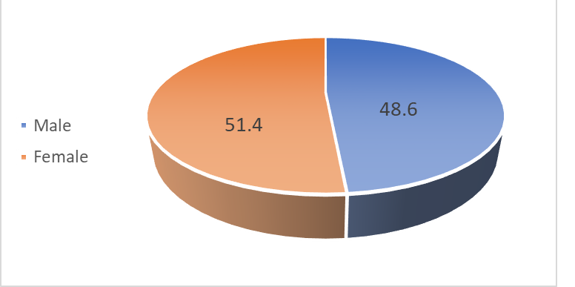
The number of females who participated in this study was slightly higher than that of males, where females represented 51.4% (n=73), and males represented 48.6% (n=69) of all the MPs targeted in this study (Figure 1).
Figure 1: Percentage representation of participant’s distribution according to gender.
The number of females and males targeted in this research complies with the fact that globally, women comprise 70% of the health and social workforce, compared to 41% across all job sectors. Nursing and midwifery jobs employ a sizable proportion of the female workforce (Nursing and Midwifery 2018).
Regarding the age variable of the participants, Figure 2 shows that the highest percentage, 47.2% (n=67) of the participants, had age ranges from 20 to 30 years old. While 30.3% (n=43) from 31 to 40 years old, 14.1% (n=20) from 41 to 50 years, and 8.5% (n=12) higher than 50 years old. This gives us an indication that the majority of the participants were youth. Thus, the advantage of youth denotes a desire for immense effort, liberality, and vigor; this stage of life allows a person to learn new skills and gain experience.
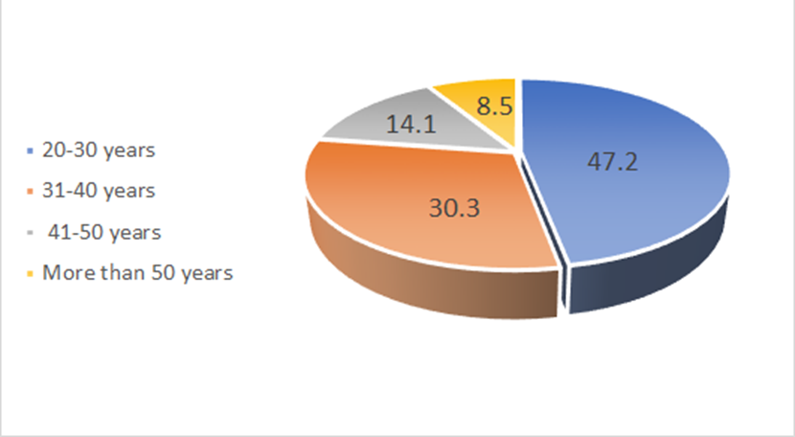
Figure 2: Percentage representation of participant’s distribution according to age.

Furthermore, most MPs, n=82 (57.7%) out of 142, attained a bachelor’s degree, and n= 48 (33.8%) master’s degree, while diploma degree n=12 (8.5%) ass seen in Figure 3. Signifying that the study sample is of high scientific qualification. Thus, Palestinian society is among the most educated people in the Arab world. Besides, nurses’ and physicians’ jobs require excessive scientific knowledge (Guanabara et al., n.d.).
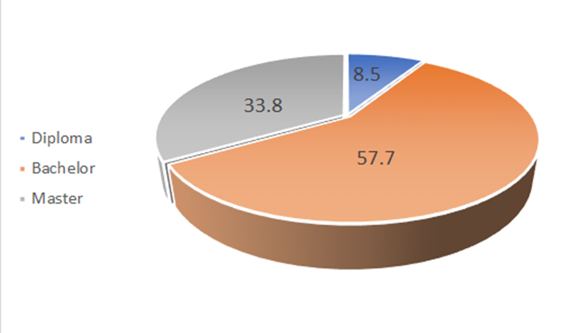
Figure 3: Percentage representation of participant’s distribution according to education level.
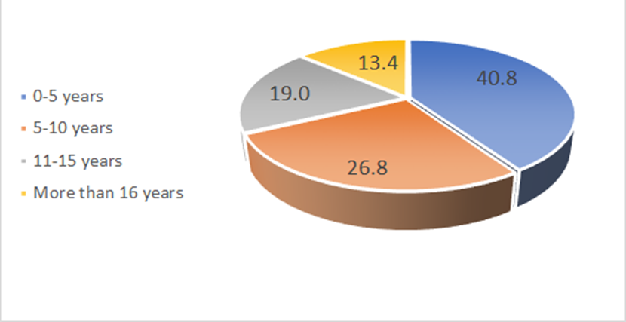
The work experience of the respondents ranged from less than five years to more than 16 years. Figure 4 shows the experience of the participants, where 40.8% (n=58) of participants had work experience of less than five years, 26.8% (n=38) had 5-10 years of experience, 19% (n=27) had 11-15 years of experience, while 13.4% (n=19) had more than 16 years of experience.
Figure 4: Percentage representation of participant’s distribution according to years of practice.
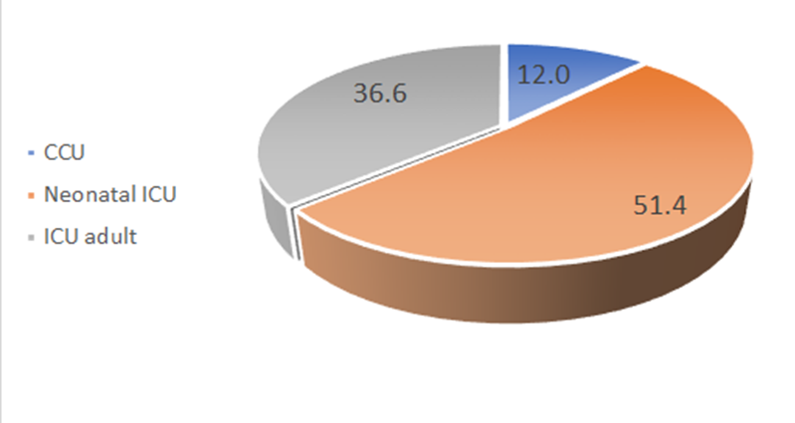
Figure 5 and Figure 6 show the distribution of participants regarding occupation and the hospital sector. Nurses represented most participants, n=104 (73.2%), and physicians n=38 (26.8%). Moreover, the majority of participants were working in NICU n=73 (51.4%), then adult ICU n=52 (36.6%), and CCU n=17 (12%).
Figure 5: Percentage representation of participant’s distribution according to occupation.

Nurses outnumber physicians in most Organization for Economic Co-operation and Development (OECD) countries, for the most part, with three nurses for every doctor. For example, the nurse-to-doctor ratio ranges from one nurse per doctor in Chile, Turkey, and Greece to more than four nurses per doctor in Japan, Ireland, Finland, and the US (OECD iLibrary 2020). In this study, the sample’s ratio of nurses to doctors was 2.74 nurses to each doctor. Found to comply with the OECD report of 2020.
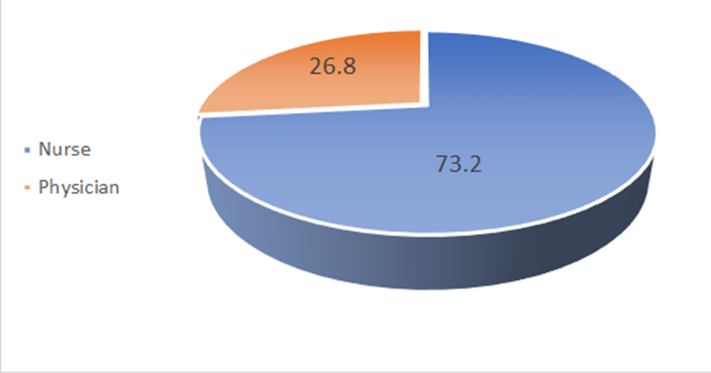
Figure 6: Percentage representation of participant distribution according to the hospital sector.

4.2 The MP’s Actual Knowledge Compared to the Self-Rating Knowledge of Radiation Protection

The self-rating knowledge and awareness of radiation protection and risks of the participants showed that almost 83 (58.5%) of the respondents were moderately confident and appraised their knowledge of ionizing radiation protection and risk as good, (26.8%) as very good, (9.69%) as excellent, and (3.5%) and (1.4%) were less confident in their knowledge as they graded themselves as fair and poor respectively. Results are presented in Table 3.
Table 3: Radiation protection self-rating knowledge results among nurses and physicians in specialized care units.
Categories of knowledge | Frequency | Percent
Excellent | 14 | 9.9%
Very good | 38 | 26.8%
Good | 83 | 58.5%
Fair | 5 | 3.5%
Poor | 2 | 1.4%

However, the results of the questionnaire section of this research related to the actual knowledge and awareness of intensive care staff of radiation protection and risk during portable radiography, which included 14 questions, revealed somehow an opposite finding, as seen in Table 4; Where the majority of participants n=58 (40.8%) have a fair level of knowledge, 33.1% have a poor level of knowledge, and only 3.5 % and 8.5% have a very good and excellent level of knowledge respectively. Our findings comply with the findings of Rassin et al., who indicated that 70% of physicians and nurses felt they had excellent radiation safety knowledge; however, their awareness regarding radiation protection was just fair to poor (Rassin et al. 2005).
Table 4: Comparison of the actual knowledge with the self-rating knowledge level of the participants regarding radiation protection and risks.
Knowledge categories |  | Actual knowledge level |  |  |  |  | Self-rating knowledge of radiation protection
 |  | Poor | Fair | Good | Very good | Excellent | Total
Excellent | Count | 2 | 3 | 4 | 1 | 4 | 14
Excellent | % | 1.4% | 2.1% | 2.8% | 0.7% | 2.8% | 9.9%
Very good | Count | 7 | 18 | 3 | 2 | 8 | 38
Very good | % | 4.9% | 12.7% | 2.1% | 1.4% | 5.6% | 26.8%
Good | Count | 32 | 37 | 12 | 2 | 0 | 83
Good | % | 22.5% | 26.1% | 8.5% | 1.4% | 0.0% | 58.5%
Fair | Count | 5 | 0 | 0 | 0 | 0 | 5
Fair | % | 3.5% | 0.0% | 0.0% | 0.0% | 0.0% | 3.5%
Poor | Count | 1 | 0 | 1 | 0 | 0 | 2
Poor | % | 0.7% | 0.0% | 0.7% | 0.0% | 0.0% | 1.4%
Total | Count | 47 | 58 | 20 | 5 | 12 | 142
Total | % | 33.1% | 40.8% | 14.1% | 3.5% | 8.5% | 100.0%

Among the 83 (58.5%) MPs who rate themselves as they have good knowledge and awareness of radiation protection, actually only 12 (8.5%) of them had good knowledge, 37 (26.1%) were fair, and 32 (22.5%) were Poor. Also, among the 38 (26.8%) MPs who rate themselves as very good, only 2 (1.4%) of them had very good knowledge, and the majority of them, 18 (12.7%), were fair, and 7 (4.9%) were poor. Moreover, among the 14 (9.9%) MPs who rate themselves as excellent, only 4 (2.8%) got an excellent level of knowledge, and the majority of them, 4 (2.8%), 3 (2.1%), and 2 (1.4%) were good, fair, and poor respectively. These findings demonstrate that the majority of the participants, 73.9%, their knowledge of radiation protection and risk was just poor to fair.
Likewise, Anim-sampong et al. studied 43 nurses’ knowledge of ionizing radiation and radiation protection during mobile radio-diagnostic examinations in 2015. They concluded that 16% of the participants were graded as having poor knowledge, 23% as average level, 0% above the average, 14% as good, 0% as very good, and 47% with no knowledge (provided no answers to the questions). Moreover, 25.6% believed that objects in the X-ray room emitted radiation after exposure. Also, 37.2% presumed that patients emitted radiation after an X-ray examination (Anim-sampong et al. 2015).
The participants’ mean knowledge and awareness level of radiation protection and risk in this research was 7.85±2.98 out of 14 and rated as a fair level of knowledge, as seen in Table 5, representing their knowledge and awareness regarding radiation protection is only 56%. This is in agreement with Mohsen Shafiee et al., who assessed the knowledge and practice of 174 nurses and 41 physicians and found that the mean of knowledge and awareness among the participants was only 43.3%. Therefore, their knowledge level was rated as insufficient (Mohsen Shafiee et al. 2021). Moreover, a previous study by Adewoyin et al. in 2019 found that healthcare workers lack knowledge about radiation safety and struggle to apply it in practice (Adewoyin et al. 2019). Furthermore, Yurt et al. evaluated the knowledge and perception of hazards involved in radiological examinations of physicians, nurses, and other staff groups and found that the number of correct answers was 15.7±3.7, 13.0±4.0, and 11.8±4.0, out of 42 respectively. Concluded that the participants had a weak level of knowledge (Yurt, Çavuşoğlu, and Günay 2014).
The above findings were also reinforced by the findings of Badawy et al., who stated that the awareness of radiation safety is poor among the respondents, where 26% of respondents answered incorrectly, and 32% answered ‘I do not know (Badawy et al. 2016). Moreover, the findings of Hamarsheh revealed a lack of knowledge regarding the radiation hazards associated with radiological examinations among 167 physicians (Hamarsheh 2009). Furthermore, Alotaibi & Saeed found that many nurses who had received radiation education during their nursing training had poor knowledge of ALARA and the 10-day rule principles (Alotaibi and Saeed 2006).
The research findings of this section, besides the literature mentioned above, deduced that there is a huge lack of knowledge of both nurses and physicians regarding radiation protection and risk management during radiological examinations worldwide and also in Palestine, especially MPs who are working in intensive care units where portable examinations are frequently requested to assess and check patients’ health status.
The lack of knowledge and practice among nurses and physicians makes them unable to protect themselves and their patients from the harmful effect of ionizing radiation. Furthermore, it may indicate a deficiency in educational training. Therefore, nurses have the right to be provided with courses, training, and workshops regarding radiation protection and risks before they work in any department involving the utilization of ionizing radiation; furthermore, they must be oriented to this department, and their level of knowledge regarding radiation protection must be assessed.
Therefore, from our point of view, the low level of knowledge and awareness of MPs of ionizing radiation fall within the administrative responsibilities to provide all healthcare workers with sufficient training and courses regarding radiation protection principles. Making sure they have enough awareness in dealing with various ionizing radiation examinations.
Table 5: shows the number of participants, with the mean, standard deviation, and percentage of the knowledge and awareness level of radiation protection and risks regarding age, gender, education, years of practice, occupation, and the hospital sector.
Variables | Subgroup | N | Mean | SD(±) | Percentages of knowledge
Gender | Male | 69 | 7.71 | 3.07 | 55.1%
Gender | Female | 73 | 7.97 | 2.90 | 56.9%
Age | From 20-30 years | 67 | 6.58 | 2.09 | 47.0%
Age | From 31-40 years | 43 | 7.84 | 2.96 | 56.0%
Age | From 41-50 years | 20 | 8.90 | 2.43 | 63.6%
Age | More than 50 years | 12 | 13.17 | 1.03 | 94.0%
Education | Diploma | 12 | 5.75 | 3.25 | 41.1%
Education | Bachelor | 82 | 7.24 | 2.89 | 51.7%
Education | Master | 48 | 9.40 | 2.35 | 67.1%
Years of practice | From 0-5 years | 58 | 7.02 | 2.51 | 50.1%
Years of practice | From 6-10 years | 38 | 7.82 | 3.15 | 55.8%
Years of practice | From 11-15 years | 27 | 7.78 | 2.87 | 55.6%
Years of practice | More than 16 years | 19 | 10.53 | 2.70 | 75.2%
Occupation | Nurse | 104 | 7.94 | 2.82 | 56.7%
Occupation | Physician | 38 | 7.58 | 3.40 | 54.1%
Hospital sector | CCU | 17 | 7.35 | 3.52 | 52.5%
Hospital sector | NICU | 73 | 7.85 | 3.03 | 56.1%
Hospital sector | ICU | 52 | 8.00 | 2.74 | 57.1%
Total |  | 142 | 7.85 | 2.98 | 56.0%

N, number of respondents; SD, standard division.

Table 5 shows that the differences in the level of knowledge and awareness of radiation protection and the risks are slight regarding gender, hospital sector, and occupation of the respondents. However, there are significant differences in the level of knowledge and awareness regarding age, education, and years of practice. This will be discussed in detail in section 4.7 of this chapter.

4.3 Questionnaire Responses Regarding Radiation Protection Knowledge and Awareness
4.3.1 ALARA principles

About 62% of the MPs, as seen in Table 6, did not know the ALARA principle by the ICRP; this result was found to comply with several studies; for example, Mohsen et al. found that only 47.7% of the participants understood the idea of ALARA (Mohsen Shafiee et al. 2021). Likewise, Hamarsheh deduced that only 6.1% of the respondents could identify the ALARA principle (Hamarsheh 2009). Besides, Alzubaidi et al. found that 86% of nurses are unaware of the ALARA principle (Alzubaidi, Al Mutairi, and Alakel 2017). Even though the ALARA principle is the fundamental concept of radiation protection, 71.8% of the questionnaire respondents failed to determine what the letters “ALARA” stand for, and 74% could not find the correct answer compatible with the ALARA principles.
Table 6: Questions related to the ALARA principle.
Q (1): Do you know what the ALARA principle is?
Questionnaire response | Frequency | Percentage
Yes | 54 | 38.0%
No | 88 | 62.0%
Q (2): What does “ALARA” stand for?
Questionnaire response | Frequency | Percentage
As Low as Reasonably Achievable | 40 | 28.2%
Allowable Administered Radiation Alert | 7 | 4.9%
All About Radioactivity Amount | 5 | 3.5%
I do not know | 90 | 63.4%
Q (3): Which of the following is compatible with the ALARA principle?
Questionnaire response | Frequency | Percentage
High kVp, low mAs | 37 | 26.1
Low kVp, high mAs | 38 | 26.8
I do not know | 67 | 47.2

By comparing the findings of this research with the literature, it is seen that the low level of knowledge of MPs regarding the ALARA principle is a global problem, not just in Palestine. From our point of view, unawareness may depend on many factors, such as:
- Few radiation protection courses in the curriculum of Palestinian universities’ medical and nursing schools.
- Less continuous education and training procedures.
- Less organizing of workshops on radiological patient safety in diagnostic radiology in collaboration with national or international radiation protection professionals.
- Healthcare workers lack interest in developing and promoting themselves or are bored with the daily work routine.
The current guidelines are based on the classic idea that there is no such thing as a safe level of exposure. Even the smallest amount of exposure can generate a stochastic impact, such as cancer. This assumption has given rise to the overall attitude of keeping exposures below recommended limits or regulatory constraints and keeping all exposure “as low as reasonably achievable. ALARA is a fundamental requirement of current radiation safety standards. Every reasonable effort must be taken to keep the worker and public doses within the statutory levels (Vermeersch et al. 2021).
However, WHO, 2004, issued tips to reduce dose through the selection of kVp and mAs: The higher the kVp selected, the more penetrating the beam, the lower the dose (the ALARA principle). And mAs (tube current x time in seconds/milliseconds) has direct role in contributing dose to patients; thus higher mAs leads to a higher dose. Hence, keep mAs as low as possible without compromising image quality (the ALARA principle) (World Health Organization 2004).\

4.3.2 Stochastic and Deterministic Effects

Despite most participants, n=93 (65.5%) could correctly identify that eye cataracts, infertility, skin cancer, and leukemia are all considered adverse health effects of ionizing radiation. However, the majority of the participants, 60.6% (n=86) of the participants could not determine the difference between stochastic and deterministic effects, as seen in Table 7. This indicates that they were unaware of the probability of biological radiation damage, either by under or overestimating radiation biological hazard effects.
Table 7: Questions related to stochastic and deterministic effects
Q1: Radiation adverse health effects include:
Questionnaire response | Frequency | Percentage
Eye cataract | 9 | 6.3%
Infertility | 16 | 11.3%
Skin cancer, leukemia | 6 | 4.2%
All of the above | 93 | 65.5%
I do not know | 18 | 12.7%
Q2: The difference between stochastic and deterministic effects of radiation is:
Questionnaire response | Frequency | Percentage
The deterministic effect has a threshold dose, but the stochastic effect has not | 56 | 39.4%
The stochastic effect had a threshold dose, but the deterministic effect has not | 8 | 5.6%
The stochastic effect and deterministic effect are the same no difference). | 12 | 8.5%
The stochastic effect includes erythema, but the determinist effect includes cancer. | 5 | 3.5%
I do not know | 61 | 43.0%

Moreover, Mohsen Shafiee et al. found a higher percentage than ours in this section, where 71.7% of their participants could not determine the difference between stochastic and deterministic effects (Mohsen Shafiee et al. 2021).
Ionizing radiation can have immediate and long-term effects, which can occur years or generations later; these biological effects are classified into two types: A) Deterministic effects, also known as nonstochastic effects. These effects are determined by the duration of exposure, the doses used, and the type of radiation used. It has a dose threshold below which the effect does not occur; the threshold may vary from person to person. Deterministic effects are those that worsen as the dose increases. Caused by acute high radiation doses damage many cells and occur quickly (days or weeks), including abnormalities such as cataracts and erythema (Edwards and Lloyd 1998). B) Stochastic effect occurs when a person receives low doses of radiation and affects only a few cells or a single cell. With increasing doses, the likelihood of these effects increases. No specific threshold dose below which a stochastic effect cannot occur. The magnitude of absorbed doses has no bearing on severity. Thus, the occurrence of a stochastic effect is probabilistic and proportional to the dose received. The stochastic effect is linked to diseases such as infertility and cancer (Choudhary 2018).
While it is true that certain studies have reported low doses delivered through general radiography, it should be noted that stochastic effects, as previously discussed, are purported to manifest even at lowered dose levels. From our perspective, it is a must for healthcare practitioners to assess the potential risks and benefits imparted by any investigatory or procedural interventions requested during patient care. Radiological examinations are not excluded from this assertion. However, the dearth of understanding of the stochastic and deterministic effects is a challenge to healthcare practitioners in adequately communicating such examinations’ potential hazards and advantages to patients. Additionally, the perilous potentiality of undervaluing the perils associated with radiological imaging could ultimately result in superfluous irradiation of individual patients and the population.

4.3.3 Principles of Radiation Protection

The majority of the participants n=133 (93.7%) could determine that using apron shielding, maximizing the distance from the radiation source, and minimizing the exposure time, will lead to reducing the received dose, as seen in Table 8; these findings reinforced by the results of Badawy et al. when they asked their participants how to minimize the exposures from an external radiation source, 93% of respondents correctly identify that using appropriate shielding, increasing the distance between yourself and the source and minimizing the time spent near the source would suffice (Badawy et al. 2016). In contrast, 70 (49.3%) of our participants could not determine the best protective mean of the three previous approaches, which is in agreement with Mohsen Shafiee et al. findings which concluded that 49.3% of all participants (nurses and physicians) could not determine that most critical factor in radiation protection that should be considered according to ALARA is distance (Mohsen Shafiee et al. 2021). Furthermore, 39.4% (n=56) could not determine the safest distance from the X-ray tube source during portable radiography according to ICRP regulations; this finding complies with the findings of Thambura et al. who evaluated the knowledge of 123 nurses in Northern Gauteng State Hospitals about ionizing radiation. They found that more than 50% of nurses lacking the basic knowledge of radiation protection principles, and 81% were unaware of the radiation-safe distance (Thambura, Vinette, and Klopper 2019). Moreover, Dianati et al. investigated 44 ICU nurses’ knowledge of radiation safety and their behaviors towards portable radiological examinations at intensive care units of Shahid Beheshti Hospital, Iran. They found that 86.4% of the participants answered wrongly regarding the safe distance from the radiation source when performing portable radiography (Dianati et al. 2014). The surprising findings that Anim-sampong et al. found by studying nurses’ knowledge of ionizing radiation and radiation protection during mobile radio-diagnostic examinations, 72.1% associated risk irrespective of source-target distance (Anim-sampong et al. 2015). Moreover, 26.8% (n=38) of our participants could not find the correct answer regarding the best material used for protection against the effect of ionizing radiation (lead). Also, Dianati et al. Found similar findings that 14 (31.8%) participants could not determine the best material for manufacturing protective clothes (Dianati et al. 2014). The results of our research are similar to the findings of the literature. However, the minor variation is due to the difference in the participants’ sample size, experience, education level, and age.
Table 8: Questions related to radiation protection.
Q1: Which of the following are considered methods of radiation protection?
Questionnaire response | Frequency | Percent
Lead screen/Apron shielding | 2 | 1.4%
Maximizing the distance from the radiation source | 3 | 2.1%
Minimizing the amount of exposure time | 1 | 0.7%
All of the above | 133 | 93.7%
I do not know | 3 | 2.1%
Q2: What is the best protective mean for nurses and physicians during portable radiography?
Questionnaire response | Frequency | Percent
Wearing Lead apron | 24 | 16.9%
Distance as possible from the source of radiation | 72 | 50.7%
Leave the ICU department | 15 | 10.6%
Stand behind the nearest wall in the department | 21 | 14.8%
I do not know | 10 | 7.0%
Q3: What is the safest distance from the X-ray tube source while performing portable radiography? (1 foot equals 30.48cm)
Questionnaire response | Frequency | Percent
At least 6 feet | 86 | 60.6%
1 foot is enough | 4 | 2.8%
2 feet | 12 | 8.5%
More than 8 feet | 40 | 28.2%
Q4: What is the best material used for protection against X-ray beams?
Questionnaire response | Frequency | Percent
Tungsten | 9 | 6.3%
Steel | 7 | 4.9%
Lead | 104 | 73.2%
Copper | 14 | 9.9%
Cesium | 8 | 5.6%

According to the findings of this research and the finding of the literature, even though the majority of MPs are familiar with the three principles of radiation safety (time, distance, and shielding), they could not determine what the best mean of the three principles should be followed during portable radiography, besides most of the MPs could not determine the safest distance from the source of radiation and the material used in manufacturing protective clothes such as shielding. Therefore, these results indicate that most MPs lack knowledge regarding reducing their occupational radiation exposure as much as possible by employing the most critical approach (distance) of the three prevention principles. Nevertheless, comprehending and implementing the concept above would safeguard healthcare professionals, such as nurses and physicians, in most circumstances related to ionizing radiation within their occupational domains.

4.3.4 Sensitivity to Radiation

In this section we studied the knowledge level of the participants regarding the sensitivity to the ionizing radiation of different age groups, genders, and organs. The majority of the participants 52.8% (n=75) did not know which gender is most sensitive to ionizing radiation, besides 43% (n= 61) could not determine which organ is more sensitive to radiation. Also, 45.8% (n=65) could not determine which group of people is more sensitive to radiation regrading to age, as seen in Table 9. On the other hand, Mohsen Shafiee et al. found that only 16.27% of participants could identify the most organ sensitive to radiation, and 88.37% correctly identified that children are most sensitive to radiation than other groups (Mohsen Shafiee et al. 2021).
Table 9: Questions related to sensitivity to radiation
Q1: Which gender of patients is the most sensitive to ionizing radiation?
Questionnaire response | Frequency | Percent
Male | 55 | 38.7
Female | 67 | 47.2
I do not know | 20 | 14.1
Q2: Which body organ is more sensitive to ionizing radiation?
Questionnaire response | Frequency | Percent
Breast | 81 | 57.0%
Bone | 4 | 2.8%
Liver | 8 | 5.6%
Gonads | 32 | 22.5%
I do not know | 17 | 12.0%
Q3: Which group of patients is the most sensitive to exposure to ionizing radiation?
Questionnaire response | Frequency | Percent
Children | 77 | 54.2%
Adults | 6 | 4.2%
Adolescents | 16 | 11.3%
Elderly | 17 | 12.0%
I do not know | 26 | 18.3%

Males experience different health conditions compared to females, regardless of radiation exposure. In 2019, Narendran et al. reviewed studies on radiation-related health hazards. Their investigation found that radiation affects males and females differently, with females being more sensitive to long-term effects (Narendran, Luzhna, and Kovalchuk 2019). Female breasts are more sensitive to ionizing radiation than males. Men rarely get breast cancer and have a low risk of radiation-induced breast cancer. While women are at higher risk of radiation-related lung, thyroid, and breast cancer (Radiological Society of North America 2017).
Accordingly, 52.8% and 43% of our research participants could not determine which gender and organ are more sensitive to ionizing radiation, respectively. Thus they may fail to adequately protect and provide additional attention to the body parts, gender, or group of people (according to age) that are more sensitive to radiation, besides they may fail to protect themselves during any practice that requires the existence of the MPs with the patient through improper use of shielding especially for breasts, thyroid, and ovarian.
Aging is affected by genetics and environment, making people more susceptible to illness. This process results in decreased bodily resilience. Aging cells differ from youthful cells in gene expression, DNA repair efficiency, and genome preservation mechanisms (Hansson 2009; Kovalchuk et al. 2014; Gorbunova et al. 2007). Consequently, the impact of radiation depends on the organism’s ability to manage the harm. Kleinerman concluded in a previous study that children in highly polluted areas have high cancer rates. Moreover, they are more likely than adults to develop secondary malignant tumors if exposed to therapeutic and diagnostic radiation (Kleinerman 2006).
Moreover, Børretzen et al. found that childhood exposure to radiation increases cancer risk, particularly for leukemia, 2-3 times more than adults (Børretzen, Lysdahl, and Olerud 2007). Furthermore, Strauss and Kaste indicated that cancer risk for a 4-year-old boy is likely 3-5 times greater than for a 40-year-old man (Strauss and Kaste 2006). Therefore, children are more sensitive to radiation because their rapidly developing cells are prone to damage or death. This is due to converting one double-stranded DNA into two single-stranded DNA chains during cell division. Radiation can damage single-stranded DNA, impairing self-repair and causing cell death due to disrupted replication. Cells can self-repair single-stranded DNA breaks caused by radiation. Higher radiation levels can cause dual breaks at opposite ends of a DNA strand. Chromosome aberration may result from flawed DNA repair. It is possible for a cell that has chromosome aberration to remain inactive for a prolonged period before developing into cancer or not developing into cancer at all (Nonn and Gross 1996).
From our point of view, there is a need for continued collaboration between radiologists, radiographers, and physicians in creating local protocols regarding the justification principle of the practice in order to minimize unnecessary exposure of individual patients and the community to radiation and its accompanying risk of cancer (this point will be discussed in details in the next section). Furthermore, it is recommended that request forms should include explicit information regarding radiation doses and associated risks. Providing this information to the requesting physician or, at times, the nursing staff provides an avenue for carefully considering potential risks associated with a given medical examination; as a result, the patient’s general awareness is increased, with the possibility for long-term changes in essential knowledge and behaviors of the medical professionals.

4.3.5 Dose Justification

Most of the participant 62% failed to find the correct answer to the question, “Which of the following statements best represents the notion of dose justification?”, as shown in Table 10. Whereas Mohsen Shafiee found somewhat the opposite findings. One of their results was that 88.37% (n=190) of the participants could correctly identify the meaning and the principle of dose justification (Mohsen Shafiee et al. 2021). Furthermore, our results found that most participants, n=108 (76.1%), correctly identify that radiographers, physicians, and radiologists are legally responsible for unnecessary exposure of patients to ionizing radiation or improper radiologic exam execution.
Table 10: Questions Related to Dose Justification
Q1: Which of the following statements best represents the notion of “dose justification”?
Questionnaire response | Frequency | Percent
Any move that affects the radiation exposure scenario should produce more good than damage. | 54 | 38.0%
Combining radiation protection with quality assurance. | 16 | 11.3%
Increasing medical physics’ support in imaging. | 10 | 7.0%
The use of radiation that is not necessary is permitted. | 13 | 9.2%
I do not know | 49 | 34.5%
Q2: Which professionals are legally responsible for unnecessary exposure to ionizing radiation or improper radiologic exam execution?
Questionnaire response | Frequency | Percent
Radiographers | 5 | 3.5%
Physicians | 7 | 4.9%
Radiologist | 8 | 5.6%
All of the above | 108 | 76.1%
I do not know | 14 | 9.9%

The justification process enables assessing whether medical exposure is warranted. Justification aims to deter superfluous, unnecessary radiological procedures and their plausible hazards. This also applies to justifying new technologies and techniques as they evolve. It is believed that up to a third of all requested radiological studies are entirely or partially unnecessary (Picano 2004); thus justification principle will play a significant role in reducing these unnecessary examinations
Individual patients’ medical exposure shall be justified through consultation between the radiologist (who reviews a variety of different kinds of imaging procedures) or physician (who requests a radiological procedure) and the radiographer (who is responsible for performing a procedure). A recommendation should be interpreted as a request for professional advice or consultation rather than an instruction or order to conduct. The referring medical practitioner contributes knowledge of the medical context and the patient’s history to decision-making, whereas the radiographer specializes in the radiological procedure. As a result, a collaborative approach is required to justify and share decisions at the level of an individual patient. Therefore, it is imperative to acknowledge that the patient’s safety falls under the complete responsibility of the referring physician or radiologist and radiographer collectively. Consequently, these individuals can face medico-legal prosecution for failing to adhere to the appropriateness and optimization criteria during a radiological examination (IAEA 2011).

4.3.6 Medical Imaging Modalities and Ionizing Radiation

Strikingly, (n=46; 32.4%) of the study subjects underestimated or did not know that magnetic resonance imaging (MRI) does not emit radiation. While (n=96; 67.6%) appropriately identified that MRI does not release radiation (Table 11). Our participant’s level of knowledge of MRI that it does not expose patients to ionizing radiation is higher than the result of Zhou et al., who evaluated the awareness of the medical personnel of the ionizing radiation exposure from common diagnostic imaging procedures and found that 25.5% did not know that ionizing radiation is not used during MRI (Zhou et al. 2010).
Table 11: Questions related to medical imaging modalities and ionizing radiation
Q1: Which one of the following modalities does not involve ionizing radiation?
Questionnaire response | Frequency | Percent
SPECT (Single Photon Emission Computed Tomography) | 23 | 16.2%
PET (Positron Emission Tomography) | 6 | 4.2%
MRI (Magnetic Resonance Imaging) | 96 | 67.6%
Iodine-111 Scan | 2 | 1.4%
I do not know | 15 | 10.6%

Furthermore, Yurt et al. evaluated the knowledge and perception, and mitigation of hazards involved in radiological examinations, focusing on healthcare personnel who use ionizing radiation as a part of their work also, Of the participants, 10.9% incorrectly stated that MRI and ultrasonography (US) entail a larger dose of radiation than a chest x-ray (Yurt, Çavuşoğlu, and Günay 2014). But the surprising finding is that Anim-sampong et al. found that 60.5% (n=26) of the participants believed that the MRI procedure was a source of ionizing radiation (Anim-sampong et al. 2015).
The results appear to suggest a lack of grasp of fundamental scientific principles. From our point of view, it may be explained by the fact that MRI is infrequently requested from the emergency department, is often difficult to access, and is more likely requested by senior staff members.

4.4 Practices and Behavior

In this section, we studied the behavior and practices of the participants regarding radiation protection during portable radiography. The results, as seen in Table 12, revealed that most participants tended to leave the intensive care units during the portable radiography, where 37.3% and 19% of the participants chose to leave the department or go to the break room, respectively. In total, 56.3% of the participants chose to leave the patient without continuous monitoring. In comparison, Dianati et al., who investigated 44 ICU nurses’ knowledge of radiation safety and their behaviors towards portable radiological examinations, found a higher percentage than ours, where 84% of the participants tend to go to the break room and out of the unit (Dianati et al. 2014). Participants who depart from the unit during portable radiological examinations may have difficulty detecting inadvertent disconnections from mechanical ventilation equipment in patients. Unintentional disconnection, if it occurs, may lead to consequential complications such as hypoxemia, prolonged hospitalization, and heightened mortality.

Table 12: Behavior of the participants regarding portable radiography
Questionnaire response | Frequency | Percent
Staying at the nursing station and monitoring patients through the central monitoring system. | 17 | 12.0%
Going out of the unit. | 53 | 37.3%
Going to the break room | 27 | 19.0%
Standing behind a lead apron | 12 | 8.5%
Distance as possible within the department | 33 | 23.2%

Our results also revealed that only 23.2% of the participants chose to use “as distance as possible within the department” as the best way to protect themselves. In comparison, 12% chose to stay at the nursing station and monitor the patients through the central monitoring system; in other words, they chose not to follow any regulations or means to protect themselves from the scattered ionizing radiation. On the other hand, Alotaibi and Saeed found similar findings where that (17%) of their participants were not afraid of radiation (Alotaibi and Saeed 2006). Moreover, Dianati et al. found that 6.8% of the participants chose to stay at the nursing station during portable radiography (Mohsen Shafiee et al. 2021). From our perspective, this is due to participants’ lack of awareness regarding the effect of ionizing radiation and inverse square law.
Furthermore, 56.3% (n=80) of our participants who tend to leave the intensive care department during portable radiography may suffer from radiophobia due to their limited knowledge and awareness of radiation protection. These findings agreed with Alotaibi and Saeed, who found that 38% of their participants feared radiation due to its hazards, such as cancer and infertility (Alotaibi and Saeed 2006). Moreover, Mohsen Shafiee et al. concluded that 54.8% of their participants had radiophobia, and some of the female nurses preferred to avoid participating in the interventional fluoroscopy procedures, which might be due to the rumors or lack of precise knowledge on the radiobiological effects of radiation (Mohsen Shafiee et al. 2021).
In this study, leaving the ICU was the most common radiation protection strategy. This finding can be related to their limited knowledge of the safe distance from the radiation source during portable radiological examinations, and they overestimate the risks of ionizing radiation and ignorance of the importance of using safety equipment.

4.5: The Use of Radiation Protection Equipment

The participants were asked to choose one of the following answers: always, sometimes, and never, regarding using radiation protection equipment’s during portable radiography, when there is a need to stay beside the patient during the examination. Our results, as seen in Table 13, revealed that most participants, 48.6%, never use lead aprons, 62.7% never use thyroid shields, 68.3% never use lead gloves, and 73.9% never use eyeglasses. Besides, only 21.8%, 8.5%, 9.9%, and 4.9% always use thyroid shields, lead gloves, lead aprons, and eyeglasses.
Table 13: Use of radiation protection equipment during portable radiography.
Subgroup | Options | Frequency | Percent
Lead aprons | Never | 69 | 48.6%
Lead aprons | Sometimes | 42 | 29.6%
Lead aprons | Always | 31 | 21.8%
Thyroid shields | Never | 89 | 62.7%
Thyroid shields | Sometimes | 41 | 28.9%
Thyroid shields | Always | 12 | 8.5%
Lead gloves | Never | 97 | 68.3%
Lead gloves | Sometimes | 31 | 21.8%
Lead gloves | Always | 14 | 9.9%
Eyeglasses | Never | 105 | 73.9%
Eyeglasses | Sometimes | 30 | 21.1%
Eyeglasses | Always | 7 | 4.9%

Our findings were reinforced by Mohsen Shafiee et al., who found that only 22.6% of their participants use leaded eyewear, 35.5% use lead gloves, 41.9% use a lead apron, and 35.5% use thyroid shields (Mohsen Shafiee et al. 2021). Furthermore, Alzubaidi et al. asked their participants about radiation protection equipment and found that only 55% answered that lead goggles, 51% lead aprons, 46% lead gloves, and 42% thyroid shields are personal protective equipment for reducing radiation exposure (Alzubaidi, Al Mutairi, and Alakel 2017).
Moreover, Alotaibi and Saeed asked their participants about the most effective protection equipment against ionizing radiation. Only 15% chose a lead rubber apron, 0% chose a thyroid shield, 0% chose a lead screen, 0% chose distance, and 86% chose a film badge. None of these participants thought increasing the distance from the radiation source was the best protection, followed by standing behind a lead screen (Alotaibi and Saeed 2006).
According to the basic principles of radiation protection, as we mentioned in chapter one, protective shields must be periodically applied during any practice requires the need for the MPs to stay with the patient during the medical imaging examination; however, most of the MPs ignored the role of the personal protective equipment in controlling the occupational radiation exposure. This could be because these equipments are uncomfortable and heavy, as Flôr and Gelbcke suggested (Flôr and Gelbcke 2013). Our results indicate a lack of knowledge and practice among the MPs, which complies with the previously mentioned literature, and this makes nurses and physicians unable to protect the patients and themselves against ionizing radiation. The poor knowledge and practices of the MPs could be due to a lack of training, courses, or lectures regarding radiation protection and the effect of ionizing radiation on the human body in universities or workplaces. This issue will be discussed in the next section.

4.6: Training and Courses

In this section, we tried to study the participants’ need for training and courses regarding radiation protection and whether they had prior training and courses in universities or hospitals regarding radiation protection and risks. Table14 shows that the majority of the participant, 85.2% indicated the need to undergo training on radiation protection, 72.5% answered that they never attended training or courses regarding radiation protection during their academic education, and 79.6% stated that their hospital’s continuous education officer does not provide them with courses or refreshment lectures regarding radiation protection.
Table 14: Participants need for training and courses regarding radiation protection
Questionnaire response | Options | Frequency | Percent
I need to undergo training in radiation protection. | No | 21 | 14.8%
I need to undergo training in radiation protection. | Yes | 121 | 85.2%
Have you ever attended training or courses regarding radiation protection? | No | 103 | 72.5%
 | Yes | 39 | 27.5%
Does your hospital’s continuous education officer provide you with courses or refreshment lectures regarding radiation protection? | No | 113 | 79.6%
 | Yes | 29 | 20.4%

These findings are compatible with Alotaibi and Saeed, who found that most of their participants (82%) suggested at least a course on radiation protection before joining the radiology department. The remaining (18%) suggested regular classes and seminars in radiation protection (Alotaibi and Saeed 2006). However, Mohsen Shafiee et al.’s results showed that 0% of the MPs had passed any theoretical or practical training on radiation protection at the universities or hospitals (Mohsen Shafiee et al. 2021). Furthermore, Badawy et al. found that only 41% of participants responded that they had received formal radiation safety training since commencing employment. In addition, 85% of respondents indicated that further radiation safety training would increase their self-confidence in day-to-day work (Badawy et al. 2016). Thambura et al. stated that most respondents (91%) did not receive any training on radiation safety, and 63% were never taught radiation safety at college or university. Overall, 93% of the respondents felt that there was a need to be trained in radiation safety via workshops or the curriculum (Thambura, Vinette, and Klopper 2019). Keijzers and Britton stated that Most participants (76%) reported never having formal training on risks to patients from radiation exposure (Keijzers and Britton 2010). When Zhou et al. asked the respondents if they had a choice in the education format for further radiation awareness, the majority answered that either lecture (40.8%) or a combination of tutorials or workshops (41.7%) would be their first choice (Zhou et al. 2010).
According to our results, besides the findings of the studies mentioned above, we can conclude that there is a considerable lack of courses, refreshment lectures, and training regarding radiation protection and risk in universities and workplaces such as hospitals or clinics where ionizing radiation practices are involved. This lack significantly affected the knowledge and practices of MPs regarding radiation protection in different countries in the world and also in Palestine. Thus, there is a need to educate MPs about ionizing radiation relevant to medical imaging, the biological effect of ionizing radiation, when and how to use protective equipment properly during any practice involving the use of ionizing radiation, how to protect their patients from the harmful effect of radiation by using radiation protection equipment, regulations and proper justification of the practice, besides their clinical role to provide accurate information to their patients. Moreover, from our point of view, the hospital administration should be responsible for hiring a radiation protection officer who will provide the MPs with the needed courses and workshops to increase knowledge and behavior during the use of ionizing radiation and recognizes radiation protection hazards, conducts, advises, or offers remedial actions and confirms their implementation.

4.7: Research Hypothesis

Hypothesis 1: There are no significant differences (p≤0.05) in radiation protection awareness and knowledge, using protective equipment, the need for further training and courses, and practice according to age and years of practice.
It is noted that the results of Table 15 show significant differences between knowledge level and the need for further training and courses regarding radiation protection according to the age of the participants, where the P-value was (0.000) and (0.040), respectively. Moreover, an inspection of Table 16 reveals that the ANOVA test found significant differences between the participants’ knowledge levels (P-value=0.000) according to years of practice at α≤0.05 level. Also, the ANOVA test revealed significant differences between the level of the need for further training and courses (P-value=0.045) according to the years of practice at α≤0.05 level. Therefore, this part of the hypothesis is rejected since the P-values are less than 0.05.
Table 15: ANOVA results for the differences in radiation protection awareness and knowledge, using protective equipment, the need for further training and courses regarding radiation protection, and practice according to their age.
Subgroup | P-value
Knowledge Level | 0.000*
The use of protective equipment | 0.997
The need for training | 0.040*
Practice and Behavior | 0.101
*There are significant differences.
In contrast, Table 16 shows no differences between the levels of using protection equipment during portable radiography and the years of practice, where the P-value was 0.708. Furthermore, there were no differences between the practice and behavior levels of the participants with years of practice, where the P-value was 0.230. Moreover, Table 15 also indicates that there are no differences between the levels of using protection equipment (P-value= 0.997) and the behavior of the participants (P-value=0.101) regarding radiation protection according to their ages at (p≤0.05). Therefore, this part of the hypothesis is accepted since P-values are higher than 0.05.
Table 16: ANOVA test results for the differences at (p≤0.05) in the radiation protection awareness and knowledge, using protective equipment, the need for further training and courses regarding radiation protection and practice according to the years of practice.
Subgroup | P-value
Knowledge Level | 0.000*
The use of protective equipment | 0.708
The need for training | 0.045*
Practice and Behavior | 0.230
*There are significant differences.
It is often assumed that individuals with higher experience are better equipped to protect themselves and their patients from potential hazards than those with less experience. However, this assumption may not always hold true. Experience alone does not guarantee expertise or competence in radiation protection. While experience can provide valuable insights and knowledge, it does not necessarily translate into better decision-making or risk-assessment skills. Additionally, the field of radiation protection is constantly evolving as new technologies and research emerge. Therefore, even experienced professionals must continually update their knowledge and skills to stay current. It is essential to recognize that there may be no difference between individuals with higher experience regarding radiation protection if they do not possess the necessary skills and knowledge to mitigate risks effectively.
The numbers of the participants, their means, and SD of their knowledge level, and the need for further training and courses regarding radiation protection according to age and years of practice are presented in Tables 17 and 18. The mean level of knowledge of the participants aged over 50 years was 13.17±1.03 out of 14 and was higher than participants whose ages ranged from 31 to 40 years old (7.84±2.96). Besides, participants with 5 to 10 years of experience had a mean level of knowledge of 7.82±3.15 out of 14, compared to 10.53±2.70 of participants with more than 16 years of experience. From the findings of this section, we found that older participants have higher work experience and a thus higher level of knowledge than younger participants. This result may be explained by the fact that new employees, especially younger ones, do not have the same experience and knowledge as senior employees.
Table 17: Numbers, Means, and Std. Deviations in the differences in radiation protection awareness and knowledge and the need for further training and courses regarding radiation protection according to their ages.
Subgroup | Age | N | Mean | SD(±)
Knowledge  Level | From 20-30 years | 67 | 6.58 | 2.09
Knowledge  Level | From 31-40 years | 43 | 7.84 | 2.96
Knowledge  Level | From 41-50 years | 20 | 8.90 | 2.43
Knowledge  Level | More than 50 years | 12 | 13.17 | 1.03
The need for training | From 20-30 years | 67 | 1.39 | 0.83
The need for training | From 31-40 years | 43 | 1.49 | 0.80
The need for training | From 41-50 years | 20 | 0.90 | 0.55
The need for training | More than 50 years | 12 | 1.17 | 0.83
N: number of participants, SD: Standard deviation.
Table 18: Numbers, Means, and SD for the differences in radiation protection awareness and knowledge, the need for further training and courses regarding radiation protection according to years of practice.
Subgroup | Years of practice | N | Mean | SD(±)
Knowledge Level | from 0-5 years | 58 | 7.02 | 2.51
Knowledge Level | from 5-10 years | 38 | 7.82 | 3.15
Knowledge Level | from 11-15 years | 27 | 7.78 | 2.87
Knowledge Level | more than 16 years | 19 | 10.53 | 2.70
The need for training | from 0-5 years | 58 | 1.29 | 0.75
The need for training | from 5-10 years | 38 | 1.61 | 0.92
The need for training | from 11-15 years | 27 | 1.26 | 0.66
The need for training | more than 16 years | 19 | 1.00 | 0.82
N: number of participants. SD: Standard deviation.
However, the Tukey test (Table 19) was done to find which group of participants regarding the age variable has better knowledge and needs more courses and lectures regarding radiation protection (in other word the Tukey test reveals if there is a statistically significant difference between the groups or not). We found statistically significant differences in the awareness and knowledge between staff who are 20 to 30 years and those who are 31 to 40 years, in favor of those who are 31 to 40 years, and also between staff who are 20 to 30 years and those who are 41 to 50 years, in favor of those who are 41 to 50 years, besides differences between staff who are 20 to 30 years and those who are more than 50 years, in favor of those who are more than 50 years, moreover between staff who are 31 to 40 years and those who are more than 50 years, in favor of those who are more than 50 years, and also, there were differences between staff who are 41 to 50 years and those who are more than 50 years, in favor of those who are more than 50 years. Furthermore, we found statistically significant differences in the need for further training and courses regarding radiation protection between participants 31 to 40 years old and those who are 41 to 50 years old in favor of those who are 31 to 40 years old. In other words, participants 31 to 40 years old need more radiation protection training and courses.
Moreover, the Tukey test (Table 20) was also done to find which group of participants with years of practice has statistically significant differences regarding knowledge and the need of more courses and lectures regarding radiation protection. We found that the differences in awareness and knowledge were between staff with 0 to 5 years of experience and those with more than 16 years of experience; in favor of those with more than 16 years of experience, there were differences between staff with 6 to 10 years of experience and those with more than 16 years of experience; in favor of those with more than 16 years of experience. Also, there were differences between staff with 11 to 15 years of experience and those with more than 16 years of experience; in favor of those with more than 16 years of experience. Moreover, we found statistically significant differences in the need for further training and courses regarding radiation protection between staff with 5 to 10 years of experience and those with more than 16 years of experience in favor of those with 6 to 10 years.
Table 19: Tukey test for the differences at (p≤0.05) in radiation protection awareness and knowledge and the need for further training and courses regarding radiation protection according to their ages.
Subgroup | Age | Mean differences
Subgroup | Age | From 20-30 years | From 31-40 years | From 41-50 years | More than 50 years
Knowledge Level | From 20-30 years |  | -1.255* | -2.318* | -6.58458*
Knowledge Level | From 31-40 years |  |  | -1.063 | -5.32946*
Knowledge Level | From 41-50 years |  |  |  | -4.26667*
Knowledge Level | More than 50 years
The need for training | From 20-30 years |  | -0.100 | 0.488 | 0.221393
The need for training | From 31-40 years |  |  | 0.588* | 0.321705
The need for training | From 41-50 years |  |  |  | -0.26667
The need for training | More than 50 years
*There are significant differences.
Table 20: The Tukey test for the differences at (p≤0.05) in radiation protection awareness and knowledge and the need for further training and courses regarding radiation protection according to the years of practice.
Subgroup | Years of practice | Mean differences
Subgroup | Years of practice | From 0-5 years | From 5-10 years | From 11-15 years | More than 16 years
Knowledge  level | From 0-5 years |  | -0.799 | -0.761 | -3.509*
Knowledge  level | From 5-10 years |  |  | 0.038 | -2.711*
Knowledge  level | From 11-15 years |  |  |  | -2.749*
Knowledge  level | More than 16 years
The need for training | From 0-5 years |  | -0.312 | 0.034 | 0.293
The need for training | From 6-10 years |  |  | 0.346 | 0.605*
The need for training | From 11-15 years |  |  |  | 0.259
The need for training | More than 16 years
*There are significant differences.
These findings comply with the results of Mohsen Shafiee et al. who concluded that the participants with a low level of work experience 1 to 4 years had less knowledge about the radiation-induced stochastic and nonstochastic effects as compared with the more experienced participants (>20 years) (P = 0.043) (Mohsen Shafiee et al. 2021). Also, the findings of Alzubaidi et al., stated that the level of knowledge was significantly associated with higher experience years (P-value=0.001) (Alzubaidi, Al Mutairi, and Alakel 2017).. Besides, Alotaibi & Saeed found that 53% of the participants with less than five years of work experience decided that the fetus is the most affected by radiation, whereas 100% of the participants with 5 to 11 years of work experience selected the fetus (Alotaibi and Saeed 2006).
Furthermore, the mean level of the need for further training and courses regarding radiation protection in our sample was higher in younger participants than older ones, where participants from age 31 to 40 years old was 1.49±0.80, while from 41 to 50 years old was 0.90±0.55, out of 3. Moreover, participants with experience of 6 to 10 years stated the need for more courses and training compared to participants with more than 16 years of experience.
According to our findings, younger staff with short experience stated the need for more training and courses regarding radiation protection than older staff. This complies with the UK Labour Force Survey held on October 2022, which found that 15% of employees from age 50 to 64 years old received training as a part of their job, compared to 39% of employees under the age of 34 years old (ONS 2022).
From our perspective, this phenomenon could be because older staff may lack the necessary credentials to take on new responsibilities, creating opportunities for training for younger or new employees. Furthermore, older workers are less likely to have formal qualifications than younger workers, which may prevent them from pursuing training and career growth. Moreover, older workers may hesitate to request training, especially if they believe their employers will deny them. Requesting training can sometimes be taken as a signal to the employer that the employee is unable to carry out their job responsibilities. Older workers who have experienced a decline in performance are particularly susceptible to losing their job, which can result in the most significant degree of fear. While these individuals could benefit from training to enhance their productivity, they are hesitant to request it as they wish to avoid letting their manager know about their skills deficiency.
These results may also be explained by the fact that older employees may think that they have a great experience, which provides them with enough knowledge to protect themselves and their patients from the effect of ionizing radiation. Thus they do not need any training or courses regarding radiation protection, even though our research found no difference between the level of practice and behavior and the use of radiation protection equipment with age or years of practice variables.
Hypothesis 2: There are no significant differences (p≤0.05) in the radiation protection awareness and knowledge, using protective equipment, the need for further training and courses regarding radiation protection and practice according to the academic education variable.
In order to test this hypothesis, an ANOVA test was applied. Table 21 reveals significant differences between the levels of knowledge (P=0.000) and the academic education level at P≤0.05. And significant differences between the levels of practice and behavior (P=0.018) and the academic education level at P≤0.05. Therefore, significant differences exist between the practice and knowledge levels with the academic education variable. Therefore, this part of the hypothesis is rejected since the P-value is less than 0.05.
Table 21: ANOVA results for the differences at (p≤0.05) in the radiation protection awareness and knowledge, using protective equipment, the need for further training and courses regarding radiation protection and practice according to academic education level.
Subgroup | P-value
Knowledge Level | 0.000*
The use of protective equipment | 0.680
The need for training | 0.901
Practice and Behavior | 0.018*
*There is a significant difference.
However, as seen from Table 22, the mean level of knowledge of the Master’s degree holders was higher than the Bachelor’s degree holders and higher than the Diploma holders. Where, the mean level of knowledge of the Diploma degree holders was 5.75±3.25, the Bachelor’s degree holders was 7.24±2.89, and the Master’s degree holders was 9.40±2.35 out of 14. Moreover, the Tukey test (Table 23) was done to find which group of participants regarding academic education level has statistically significant differences in the knowledge and practice of radiation protection. We found that the differences in the knowledge were between staff who have a diploma degree and those who have a master’s degree, in favor of those who have a master’s degree. Also, there were differences between staff who have a bachelor’s degree and those with a master’s degree, in favor of those with a master’s degree.
Table 22: Numbers, Means, and SD of the level of knowledge and practice of the participants according to academic education variable.
Subgroup | Academic education | N | Mean | SD(±)
Knowledge level | Diploma | 12 | 5.75 | 3.25
Knowledge level | Bachelor | 82 | 7.24 | 2.89
Knowledge level | Master | 48 | 9.40 | 2.35
Practice and behavior | Diploma | 12 | 3.58 | 1.08
Practice and behavior | Bachelor | 82 | 2.67 | 1.34
Practice and behavior | Master | 48 | 3.23 | 1.39
N: number of participants, SD: Standard deviation.
Table 23: Tukey test for the differences at (p≤0.05) in the radiation protection awareness and knowledge, and in practice according to academic education variable
Subgroup | Academic education | Mean differences
Subgroup | Academic education | Diploma | Bachelor | Master
Knowledge level | Diploma |  | -1.494 | -3.646*
Knowledge level | Bachelor |  |  | -2.152*
Knowledge level | Master
Practice and behavior | Diploma |  | 0.913* | 0.354
Practice and behavior | Bachelor |  |  | -0.558
Practice and behavior | Master
*There is a significant difference.

From our result, we concluded that the participants with higher academic education have a higher level of knowledge than the others; this result may be explained by the fact that people holding higher academic degrees may seek more advanced knowledge than others. In addition, they may also have the ability to be exposed to and manage new learning techniques. These results are in good agreement with the results obtained by Thambura et al., Alzubaidi et al., and Anim-sampong et al. (Thambura, Vinette, and Klopper 2019; Alzubaidi, Al Mutairi, and Alakel 2017; Anim-sampong et al. 2015).
Furthermore, the practice and behavior level of the participants during portable radiography (Table 23) represents differences between participants who have a diploma degree and those who have a bachelor’s degree in favor of those who have a diploma degree. The mean level of practice of the diploma degree holders, as shown in Table 22, was 3.58±1.08, which is significantly higher than the bachelor’s degree holders (2.67±1.34) out of 5. This could be explained by the fact that most diploma holders are often older than the bachelor’s degree holders, which reinforced their level of behavior during portable radiography.
However, as Table 21 represents, there was no difference between the level of using protective equipment during portable radiography and the academic education level, where the P-value was 0.680, which is higher than the value of 0.05, leading to accepting this part of the hypothesis. From our perspective, this could be explained by the fact that the participants may copy each other behavior during their work time (regardless of the academic education level). The phenomenon of nurses copying each other’s behavior could be due to various reasons. For example, some nurses may feel more comfortable copying the actions of their peers rather than taking the time to think about the correct course of action. In addition, some nurses may feel pressured to conform to the norms and practices of their colleagues for fear of being seen as an outsider.
Moreover, there was no difference between the need for further courses and lectures regarding radiation protection with academic education, where the P-value was 0.901; P-values are higher than 0.05, leading to accepting this part of the hypothesis. From our point of view, regardless of the academic education level, employees may refuse training and courses for various reasons. An employee may be able to refuse training if the request itself is unreasonable or they have a reasonable basis upon which to object. For example, they may object if the training is outside their working hours or at a different location than where they usually work. Additionally, employees may refuse training due to a history of boring and poorly delivered workshops. Besides, training sessions offered during an employee’s free time or at the wrong times of the month or day can also be problematic. Finally, limited time and competing priorities can prevent employees from attending training sessions, as they continually work to prioritize sometimes overwhelming lists of tasks and meetings.
On the other hand, some employees may refuse training and courses due to a lack of motivation or interest. They may not see the value in investing time and effort into learning new skills or knowledge. Moreover, they may believe they already have enough knowledge and skills to perform their job effectively.
Hypothesis 3: There are no significant differences (p≤0.05) in radiation protection awareness and knowledge, using protective equipment, the need for further training and courses regarding radiation protection, and practice according to gender.
The T-test (Table 24) was applied to inspect the relationship between the levels of knowledge (P-value=0.601), the use of protection equipment (P-value=0.206), the need for further training and courses regarding radiation protection (P-value=0.973), and the behavior and practice of participants during portable radiography (P-value=0.683), according to the gender variable. The study results indicate no statistically significant differences between males and females in these areas, as determined by a P-value of 0.05 or less. In other words, the researchers did not find evidence that gender is a significant factor in determining the levels of knowledge and adherence to radiation protection principles. Which results in this hypothesis’s acceptance.
Table 24: T-test for the differences at (p≤0.05) in the radiation protection awareness and knowledge, using protective equipment, the need for further training and courses regarding radiation protection, and practice according to gender.
Subgroup | Gender | N | Mean | SD(±) | P-value
Knowledge level | Male | 69 | 7.71 | 3.07 | 0.601
Knowledge level | Female | 73 | 7.97 | 2.90 | 0.601
The use of Protective equipment | Male | 69 | 6.14 | 2.15 | 0.206
The use of Protective equipment | Female | 73 | 5.70 | 2.04 | 0.206
The need for training | Male | 69 | 1.33 | 0.85 | 0.973
The need for training | Female | 73 | 1.33 | 0.76 | 0.973
Practice and behavior | Male | 69 | 2.90 | 1.38 | 0.683
Practice and behavior | Female | 73 | 2.97 | 1.36 | 0.683
N: number of participants, SD: Standard deviation.
Babaloui et al. found no significant difference between the level of awareness in male and female nurses (P-value=0.565) (Babaloui et al. 2018). Moreover, Adewoyin et al. stated that healthcare workers’ radiation safety knowledge level does not show any significant difference according to gender variable (p>0.05) (Adewoyin et al. 2019), and Liu et al. found that nurses’ gender was not significantly associated with their behavior and critical thinking (Liu et al. 2019). Also, Dehghani et al. evaluated the level of radiation awareness among staff and patients and found that the level of staff awareness was not associated with their gender. (Dehghani et al. 2014)
From our point of view, the reasons why there are no differences between males and females are that both genders who have the same level of education studied the same course and materials in the same universities and colleges under the same studying conditions either in Palestine or worldwide, both had the same exams, assessments, and training, besides both of the genders got the same level of education, certificates, and professional licenses. Moreover, both genders are working under the same work conditions and pressure. Thus, individual characteristics such as experience, education, training, motivation, and job skills play a crucial role in determining an individual’s career success and contribute to their overall competency and effectiveness in their respective field. This suggests that the above-mentioned factors may significantly impact radiation protection practices and awareness more than gender alone. Therefore, from our findings, besides the literature, gender does not play a critical role in determining the participants’ behavior and practices, awareness and knowledge regarding radiation protection.
Hypothesis 4: There are no significant differences (p≤0.05) in the radiation protection awareness and knowledge, using protective equipment, the need for further training and courses regarding radiation protection, and practice according to occupation variable.
In order to test this hypothesis, a T-test was applied. As a result, Table 25 reveals that there are no statically significant differences between the levels of knowledge (P-value=0.521), the use of protection equipment (P-value=0.155), the need for further training and courses regarding radiation protection (P-value=0.712), and the behavior and practice of participants during portable radiography (P-value=0.070), according to the occupation variable at P≤0.05 level, since the P-value is higher than 0.05, which results in the acceptance of this hypothesis.
Table 25: Results of T-test for the differences at (p≤0.05) in the radiation protection awareness and knowledge, using protective equipment, the need for further training and courses regarding radiation protection and practice according to occupation.
Subgroup | Occupation | N | Mean | SD(±) | P-value
Knowledge level | Nurse | 104 | 7.94 | 2.82 | 0.521
Knowledge level | Physician | 38 | 7.58 | 3.40 | 0.521
The use of Protective equipment | Nurse | 104 | 6.07 | 2.27 | 0.155
The use of Protective equipment | Physician | 38 | 5.50 | 1.47 | 0.155
The need for training | Nurse | 104 | 1.35 | 0.84 | 0.712
The need for training | Physician | 38 | 1.29 | 0.69 | 0.712
Practice and behavior | Nurse | 104 | 2.81 | 1.34 | 0.070
Practice and behavior | Physician | 38 | 3.29 | 1.39 | 0.070
N: number of participants, SD: Standard deviation.
However, Yurt et al. found the opposite findings; they evaluated the knowledge of ionizing radiation hazards involved in radiological examinations of physicians, nurses, and other staff. The average number of correct answers of 42 points was most outstanding among the physicians than among the other participants (p=0.005) (Yurt, Çavuşoğlu, and Günay 2014). Moreover, Mohsen Shafiee et al. found a significant disparity between physicians and nurses concerning shielding (P < 0.001) (Shafiee et al. 2021).
The result of our thesis could be explained by the fact that nurses and doctors receive similar training on radiation protection and shielding during their education; besides, they are required to undergo regular training updates throughout their careers. Thus, their shared knowledge about radiation protection leads them to exhibit similar behavior regarding this issue. Therefore, there are no differences in radiation protection awareness and knowledge, using protective equipment, the need for further training and courses, and the behavior between nurses and physicians.
From our point of view, this discrepancy between the findings of the mentioned studies and those of our study can be attributed to the nurses and physicians’ being away from academic education, unwillingness to continue learning and reading up-to-date scientific studies, lack of ongoing studies, or unavailability of policies and regulations in the workplace, as well as the unavailability of sufficient educational facilities for them. Therefore, all of these factors could be the reason for the discrepancy between the results of our thesis and the previous studies. Moreover, the opposite findings could be due to the differences in the methodology, sample size, type of target population, and the country where the study was performed.
Hypothesis 5: There are no significant differences (p≤0.05) in the radiation protection awareness and knowledge, using protective equipment, the need for further training and courses regarding radiation protection and practice according to the hospital sector variable.
It is noted that the results of Table 26 show differences between the use of protection equipment (P-value=0.016) and the need for further training and courses regarding radiation protection (P-value=0.029), with the hospital sector variable since the P-values are smaller than the value of significance 0.05. Leading to reject this part of the hypothesis.
Table 26: (ANOVA) results for the differences at (p≤0.05) in the radiation protection awareness and knowledge, using protective equipment, the need for further training and courses regarding radiation protection, and practice according to the hospital sector.
Subgroup | P-value
Knowledge level | 0.741
The use of protective equipment | 0.016*
The need for training | 0.029*
Practice and behavior | 0.746
*There are significant differences.
However, the Tukey test (Table 28) was done to find which group of participants, regarding the hospital sector variable, has statistically significant differences in the need of more courses and lectures regarding radiation protection and the use of radiation protection equipment during mobile radiography examinations, we found differences in the level of using protective equipment were between staff who work in NICU and those who work in ICU adult, in favor of those who work in ICU adult. The mean level of using radiation protection equipment, as shown in Table 27, was 5.45±1.92 for the participants in the NICU and was found to be lower than the mean level of the participants in the ICU, 6.54±2.37 out of 12. Also, we found differences in the need for further training and courses regarding radiation protection between staff who work in the CCU unit and those who work in the NICU in favor of those who work in the CCU unit. The mean level of the need for further training and courses was 1.71±1.10 for CCU, which was higher than the mean of NICU 1.18±0.65 out of 3, as seen in Table 27.
Table 27: Numbers, Means, and Std. Deviations in the differences in using protective equipment and in need for further training and courses regarding radiation protection according to the hospital sector.
Subgroup | Hospital sector | N | Mean | SD(±)
The use of protective equipment | CCU | 17 | 6.00 | 1.46
The use of protective equipment | Neonatal ICU | 73 | 5.45 | 1.92
The use of protective equipment | ICU | 52 | 6.54 | 2.37
The need for training | CCU | 17 | 1.71 | 1.10
The need for training | Neonatal ICU | 73 | 1.18 | 0.65
The need for training | ICU | 52 | 1.42 | 0.85
N: number of participants, SD: Standard deviation.
Table 28: Tukey test for the differences at (p≤0.05) in using protective equipment and in need for further training and courses regarding radiation protection according to the hospital sector.
Subgroup | Hospital sector | Mean differences
Subgroup | Hospital sector | CCU | NICU | ICU
The use of protective equipment | CCU |  | 0.548 | -0.538
The use of protective equipment | Neonatal ICU |  |  | -1.086*
The use of protective equipment | ICU
The need for training | CCU |  | 0.528* | 0.283
The need for training | Neonatal ICU |  |  | -0.245
The need for training | ICU
*There are significant differences.
Radiation protection is a critical concern in healthcare, particularly in intensive care departments, where patients are often exposed to high radiation levels through portable CXRs. With advancements in portable technology and increased demand for critical care services, the use of portable CXRs in ICU departments has risen significantly. However, this increased use of portable CXRs has significant implications for radiation exposure, potentially putting patients, healthcare workers, and the environment at risk. By comparing the mean levels, we found differences in the use of radiation protective equipment between ICU and NICU staff. Our results could be explained by the fact that the COVID-19 pandemic has significantly increased the number of patients admitted to ICU departments worldwide. Thus, the workload of healthcare professionals in ICU departments also has significantly increased during the pandemic due to the high number of critically ill COVID-19 patients, which led to an increase in the number of portable CXRs requested to assess and check patients’ health status. This increase in the number of portable CXRs may cause concerns among the staff regarding their occupational exposure and thus spontaneously increase their level of using radiation protection equipment compared to the NICU staff.
Training is crucial for nurses and physicians to acquire new skills and knowledge that they can apply to their daily practice. In addition, it helps them stay up-to-date with the latest medical advancements and technology. Additionally, training provides them with the necessary tools to handle complex situations that may arise while caring for patients. Thus, patients can receive consistently high-quality care regardless of their department by ensuring that all nurses and physicians receive the same foundational courses and specialized training when necessary. From our perspective, the differences between the levels of the need for further training regarding radiation protection could be due to the fact that not all the participants have the same educational level, the same level of knowledge regarding the hazards of ionizing radiation, and the same attitude towards radiation protection.

Chapter 5

Conclusion and Recommendation

5.1. Conclusion

The research investigated nurses’ and physicians’ knowledge of ionizing radiation, their behavior regarding radiation protection, the use of radiation protection equipments, and the need for further training and courses regarding radiation protection during mobile radiography in nine Bethlehem and East Jerusalem hospitals, including six NICUs, seven ICUs, and two CCUs. In addition, 142 questionnaires were collected from all the participants.
The study shows that most participants have limited knowledge of ionizing radiation and its risks. Whereas the mean level of knowledge of radiation protection was found to be 56% and rated as a fair level of knowledge. Moreover, the behavior level regarding radiation protection was only 23.2% and rated as poor. The use of radiation protection during mobile radiography, when there is a need for the nurses or the physicians to stay beside the patient during the examination, was as the following: 48.6%, 62.7%, 68.3%, and 73.9% stated that they never use lead aprons, thyroid shields, lead gloves, and eyeglasses, respectively, during mobile radiography. Furthermore, 72.5% stated they never attended training or courses regarding radiation protection in universities or colleges, and 79.6% stated that continuous education officer does not provide them with courses or refreshment lectures in hospitals and workplaces.
The absence of curricula in some universities and colleges in essential radiation protection, besides the lack of periodic training and workshops at the hospital workplace, was a significant factor in reducing the knowledge level of the participants.
The results suggest that courses on ionizing radiation and the biological effects of radiation should be included in the education of healthcare professionals, both during and after their education, to increase awareness of the safety precautions necessary to protect both them and their patients against the harmful effects of ionizing radiation.

5.2. Recommendation

- Revision of the curriculum of Palestinian universities’ medical and nursing schools to include more radiation protection materials and courses to increase students’ knowledge of the biological effects of ionizing radiation, radiation protection principles and measures, and international radiation protection laws and regulations.
- Evaluating the level of knowledge about radiation protection among medical and nursing students in their final year at Palestinian colleges and universities to determine the pros and cons of the student’s curriculum.
- All nurses and physicians should pass a radiation protection exam before obtaining a license to practice their profession. First, to ensure that their awareness and behavior level regarding radiation protection during portable examinations or even during any practices involving radiation is good enough to protect them and their patients from the harmful effect of ionizing radiation. Furthermore, to determine how well the physicians justify the need for the examination outside the radiology department (mobile radiography).
- Radiologists must be essential in determining the appropriateness of mobile X-ray exams and raising radiation awareness among nurses and physicians (consultation).
- Each hospital should employ a Radiation Protection Officer (RPO). An RPO is a professional who recognizes radiation protection hazards, conducts, advises, or offers remedial actions and confirms their implementation. Also, avoid unnecessary ionizing radiation exposure and keep necessary doses as low as reasonably practicable.
- Providing practical radiation safety courses, refreshment lectures, and training programs to all physicians and nurses at hospital workplaces. To cover basic principles of patient and self-protection, justification of medical examinations, biological effects of ionizing radiation, and risks against advantages of radiological exams.
- Improving nurses’ and physicians’ access to scientific publications that contain current research and other material on radiation risks. Also, professional-oriented websites must be available to provide nurses and physicians with updated radiation protection materials.
- Organizing workshops on radiological protection and safety in diagnostic radiology in collaboration with national and international radiation protection professionals and organizations.
- More in-depth qualitative research may be required to investigate the variables that may lead to physicians’ and nurses’ lack of knowledge, their actual practices, and their degree of expertise with portable radiological exams.
- The replication of this study in a broader sample and on other healthcare providers will aid in determining the factors that may contribute to the lack of knowledge and the poor behavior of MPs regarding radiation protection, which will help reduce radiation-related health concerns.

References

Abo El Aish, A.Z., M. Abuqamer, and Y. Alajerami. 2022. “Knowledge, Attitude, and Practice Assessment of Pediatric Radiation Protection Guidelines amongst Radiographers and Radiologists at Governmental Hospitals in the Gaza Strip.” Radiography 28: S3–4. https://doi.org/10.1016/j.radi.2022.10.023.
Abuzaid, M. M., W. Elshami, M. Shawki, and D. Salama. 2019. “Assessment of Compliance to Radiation Safety and Protection at the Radiology Department.” International Journal of Radiation Research 17 (3): 439–46. https://doi.org/10.18869/acadpub.ijrr.17.3.439.
Adewoyin, O. O., M. Omeje, E. S. Joel, and O. A. Odetunmibi. 2019. “Comparative Assessment of Natural Radioactivity and Radiological Hazards in Building Tiles and Sharp Sand Sourced Locally and Those Imported from China and India.” International Journal of Radiation Research 17 (3): 455–63. https://doi.org/10.18869/acadpub.ijrr.17.3.455.
Adhikari, Neill K.J., Robert A. Fowler, Satish Bhagwanjee, and Gordon D. Rubenfeld. 2010. “Critical Care and the Global Burden of Critical Illness in Adults.” The Lancet 376 (9749): 1339–46. https://doi.org/10.1016/S0140-6736(10)60446-1.
Alotaibi, Muhammad, and Raed Saeed. 2006. “Radiology Nurses’ Awareness of Radiation.” Journal of Radiology Nursing 25 (1): 7–12. https://doi.org/10.1016/j.jradnu.2005.12.001.
Alzubaidi, Mohammed Ali, Huda Hamad Al Mutairi, and Soliman Mohammed Alakel. 2017. “Assessment of Knowledge and Attitude of Nurses towards Ionizing Radiation during Radiography in Jeddah City, 2017.” The Egyptian Journal of Hospital Medicine 69 (7): 2906–9. https://doi.org/10.12816/0042590.
Amer, Ahmed Youssef Ali, Femke Wouters, Julie Vranken, Dianne de Korte-De Boer, Valérie Smit-Fun, Patrick Duflot, Marie Hélène Beaupain, et al. 2020. “Vital Signs Prediction and Early Warning Score Calculation Based on Continuous Monitoring of Hospitalised Patients Using Wearable Technology.” Sensors (Switzerland) 20 (22): 1–21. https://doi.org/10.3390/s20226593.
Anim-sampong, Samuel, Samuel Yaw Opoku, Patience Addo, and Benard Ohene Botwe. 2015a. “Nurses Knowledge of Ionizing Radiation and Radiation Protection during Mobile Radiodiagnostic Examinations.” Educational Research (ISSN: 2141-5161), no. May. https://doi.org/10.14303/er.2015.020.
———. 2015b. “Nurses Knowledge of Ionizing Radiation and Radiation Protection during Mobile Radiodiagnostic Examinations.” Educational Research (ISSN: 2141-5161) 6 (3): 39–49.
Babaloui, Somayyeh, Wrya Parwaie, Soheila Refahi, Malihe Abrazeh, and Mahdieh Afkhami Ardekani. 2018. “Awareness Assessment of Nurses in the OR, ICU, CCU, and PICU About Radiation Protection Principles of Portable Radiography in Hospitals of Bandar Abbas, Iran.” Journal of Radiology Nursing 37 (2): 126–29. https://doi.org/10.1016/j.jradnu.2017.12.005.
Badawy, Mohamed Khaldoun, Kam Shan Mong, U. Paul Lykhun, and Pradip Deb. 2016. “An Assessment of Nursing Staffs’ Knowledge of Radiation Protection and Practice.” Journal of Radiological Protection 36 (1): 178–83. https://doi.org/10.1088/0952-4746/36/1/178.
Børretzen, Ingelin, Kristin Bakke Lysdahl, and Hilde Merete Olerud. 2007. “Diagnostic Radiology in Norway - Trends in Examination Frequency and Collective Effective Dose.” Radiation Protection Dosimetry 124 (4): 339–47. https://doi.org/10.1093/rpd/ncm204.
Bwanga, Osward. 2020. “What Nurses Need to Know about Mobile Radiography.” British Journal of Nursing 29 (18): 1064–67. https://doi.org/10.12968/bjon.2020.29.18.1064.
Carbno, Collin. 2007. “Business Statistics: Contemporary Decision Making.” Technometrics 49 (4): 495–96. https://doi.org/10.1198/tech.2007.s691.
Chiang, Hsien Wen, Ya Ling Liu, Tou Rong Chen, Chun Lon Chen, Hsien Jen Chiang, and Shin Yu Chao. 2015. “Scattered Radiation Doses Absorbed by Technicians at Different Distances from X-Ray Exposure: Experiments on Prosthesis.” Bio-Medical Materials and Engineering 26: S1641–50. https://doi.org/10.3233/BME-151463.
Choudhary, Sofiya. 2018. “Deterministic and Stochastic Effects of Radiation.” Cancer Therapy & Oncology International Journal 12 (2): 1–2. https://doi.org/10.19080/ctoij.2018.12.555834.
Cohen, Mervyn D., Matt L. Cooper, Kelly Piersall, and Bruce K. Apgar. 2011. “Quality Assurance: Using the Exposure Index and the Deviation Index to Monitor Radiation Exposure for Portable Chest Radiographs in Neonates.” Pediatric Radiology 41 (5): 592–601. https://doi.org/10.1007/s00247-010-1951-9.
Danielis, Matteo, Simona Chiaruttini, and Alvisa Palese. 2018. “Unplanned Extubations in an Intensive Care Unit: Findings from a Critical Incident Technique.” Intensive and Critical Care Nursing 47: 69–77. https://doi.org/10.1016/j.iccn.2018.04.012.
DECC. 2014. “The Justification of Practises Involving Ionising Radiation Regulations 2004 : UK ABWR” 2019 (December): 100. https://www.gov.uk/government/uploads/system/uploads/attachment_data/file/384112/abwr_justification_decision_document.pdf.
Dehghani, Ali, Mohammad Ranjbarian, Arash Mohammadi, Mansour Soleiman-Zade, and Ali Dadashpour-Ahangar. 2014. “Radiation Safety Awareness amongst Staff and Patients in the Hospitals.” International Journal of Occupational Hygiene 6 (3): 114–19. https://ijoh.tums.ac.ir/index.php/ijoh/article/view/107.
Dellie, Seife Teferi, Daniel Admassie, and Yenework Ewnetu. 2014. “An Assessment of Final-Year Medical Students and Interns Awareness of Radiation Exposure to Common Diagnostic Imaging Procedures.” Advances in Radiology 2014: 1–7. https://doi.org/10.1155/2014/426909.
Dianati, Mansoor, Azita Zaheri, Hamid Reza Talari, Fateme Deris, and Sara Rezaei. 2014. “Intensive Care Nurses’ Knowledge of Radiation Safety and Their Behaviors Towards Portable Radiological Examinations.” Nursing and Midwifery Studies. https://doi.org/10.17795/nmsjournal23354.
Draze, Dianne. 2021. “Lesson 14.” In Math-a-Logic, 17–17. https://doi.org/10.4324/9781003236566-17.
Edwards, A. A., and D. C. Lloyd. 1998. “Risks from Ionising Radiation: Deterministic Effects.” Journal of Radiological Protection 18 (3): 175–83. https://doi.org/10.1088/0952-4746/18/3/004.
Flôr, Rita de Cássia, and Francine Lima Gelbcke. 2013. “Radiation Protection and the Attitude of Nursing Staff in a Cardiac Catherization Laboratory.” Texto e Contexto Enfermagem 22 (2): 416–22. https://doi.org/10.1590/S0104-07072013000200018.
Gorbunova, Vera, Andrei Seluanov, Zhiyong Mao, and Christpher Hine. 2007. “Changes in DNA Repair during Aging.” Nucleic Acids Research 35 (22): 7466–74. https://doi.org/10.1093/nar/gkm756.
Guanabara, Editora, Koogan Ltda, Editora Guanabara, and Koogan Ltda. n.d. “EDUCATION AND BUSINESS STUDY Occupied Palestinian Territory.”
Hamarsheh, Ahmad Fathi. 2009. “Assessment of Radiological Examinations Hazards ’ Knowledge among Palestinian Physicians at Al-Makassed Hospital and Ramallah Governmental Hospital Assessment of Radiological Examinations Hazards ’ Knowledge among Palestinian Physicians at Al-Makassed Hos.” Al-Quds Univeristy.
Hansson, Sven Ove. 2009. “Should We Protect the Most Sensitive People?” Journal of Radiological Protection 29 (2): 211–18. https://doi.org/10.1088/0952-4746/29/2/008.
Hauptmann, Michael, Robert D. Daniels, Elisabeth Cardis, Harry M. Cullings, Gerald Kendall, Dominique Laurier, Martha S. Linet, et al. 2020. “Epidemiological Studies of Low-Dose Ionizing Radiation and Cancer: Summary Bias Assessment and Meta-Analysis.” Journal of the National Cancer Institute - Monographs 2020 (56): 188–200. https://doi.org/10.1093/JNCIMONOGRAPHS/LGAA010.
IAEA. 2011. “Justification and Optimization | IAEA.” https://www.iaea.org/resources/rpop/resources/international-safety-standards/justification-and-optimization.
Jorgensen, Timothy J. 2017. “How Marie Curie Brought X-Ray Machines To the Battlefield.” Smithsonian Magazine. 2017. https://www.smithsonianmag.com/history/how-marie-curie-brought-x-ray-machines-to-battlefield-180965240/.
Keijzers, Gerben B., and Charles J. Britton. 2010. “Doctors’ Knowledge of Patient Radiation Exposure from Diagnostic Imaging Requested in the Emergency Department.” Medical Journal of Australia 193 (8): 450–53. https://doi.org/10.5694/j.1326-5377.2010.tb03998.x.
Kenton, Will. 2022. “Analysis of Variance (ANOVA) Explanation, Formula, and Applications.” Investopedia. 2022. https://www.investopedia.com/terms/a/anova.asp.
Kim, Jae Hun. 2018. “Three Principles for Radiation Safety: Time, Distance, and Shielding.” Korean Journal of Pain 31 (3): 145–46. https://doi.org/10.3344/kjp.2018.31.3.145.
Kleinerman, Ruth A. 2006. “Cancer Risks Following Diagnostic and Therapeutic Radiation Exposure in Children.” Pediatric Radiology 36 (2): 121–25. https://doi.org/10.1007/s00247-006-0191-5.
Kobes, Kevin J., Annemarie Budau-Bymoen, Yogesh Thakur, and Charlotte J. Yong-Hing. 2020. “Multidisciplinary Development of Mobile Radiography Guidelines Reduced the Number of Inappropriate Mobile Exams in Patients Receiving Chest Radiographs in British Columbia.” Canadian Association of Radiologists Journal 71 (1): 110–16. https://doi.org/10.1177/0846537119888357.
Kovalchuk, Igor P., Andrey Golubov, Igor V. Koturbash, Kristy Kutanzi, Olga A. Martin, and Olga Kovalchuk. 2014. “Age-Dependent Changes in DNA Repair in Radiation-Exposed Mice.” Radiation Research 182 (6): 683–94. https://doi.org/10.1667/RR13697.1.
Levy, Harvey, and Lena R. Rotenberg. 2016. “Tools and Equipment for Managing Special Care Patients Anywhere.” Dental Clinics of North America 60 (3): 567–91. https://doi.org/10.1016/j.cden.2016.03.001.
Lin, Y. C., S. L. Dong, Y. H. Yeh, Y. S. Wu, G. Y. Lan, C. M. Liu, and Tieh Chi Chu. 2005. “Emergency Management and Infection Control in a Radiology Department during an Outbreak of Severe Acute Respiratory Syndrome.” British Journal of Radiology 78 (931): 606–11. https://doi.org/10.1259/bjr/17161223.
Litmanovich, Diana E., Michael Chung, Rachael R. Kirkbride, Gregory Kicska, and Jeffrey P. Kanne. 2020. “Review of Chest Radiograph Findings of COVID-19 Pneumonia and Suggested Reporting Language.” Journal of Thoracic Imaging 35 (6): 354–60. https://doi.org/10.1097/RTI.0000000000000541.
Liu, Nai Yu, Wen Yi Hsu, Chao An Hung, Pei Ling Wu, and Hsiang Chu Pai. 2019. “The Effect of Gender Role Orientation on Student Nurses’ Caring Behaviour and Critical Thinking.” International Journal of Nursing Studies 89: 18–23. https://doi.org/10.1016/j.ijnurstu.2018.09.005.
M. Hassan. 2018. “Assessment of Radiation Protection Awareness, Policies and Practices among Palestinian Radiographers in Governmental Hospitals-Palestine.” Journal of Materials Processing Technology 1 (1): 1–8. http://dx.doi.org/10.1016/j.cirp.2016.06.001%0Ahttp://dx.doi.org/10.1016/j.powtec.2016.12.055%0Ahttps://doi.org/10.1016/j.ijfatigue.2019.02.006%0Ahttps://doi.org/10.1016/j.matlet.2019.04.024%0Ahttps://doi.org/10.1016/j.matlet.2019.127252%0Ahttp://dx.doi.o.
Mohsen Shafiee et al. 2021. “A Study to Assess the Knowledge and Practice of Medical Professionals on Radiation Protection in Interventional Radiology.” https://doi.org/10.4103/ijri.IJRI.
Narendran, Nadia, Lidia Luzhna, and Olga Kovalchuk. 2019. “Sex Difference of Radiation Response in Occupational and Accidental Exposure.” Frontiers in Genetics 10 (MAY): 1–11. https://doi.org/10.3389/fgene.2019.00260.
Nonn, Robert A., and Nicholas J. Gross. 1996. “Effects of Radiation on the Lung.” Current Opinion in Pulmonary Medicine 2 (5): 390–95. https://doi.org/10.1097/00063198-199609000-00008.
Nursing and Midwifery. 2018. Nursing and Midwifery. https://doi.org/10.37609/akya.1592.
Nursing and Midwifery Board of Ireland. 2020. “Nurse Authority to Refer for Radiological Procedures Standards and Requirements for Education Programmes.” www.NMBI.ie/Education/Higher-Education-Institutions.
Nyirenda, D., W. ten Ham-Baloyi, R. Williams, and D. Venter. 2018. “Knowledge and Practices of Radiographers Regarding Infection Control in Radiology Departments in Malawi.” Radiography 24 (3): e56–60. https://doi.org/10.1016/j.radi.2018.01.002.
O’Sullivan, Jennifer, Owen J. O’Connor, Kevin O’Regan, Bronagh Clarke, Louise N. Burgoyne, Max F. Ryan, and Michael M. Maher. 2010. “An Assessment of Medical Students’ Awareness of Radiation Exposures Associated with Diagnostic Imaging Investigations.” Insights into Imaging 1 (2): 86–92. https://doi.org/10.1007/s13244-010-0009-8.
OECD iLibrary. 2020. “Water and Sanitation | Health at a Glance: Asia/Pacific 2020 : Measuring Progress Towards Universal Health Coverage | OECD ILibrary.” 2020. https://www.oecd-ilibrary.org/sites/ec8a199e-en/index.html?itemId=/content/component/ec8a199e-en.
ONS. 2022. “EMP15: Job Related Training Received by Employees - Office for National Statistics.” Office for National STatistics. 2022. https://www.ons.gov.uk/employmentandlabourmarket/peopleinwork/employmentandemployeetypes/datasets/jobrelatedtrainingreceivedbyemployeesemp15.
Picano, Eugenio. 2004. “Sustainability of Medical Imaging.” British Medical Journal 328 (7439): 578–80. https://doi.org/10.1136/bmj.328.7439.578.
Puerta-Ortiz, J. Anselmo, and Javier Morales-Aramburo. 2020. “Biological Effects of Ionising Radiation.” Revista Colombiana de Cardiologia 27: 61–71. https://doi.org/10.1016/j.rccar.2020.01.005.
Rachh, Pratik, Alexa O. Levey, Andrew Lemmon, Aurora Marinescu, William F. Auffermann, Daniel Haycook, and Eugene A. Berkowitz. 2018. “Reducing STAT Portable Chest Radiograph Turnaround Times: A Pilot Study.” Current Problems in Diagnostic Radiology 47 (3): 156–60. https://doi.org/10.1067/j.cpradiol.2017.05.012.
Radiological Society of North America, Inc. (RSNA). 2017. “Does Radiation Risk Depend on Age?” https://www.radiologyinfo.org/en/info/safety-hiw_06.
Rafiq, Ahmad, Mohammad Abu, Arif Faisal, and Ahmad Hamim Sadewa. 2011. “Assessment of the Application Level of Radiation Protection and Awareness of Radiation Safety Regulations among the Radiographers at Yogyakarta Special Region , Indonesia” 43 (2): 116–25.
Rassin, Michal, Prina Granat, Miri Berger, and Dina Silner. 2005. “Attitude and Knowledge of Physicians and Nurses about Ionizing Radiation.” Journal of Radiology Nursing 24 (2): 26–30. https://doi.org/10.1016/j.jradnu.2005.04.001.
Royal College of Nursing. 2008. “Clinical Imaging Requests from Non-Medically Qualified Professionals,” 1–12.
Sheyn, David D., John M. Racadio, Jun Ying, Manish N. Patel, Judy M. Racadio, and Neil D. Johnson. 2008. “Efficacy of a Radiation Safety Education Initiative in Reducing Radiation Exposure in the Pediatric IR Suite.” Pediatric Radiology 38 (6): 669–74. https://doi.org/10.1007/s00247-008-0826-9.
Stollfuss, J., K. Schneider, and I. Krüger-Stollfuss. 2015. “A Comparative Study of Collimation in Bedside Chest Radiography for Preterm Infants in Two Teaching Hospitals.” European Journal of Radiology Open 2: 118–22. https://doi.org/10.1016/j.ejro.2015.07.002.
Strauss, Keith J., and Sue C. Kaste. 2006. “The ALARA (as Low as Reasonably Achievable) Concept in Pediatric Interventional and Fluoroscopic Imaging: Striving to Keep Radiation Doses as Low as Possible during Fluoroscopy of Pediatric Patients - A White Paper Executive Summary.” Pediatric Radiology 36 (SUPPL. 2): 110–12. https://doi.org/10.1007/s00247-006-0184-4.
Tang, Feng Ru, and Konstantin Loganovsky. 2018. “Low Dose or Low Dose Rate Ionizing Radiation-Induced Health Effect in the Human.” Journal of Environmental Radioactivity 192 (May): 32–47. https://doi.org/10.1016/j.jenvrad.2018.05.018.
Tavakoli, M. R., Tossi F. Seilanian, and S.A. Saadatjou. 2003. “Knowledge of Medical Students on Hazards of Ionizing Radiation.” Journal of Medical Education 3 (1).
Thambura, Muchui J., Conradie I. Vinette, and Sune’ Klopper. 2019. “Nurses’ Knowledge of Ionizing Radiation in Northern Gauteng State Hospitals in South Africa.” Journal of Radiology Nursing 38 (1): 56–60. https://doi.org/10.1016/j.jradnu.2018.11.002.
“The Ionising Radiation (Medical Exposure) Regulations 2017.” 1973. https://www.legislation.gov.uk/uksi/2017/1322/contents/made.
United Nation. 2000. Sources and Effects of Ionizing Radiation Volume I. UNSCEAR 2000 Report. Vol. I.
Vermeersch, Fernand, Pascal Croüail, Julie Morgan, Nicolas Stritt, and Sylvain Andresz. 2021. “The European ALARA Network , Activities and Outputs,” 1–7.
Wandtke, C. 1994. “Bedside Chest Radiography.” Radiology, 1–10.
WHO. 2016. “Communicating Radiation Risks in Pediatric Imaging.” Communicating Radiation Risks in Paediatric Imaging.
World Health Organization. 2004. “Basics of Radiation Protection; How to Achieve ALARA.”
Yurt, Ayşegül, Berrin Çavuşoğlu, and Türkan Günay. 2014. “Evaluation of Awareness on Radiation Protection and Knowledge About Radiological Examinations in Healthcare Professionals Who Use Ionized Radiation at Work.” Malecular Imaging and Radionuclide Therapy 22 (2): 48–53. https://doi.org/10.4274/mirt.00719.
Zhou, G. Z., D. D. Wong, L. K. Nguyen, and R. M. Mendelson. 2010. “Student and Intern Awareness of Ionising Radiation Exposure from Common Diagnostic Imaging Procedures.” Journal of Medical Imaging and Radiation Oncology 54 (1): 17–23. https://doi.org/10.1111/j.1754-9485.2010.02132.x.

تقدير مستوى معرفة وممارسات اطباء وممرضي اقسام العناية الحثيثة للحماية من الاشعاع أثناء التصوير الشعاعي المتنقل في مدينة بيت لحم والقدس الشرقية، فلسطين

إعداد الطالب: الياس عيسى الياس جحا

إشراف: البروفيسور عدنان اللحام

الملخص
تطبيق الإشعاع المؤين في التصوير الشعاعي المتنقل هو أسلوب شائع الاستخدام داخل المستشفيات، خاصةً عندما يُعتبر المرضى غير لائقين طبياً لنقلهم إلى قسم التصوير الطبي. فعليه فان عملية التصوير الطبي قد تعرض بعض عاملي الرعاية الصحية لمضار الاشعاع.
قيمت هذه الدراسة مستوى وعي أطباء وممرضي اقسام العناية الحثيثة ومدى ممارساتهم لمبادئ الحماية من الإشعاع في كل من وحدات العناية القلبية الحثيثة ووحدات العناية الحثيثة لحديثي الولادة ووحدات العناية الحثيثة للبالغين في تسعة مستشفيات في بيت لحم والقدس الشرقية.
لجمع البيانات ، صمم الباحث دراسة استقصائية متعددة الخيارات تتكون من ستة أجزاء؛ يحتوي الجزء الأول على مجموعة من الأسئلة حول العوامل الاجتماعية والديموغرافية ومعلومات العمل ذات الصلة؛ ويتناول الجزء الثاني مدى معرفة المشازكين بمبادىء الحماية من الإشعاع، فيما يتناول الجزء الثالث الممارسات والسلوكيات المشاركين أثناء التصوير الشعاعي المتنقل؛ ويقيِّم الجزء الرابع مدى استخدام المشاركين لمعدات الحماية من الإشعاع ؛ ويتناول الجزء الخامس مدى حاجة المشاركين لمزيد من التدريبات والدورات المتعلقة بالوقاية من الإشعاع، واما الجزء الاخير فانه يتناول مستوى تقيم المشاركين لانفسهم بمدى معرفتهم بالوقاية من الإشعاع. تم تحليل البيانات باستخدام برنامج SPSS إصدار 21.0 واختبار T واختبارANOVA، علاوة على ذلك، تم ايجاد كل من المتوسطات والانحرافات المعيارية والنسب المئوية.
أظهرت النتائج فروق ذات دلالة إحصائية بين مستوى المعرفة والحاجة إلى مزيد من التدريب فيما يتعلق بالوقاية من الإشعاع بناءا على متغير العمر والخبرة العملية، بالاضافة الى فروقات بين مستوى المعرفة والممارسات بناءا على متغير التعليم الأكاديمي، وايضا يوجد فروقات ذات دلالة احصائية بين الحاجة إلى مزيد من التدريب والدورات ومستوى استخدام معدات الحماية من الإشعاع فيما يتعلق بمتغير اقسام العناية الحثيثة.
كما أظهرت النتائج عدم وجود فروق بين مستوى المعرفة والحاجة إلى مزيد من التدريب ومستوى استخدام معدات الحماية من الإشعاع والممارسات فيما يتعلق بمتغيري الجنس والمهنة، ولا يوجد فروقات بين مستوى استخدام معدات الحماية من الإشعاع والممارسات بالنسبة لمتغير العمر والخبرة العملية، ولا يوجد فروقات بين الحاجة لمزيد من التدريب والدورات ومستوى استخدام ادوات الحماية من الإشعاع فيما يتعلق بمتغير مستوى التعليم الأكاديمي، ولا يوجد فروقات بين مستوى المعرفة والممارسات فيما يتعلق بمتغير اقسام العناية الحثيثة.
وعليه، فإن مستوى المعرفة العامة والوعي فيما يتعلق بالحماية من الإشعاع لدى المشاركين بلغت 56٪ وتم تصنيفه على أنه مقبول. علاوة على ذلك، وجدت الدراسة ان 56.3٪ من المشاركين يقومون بمغادرة وحدة العناية الحثيثة أثناء التصوير الاشعاعي المحمول ، وأفاد 48.6٪ و62.7٪ و68.3٪ و73.9٪، بعدم استخدامهم لمآزر الرصاص ودروع الغدة الدرقية وقفازات الرصاص والنظارات عند وجودهم بجانب المريض خلال عملية التصوير الاشعاعي المتنقل.
لخصت الدراسة الى ضرورة تقديم دورات ومحاضرات تثقيفية وتوعوية، وتدريب عاملي الرعاية الصحية كافة داخل المستشفيات او المراكز لرفع مستوى معرفتهم بالاشعاع ومخاطره والطرق الصحيحة لحماية كل من المرضى وانفسهم. توصي الدراسة بإجراء المزيد من الابحاث عن هذا الموضوع باستخدام عينة أكبر.

Appendix A: Questionnaire

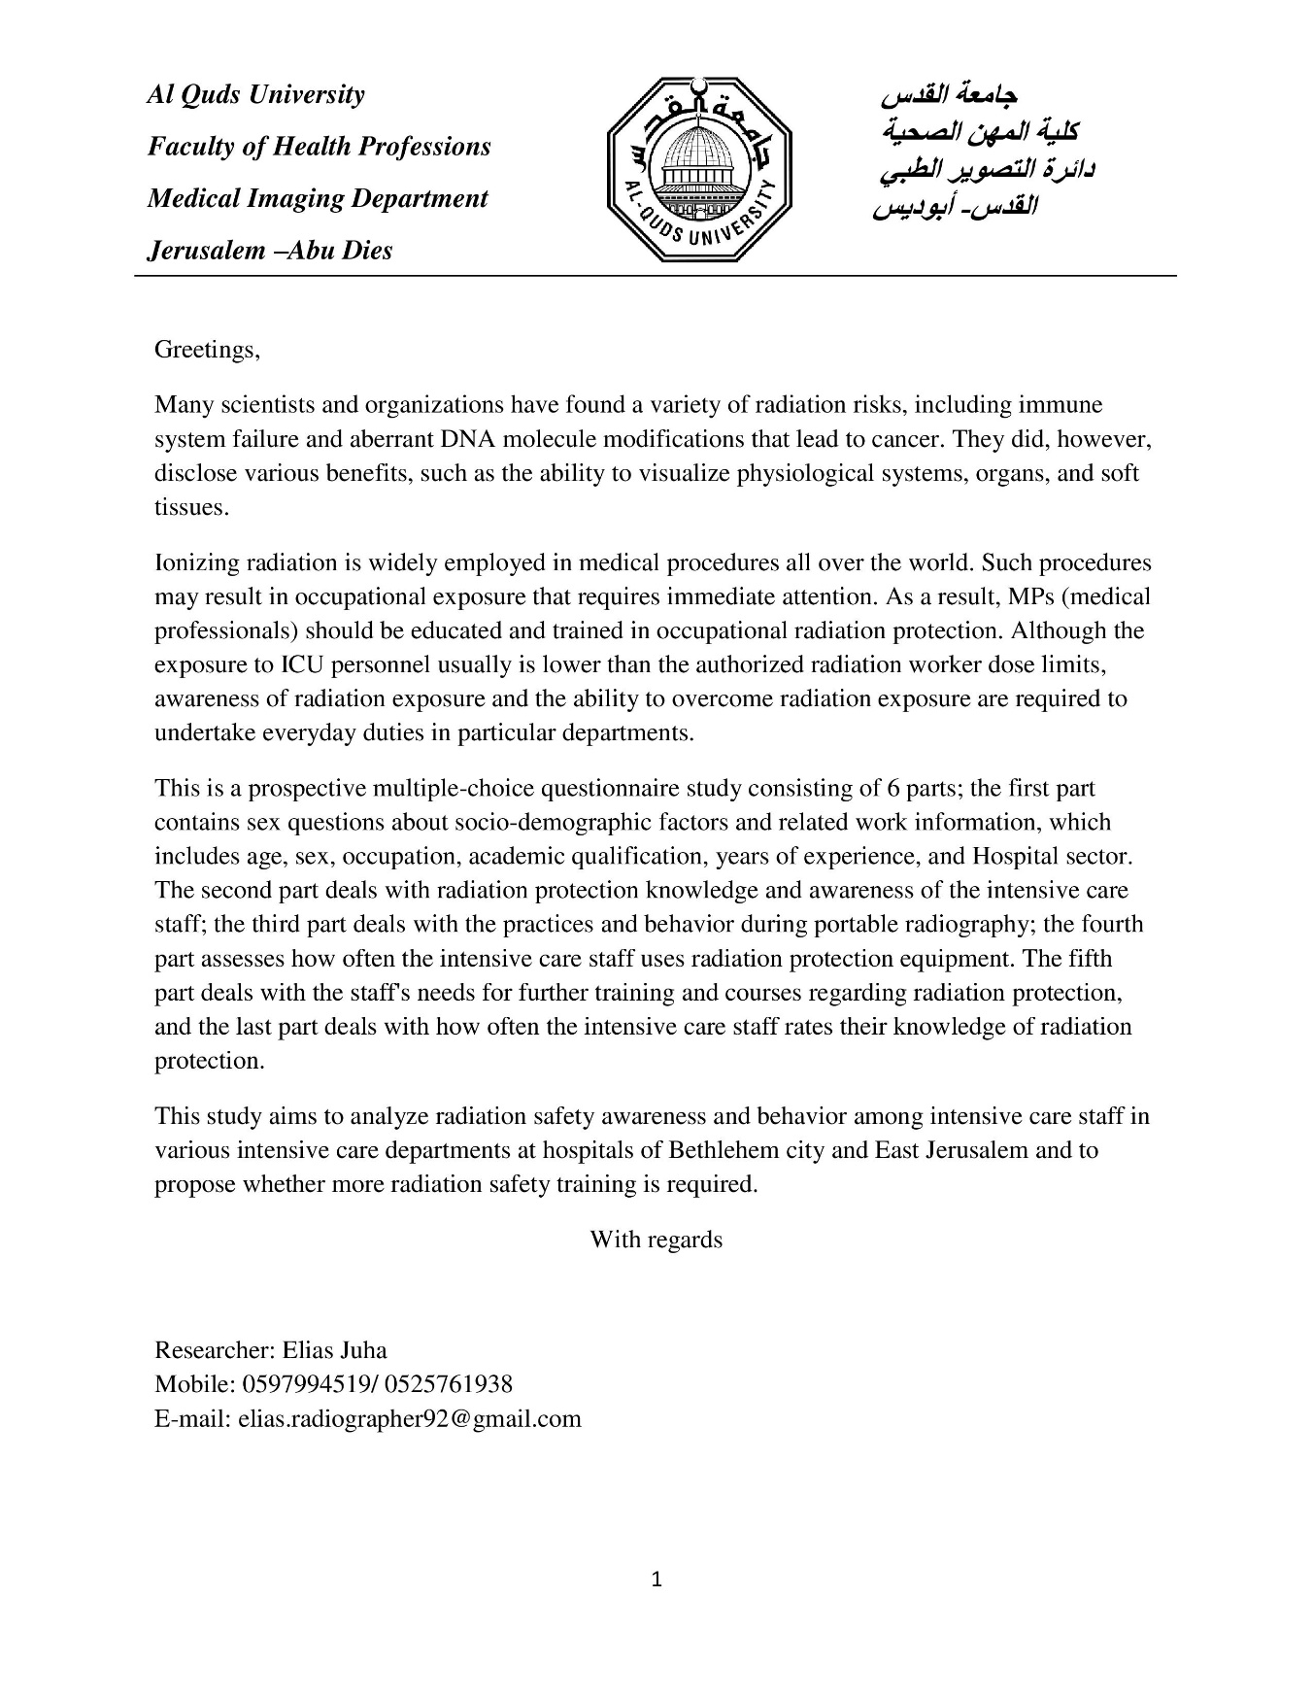

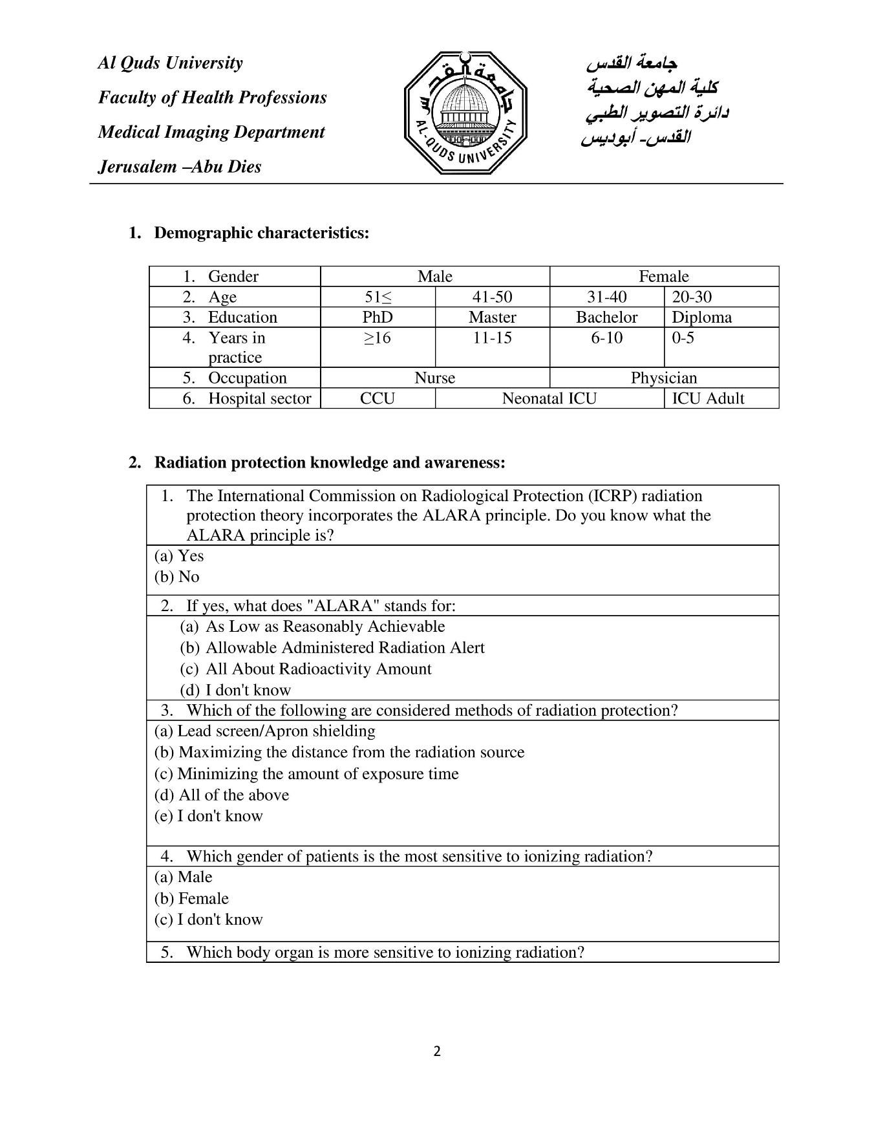

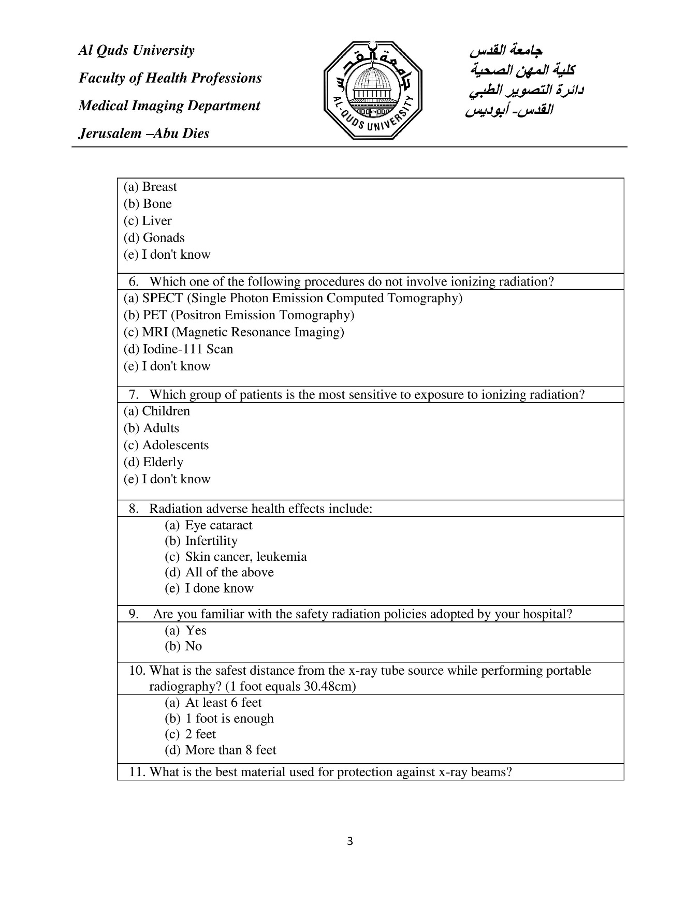

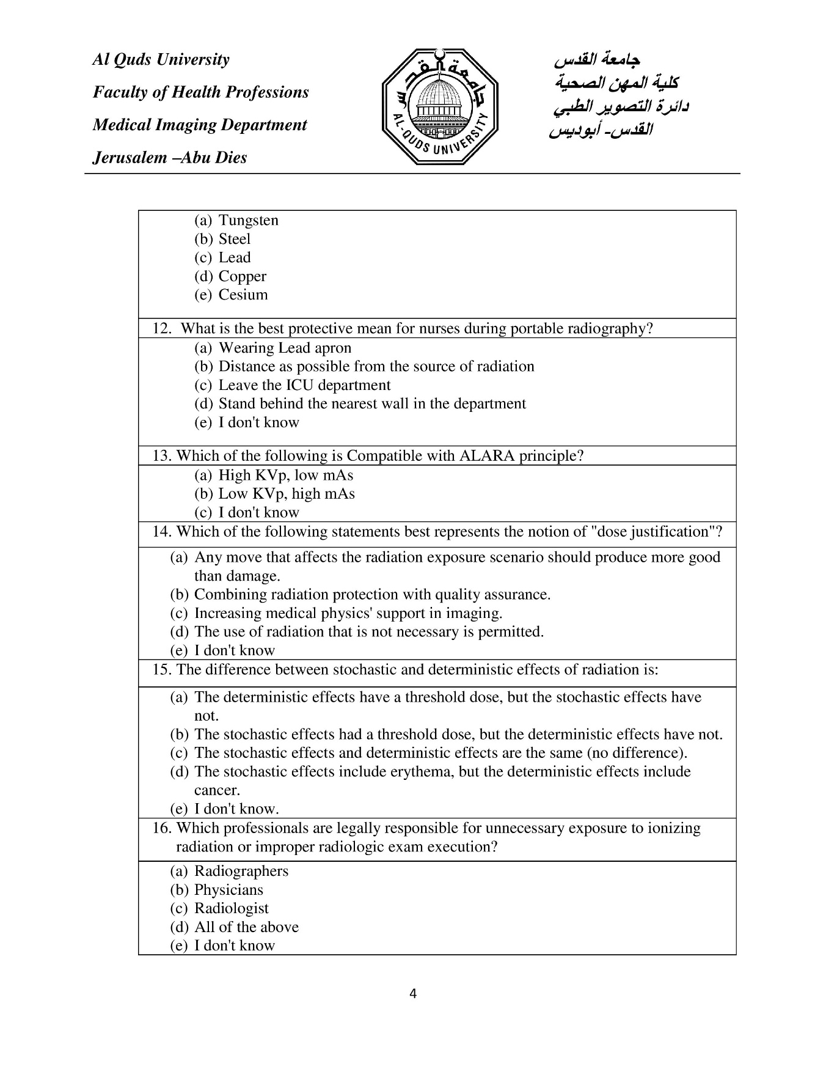

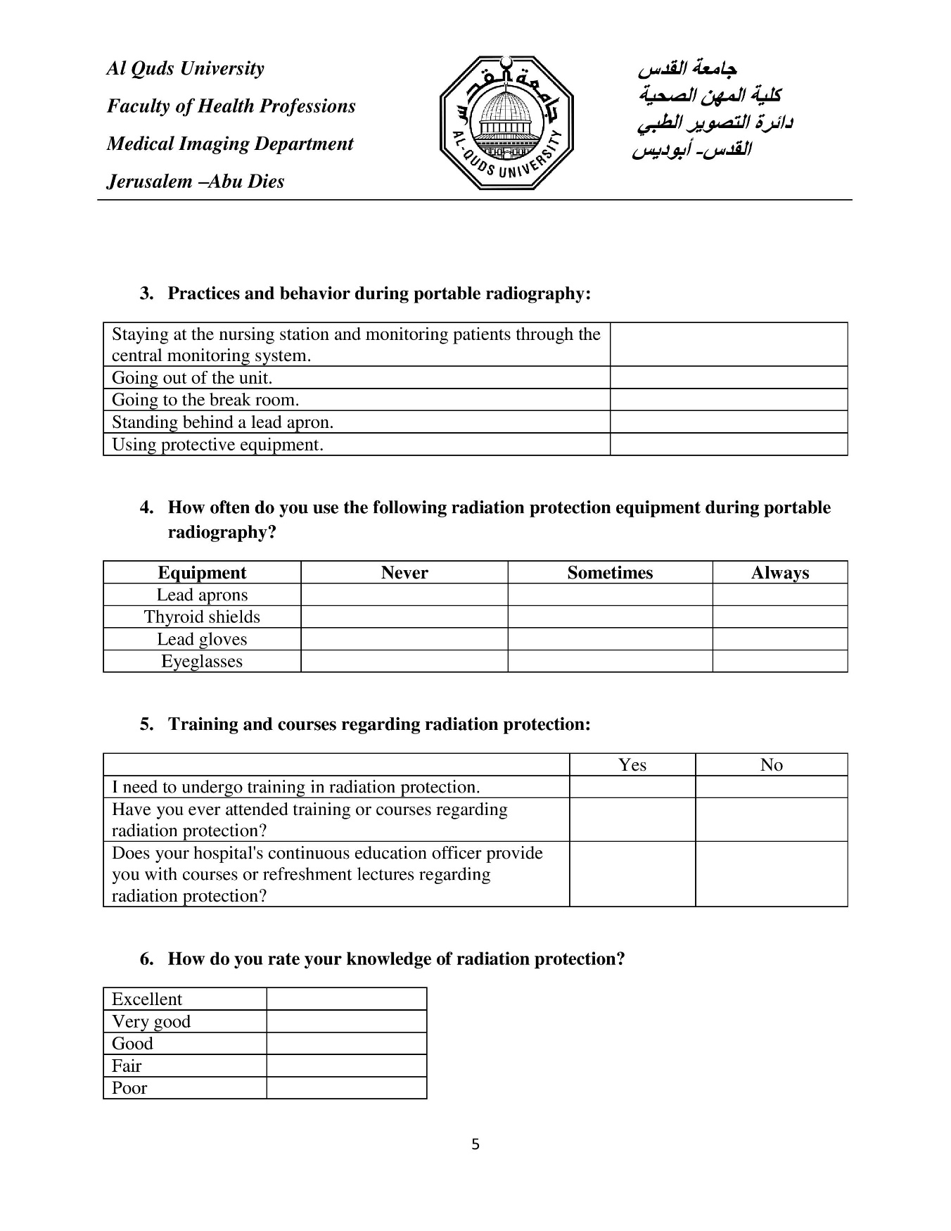

Appendix B: Letter of Approval
